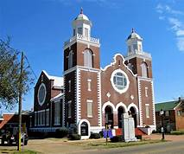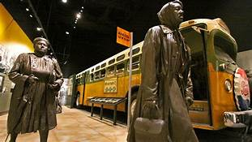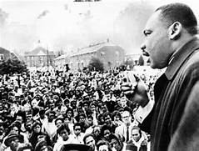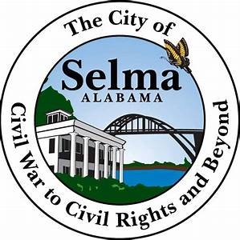

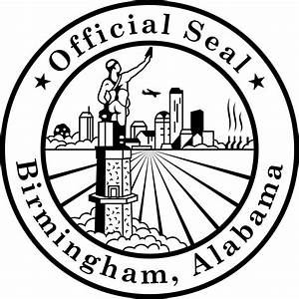

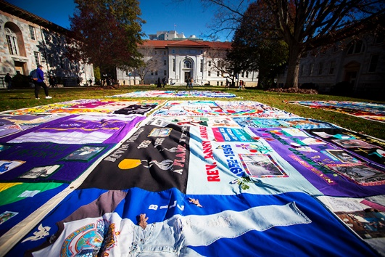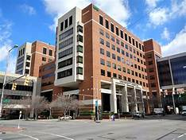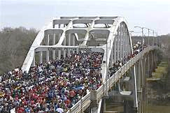

**Join Rabbi Shira Joseph with Rabbi Tom Alpert, Rabbi Ken Carr, Father Tom Mulvey for**

**Massachusetts Congregations**

**Civil Rights Journey**

***Atlanta, Montgomery, Selma & Birmingham***

**November 29 to December 2, 2018**

**For more information contact:** [**rabbishirajoseph@gmail.com**](mailto:rabbishirajoseph@gmail.com) **or 781-749-8103**

## THURSDAY NOV. 29

12:30pm Meet at Atlanta airport

1:30pm Leo Frank Site

*Hear the story of Leo Frank, a New York Jew who moved to Atlanta, was falsely convicted of murder and was lynched.*

*This has impacted the identity of Jews in the South since it occurred in 1915*

2:30pm Center for Civil & Human Rights

4:30pm Depart for Montgomery

Dinner on own in downtown Montgomery

Hotel: Fairfield Inn East Chase

## FRIDAY NOV. 30

Breakfast at hotel

9:30am Southern Poverty Law Center Memorial

11am Rosa Park Museum

*Stand where the Civil Rights movement began and learn about the Montgomery Bus Boycott*

12:30pm Lunch at Martha’s Place

2:15pm Equal Justice Initiative Museum and Memorial

*Discuss modern civil rights issues such as poverty, race, prison, death penalty*

*See how Civil Rights is still a struggle today*

Go to hotel and change for Friday night services

5:15pm Depart for Shabbat services

6:00pm Friday Night Services at Beth Or

Dinner

## SATURDAY DEC. 1

Breakfast at hotel

8am Leave for Selma

9am Creative Saturday Morning Services at Edmund Pettus Bridge - *The site of the beatings of the Selma-Montgomery march.*

10am Tour Selma & The Edmund Pettus Bridge

*Meet with someone who was beaten on the march. Hear her story.*

*Learn about Rabbi Abraham Joshua Heschel and his involvement in the struggle.*

11:30pm Depart for Birmingham and Lunch

2:30pm Birmingham Civil Rights Institute

*Explore museum about the Civil Rights movement*

4:45pm Walking tour of Freedom Park & 16th Street Baptist Church

*Get a walking tour by a Reverend who was a Civil Rights worker in Birmingham in the 50s & 60s and was arrested and had the dogs & hoses turned on him. See the historic church where 4 girls died in a bombing.*

Dinner, Depart for Atlanta

Hotel: Best Western Plus Fairburn

## SUNDAY DEC. 2

Breakfast at hotel

8:30am Depart hotel

9 am Names Project/AIDS Quilt

*See* *the AIDS Quilt and hear the story of the quilt and the politics of AIDS in America*. *Understand the fight for rights of the gay community in the 1980s.*

10am Arrive at The King Center and tour the Auburn Street neighborhood where King was born, preached and is buried

11:30am Sunday morning services at Ebenezer Baptist Church

*Dr. King’s historic church*

1pm Depart for airport and home

**$600 deposit of $1,200 by July 19 or $650 deposit of $1,300 after July 19**

*Deposit refundable until Sept 1st | Full payment due by September 26*

**Pricing is based on and includes:\*** - double occupancy ($200 addition for single)

- all meals beginning Friday breakfast and ending with Sunday breakfast.

- All hotel fees, ground transportation in coach deluxe bus, programming admissions and fees.

- Program with hotels of Fairfield Inn in Montgomery and Best Western Plus in Atlanta

*\*Does not include airfare.*

**Please make checks payable to: ETGAR36 and mail to: CSS , 1112 Main Street, Hingham, MA 02043**

**Or visit: https://secure.acceptiva.com/?cst=595c5c**