
June Reflections
FROM CMS:
The Centers for Medicare & Medicaid Services (CMS) posted the updated Appendix PP​ of the State Operations Manual as outlined in QSO-25-14-NH. The updates provide significant changes to the surveyor’s guidance in assessing compliance with federal regulations in long term care facilities. https://www.cms.gov/Regulations-and-Guidance/Guidance/Manuals/downloads/som107ap_pp_guidelines_ltcf.pdf

FROM CMS posted to 6-6-2025 https://www.cms.gov/medicare/health-safety-standards/quality-safety-oversight-general-information/policy-memos/policy-memos-states-and-cms-locations
- QSO-25-12-NH EXPIRED effective 3-19-25: Expiration Information: Refer to QSO-25-14-NH: REVISED: Revised Long-Term Care (LTC) Surveyor Guidance: Significant revisions to enhance quality and oversight of the LTC survey process
- QSO-25-07-NH EXPIRED effective 1-15-25: Expiration Information: Refer to QSO-25-14-NH: REVISED: Revised Long-Term Care (LTC) Surveyor Guidance: Significant revisions to enhance quality and oversight of the LTC survey process
- QSO-20-29-NH EXPIRED effective 12-31-2024: This memo was superseded by QSO-25-11-NH Long-Term Care (LTC) Facility Acute Respiratory Illness Reporting Requirements released 12/21/2024. See QSO-25-11-NH for current requirements regarding respiratory illness reporting.
- QSO-23-01-NH EXPIRED effective 10-4-2024: Revised the timeline for adjusting the quality measures so that all affected quality measures are updated at the same time. See QSO-25-01-NH

FROM CMS
Post-Acute Care Quality Programs

FY 2026 SNF VBP Program June 2025 Quarterly Reports are Now Available
The June 2025 Quarterly Confidential Feedback Reports for the fiscal year (FY) 2026 Skilled Nursing Facility Value-Based Purchasing (SNF VBP) Program are now available to download via the Internet Quality Improvement and Evaluation System (iQIES).
These reports contain facility-level measure results for four quality measures during FY 2024, the FY 2026 SNF VBP Program performance period:
- SNF 30-Day All-Cause Readmission Measure (SNFRM)
- Skilled Nursing Facility Healthcare-Associated Infections Requiring Hospitalization (SNF HAI)
- Total Nursing Staff Turnover (Nursing Staff Turnover)
- Total Nurse Staffing Hours per Resident Day (Total Nurse Staffing)
These results will be used for the FY 2026 SNF VBP Program year scoring and incentive payment calculations that will take effect October 1, 2025. Performance scores and incentive payment multipliers for the FY 2026 SNF VBP Program year will be disseminated in the August 2025 Performance Score Reports.
SNFs may submit corrections requests for their FY 2024 measure results up to 30 days following this report being made available, until July 9, 2025. Corrections are limited to errors made by CMS or its contractors when calculating a SNF’s measure results. SNFs must submit correction requests to SNFVBPquestions@cms.hhs.gov with the subject line “SNF VBP Review and Correction Inquiry” and include your SNF’s CMS Certification Number (CCN), SNF’s name, correction request, and reason for requesting the correction.
These reports contain stay-level data for the SNFRM protected by the Health Insurance Portability and Accountability Act of 1996 (HIPAA). Any disclosure of protected health information (PHI) or personally identifiable information (PII) should only be in accordance with, and to the extent permitted by, the HIPAA Privacy and Security Rules and applicable law. When referring to the contents of the report, use the Line Number (located in the leftmost column of the ‘SNFRM Eligible Stays’ tab) of the stay in question.
To locate your new report in iQIES, please follow the instructions listed below:
- Log into iQIES at https://iqies.cms.gov/ using your Health Care Quality Information Systems (HCQIS) Access Roles and Profile (HARP) user ID and password. (If you do not have a HARP account, you may register for a HARP ID.)
- In the Reports menu, select My Reports.
- From the My Reports page, locate the MDS 3.0 Provider Preview Reports folder. Select the MDS 3.0 Provider Preview Reports link to open the folder.
- Here you can see the list of reports available for download. Locate the desired SNF VBP Program Quarterly Confidential Feedback Report.
- Once located, select More next to your desired SNF VBP Program Quarterly Confidential Feedback Report and the report will be downloaded through your browser. Once downloaded, open the file to view your facility’s report.
For additional questions about accessing your SNF’s report, which can only be accessed in iQIES, please contact the iQIES Service Center by phone at (800) 339-9313 or by email at iqies@cms.hhs.gov.

FROM AHCA STATE AFFILIATE NETWORK (STATE AFFILIATE FROM ILLINOIS)
Some of our members are calling with concerns over PCC's upcoming (OCTOBER?) two-step verification process for their access to resident records. The concerns are coming in two forms:

- State surveyors who during trials would not download the app on their phones because it is their personal phone; and because the State's VPN system cannot access through the facility's internet;
- Employees using off-site and not wanting to have the app on their phone.

From the discussions I have been told that if in the facility on the facility's internet this two-step would not be needed but I am not sure about that.

Any insights? I have pushed back at the providers using PCC that they need to tell PCC they have to come up with a work around otherwise in IL we will be forced back to providing surveyors' laptops and that will be a problem for the State and other issues.

FROM LTC NATIONAL INFECTION PREVENTION FORUM
As you may have seen in the news, there are changes in recommendations coming up for the COVID-19 vaccine that will affect the long-term care workforce. The FDA has approved 2 new vaccines so far - Moderna mRNA and Novavax, non-mRNA., They are approved for use in everyone 65 and over and those 12 - 64 with at least 1 health condition that puts them at increased risk of severe outcome from COVID-19. Note that being a healthcare worker is not one of these conditions. It is expected that the updated Pfizer vaccine will be approved soon with the same indications. As we know, the CMS SOM requires education and offering of the vaccine for all healthcare workers: "(i) When COVID-19 vaccine is available to the facility, each resident and staff member is offered the COVID-19 vaccine unless the immunization is medically contraindicated or the resident or staff member has already been immunized;"
If a staff member is under 65 and does not have a health risk factor, then administration of the new vaccine would be considered off-label. Presumably all residents would either be over 64 and/or have at least one risk factor. It appears that there needs to be some adjustment in the CMS requirements unless it is assumed that the new vaccine is medically contraindicated in those under 65 with no risk factors.
Has anyone heard anything to clarify this?
Note that the 2024 - 2025 vaccine is still out there and OK for those 64 and under - the CDC has not changed their published guidance as of this morning: Adult Immunization Schedule by Age | Vaccines & Immunizations | CDC therefore no changes yet or until the new vaccine is available and the 2024 - 2025 is shelved. I assume that the new CDC guidance will eventually align with the FDA approved use.
RESPONSE FROM DR. DAVID GIFFORD (AHCA CHIEF MEDICAL OFFICER): Thanks for raising this. We will take this to CMS but are waiting to see what ACIP decides at its June meeting https://www.cdc.gov/acip/meetings/index.html and CDC finalizes since that may further impact existing CMS regulations. We will post CMS's response later in the year after ACIP meets.
FROM MCKNIGHTS
A proposed 2026 Trump administration budget request would shift nursing home survey priorities, further delaying the time between standard inspections at many facilities.
The Centers for Medicare & Medicaid Services budget justification published late Friday calls for a $45 million increase in survey spending across multiple sectors next fiscal year. But it also prioritizes complaint surveys in a way that would reduce the availability of surveyors to conduct routine, annual inspections mandated by law.
The document from the Department of Health and Human Services shows the percentage of nursing home standard surveys completed each year would fall from 74% in fiscal year 2024 to a projected 65% completion rate in fiscal year 2026.
The shift is an intentional one that would encourage state surveyors to respond to complaint surveys before standard surveys in most situations, prolonging a trend that skyrocketed during the pandemic. A focus on infection control surveys and complaints early in COVID — as well as months when inspectors were largely barred from conducting regular inspections — sent the average time between surveys soaring in almost all states.
The average nursing home went three years without a routine inspection in many states. By this spring, some states were still at those levels, leaving uninspected nursing homes with grossly outdated Care Compare metrics and star ratings.

FROM CMS:
Post-Acute Care Quality Programs

UPDATED: Draft MDS 3.0 Item Sets version 1.20.1v3-Section_R_removed
The draft Minimum Data Set (MDS) 3.0 Item Sets version (v)1.20.1v3-Section_R_removed and Item Matrix v1.20.1v3-Section_R_removed are now available in the Downloads section on the Minimum Data Set (MDS) 3.0 Resident Assessment Instrument (RAI) Manual page. The MDS Item Sets v1.20.1 will be effective beginning October 1, 2025.

All QCOR data below is for FY2025 (October 2024-current)
Average Number of Deficiencies in Standard Health Surveys
National FY2025
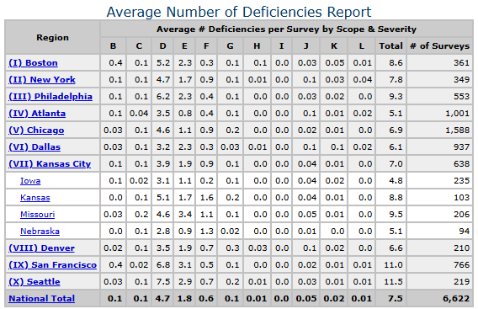

National Citation Frequency Overall Surveys FY2025 Top 10
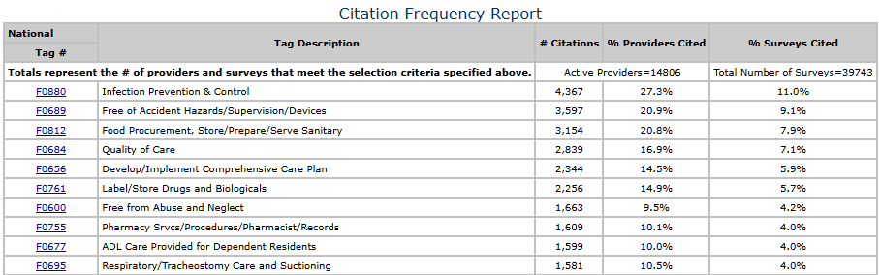

National Citation Frequency Report Standard Surveys FY2025 Top 10
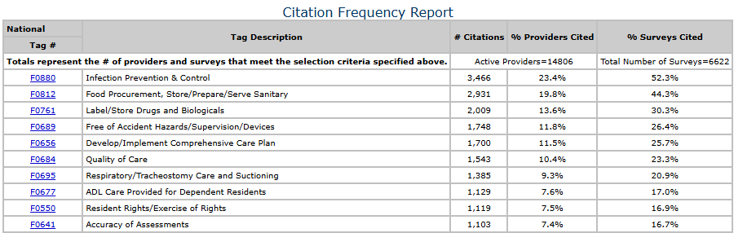

Iowa FY 2025-Standard Top 10
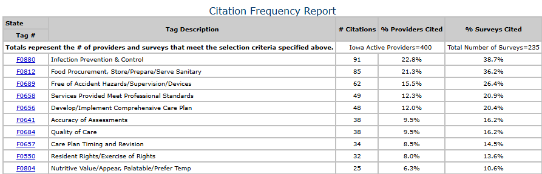

Iowa FY2025-Complaint Top 10
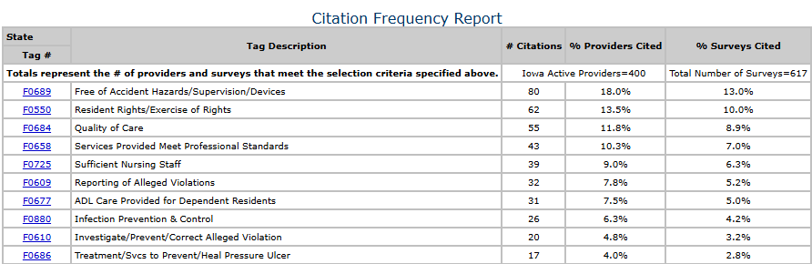

Kansas FY2025-Standard Top 10
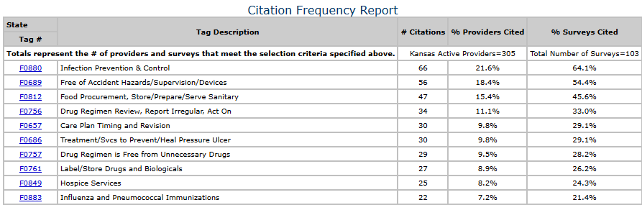

Kansas FY2025-Complaint Top 10
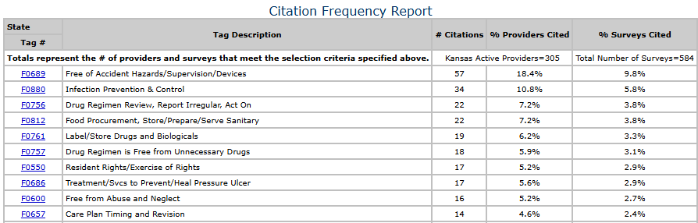

Missouri FY2025-Standard Top 10
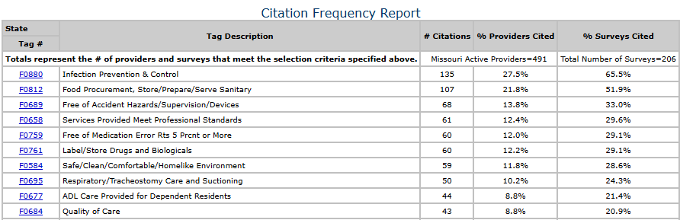

Missouri FY2025-Complaint Top 10
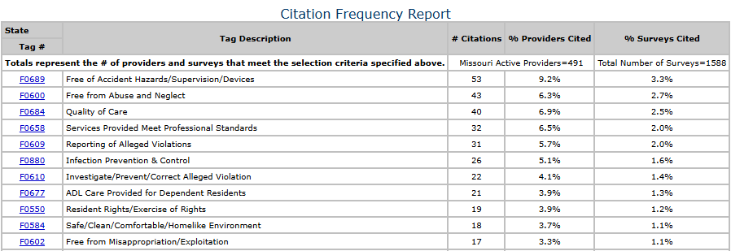

Nebraska FY2025-Standard Top 10
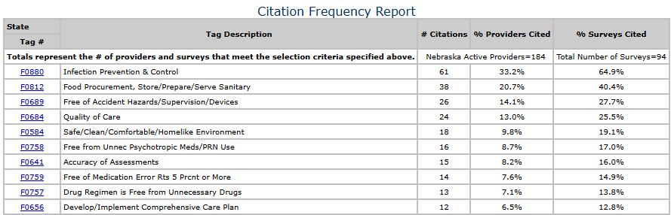

Nebraska FY2025-Complaint Top 10
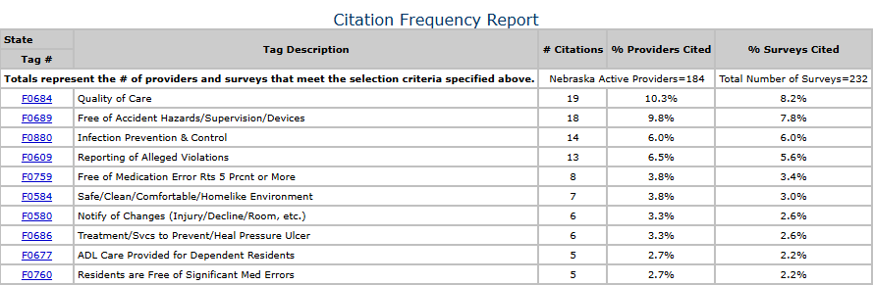

New York FY2025-Standard Top 10
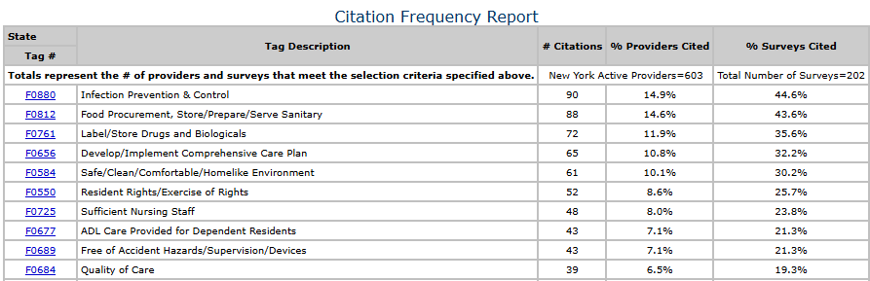

New York FY2025-Complaint Top 10
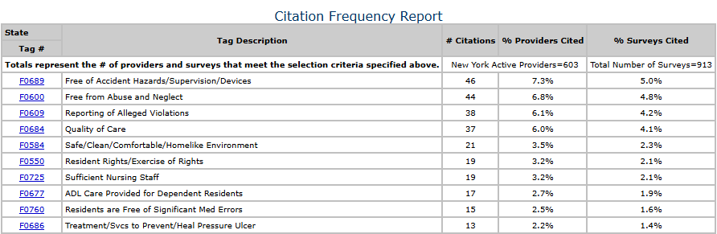

Pennsylvania FY2025-Standard Top 10
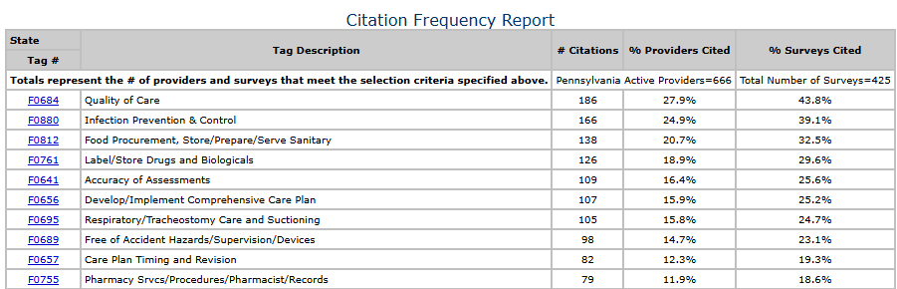

Pennsylvania FY2025-Complaint Top 10
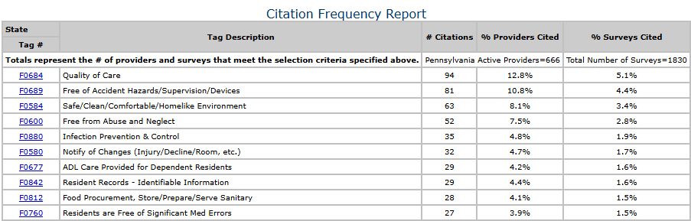

Overdue Recertification Surveys Report (16 months) FY2025
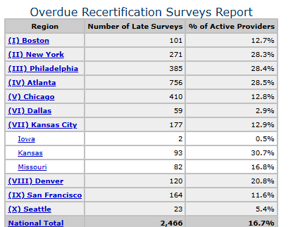

Number of G+ Deficiencies FY2025
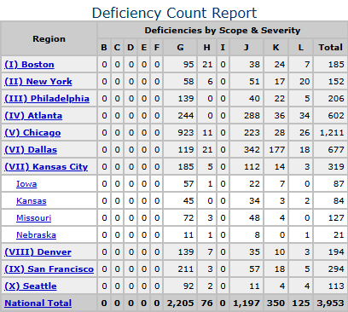

National G+ Citation Frequency FY2025 Top 10
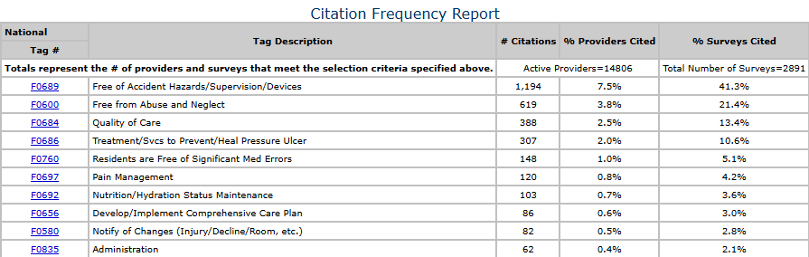

National J+ Citation Frequency FY2025 Top 10
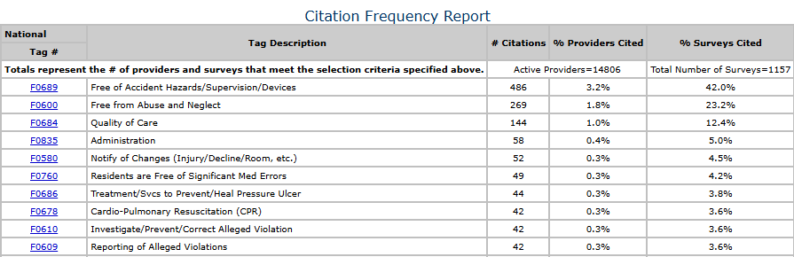

Civil Money Penalty (CMP) Report, FY2025
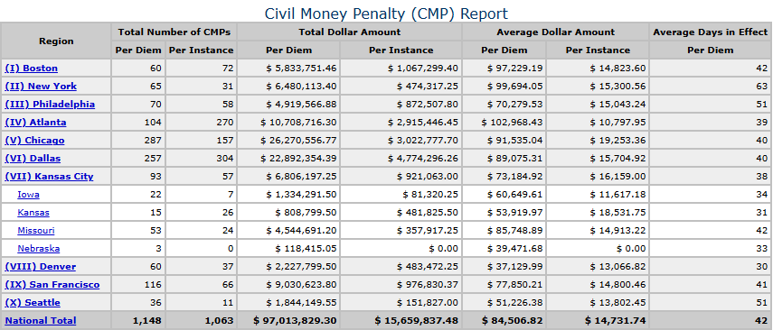

If I can help you in any way, please feel free to contact me.
Linda Farrar, RN/LNHA linda@licamedman.com 785-383-3826

