Welcome to the new enhanced background check system. At this time, we will continue processing name-based background checks. Please follow the steps below to set up your account and gain access.
🔗 Access the system here:
https://ksdadsv7prod.glsuite.us/ui/LicenseeLogin/Login

Step 1: Create an Account
- Go to the link above.
- At the bottom of the page, click “Sign up now.”
- Enter your email address.
- Complete the CAPTCHA (“Help us beat the bots”) by entering the characters shown.
- Click Send Verification Code.
  - A verification code will be sent to the email address you entered.
- Follow the prompts to verify your email and complete your account setup.
(See Pictures 1–2 for reference.)
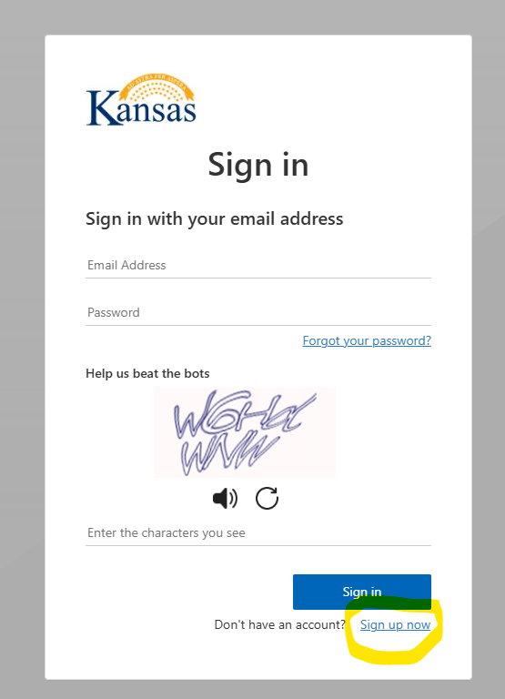
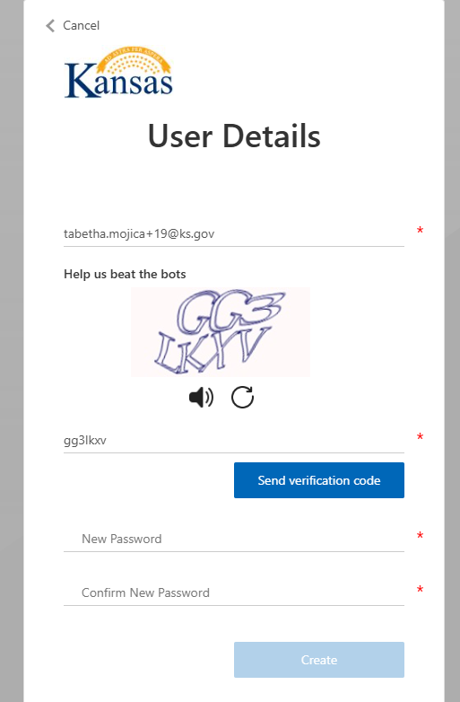

Step 2: Create a Password
You will now be prompted to create and confirm your password.
Your password must:
- Be between 8 and 64 characters in length
- Include at least three of the following:
  - A lowercase letter
  - An uppercase letter
  - A number
  - A symbol
Once your password meets these requirements, click Create Account.
(See Picture 3 for reference.)
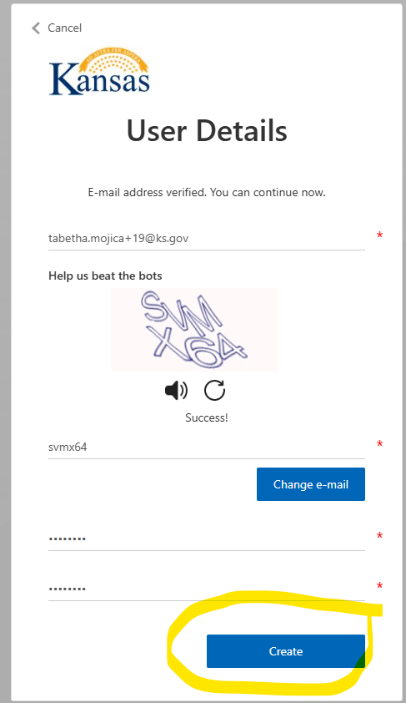

Step 3: Multi-Factor Authentication (MFA)
Please note:
If you are using an office phone, select the “Call Me” option to receive your verification code, as office phones are not typically set up for text messaging.
Enter the code you receive and click Verify Code.
(See Picture 4 for reference.)
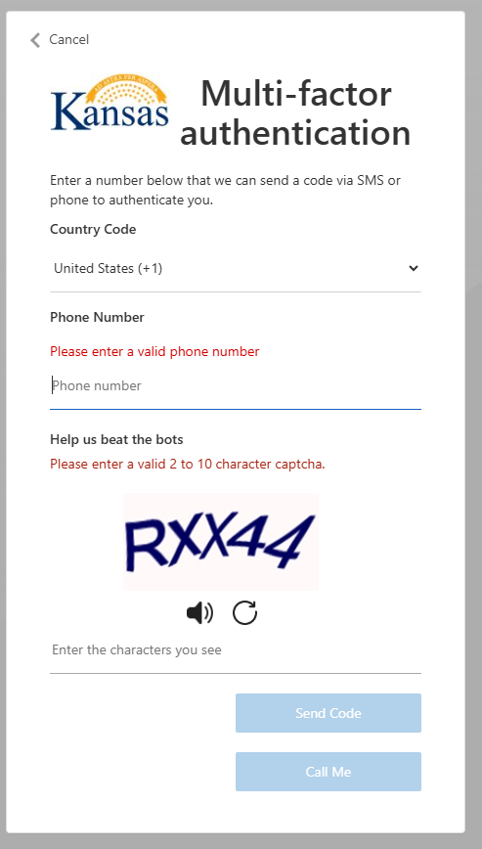

Step 4: Link Your Account
The next page will prompt you to link your account by selecting one of the following options:
- Verify User
- Access as New User
In most cases, you should select New User. However, if your information already exists in our system, you may need to enter your details twice to complete the verification process.
(See Picture 5 for reference.)
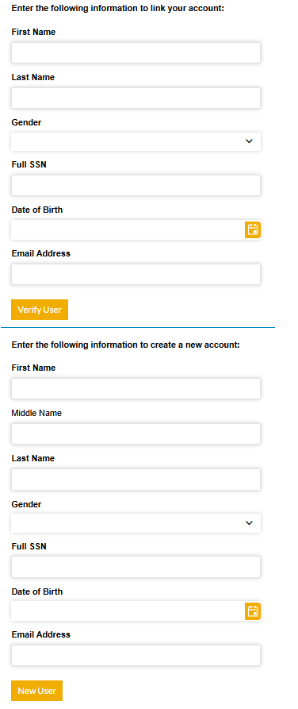

Start by entering your information under the “New User” section.
If you receive an error message indicating a duplicate SSN (see Picture 6), this means your information may already exist in the system.
- Refresh the page to close the error message.
- Then, re-enter your information under the “Verify User” section (the top portion of the page).
If you attempt to verify and the system does not find an existing account, you will see a message similar to the one shown in Picture 7.
- When this happens, return to the main page,
- Clear the information entered in the top portion, and
- Re-enter your details under “Create New Account.”
(See Pictures 6–7 for reference.)
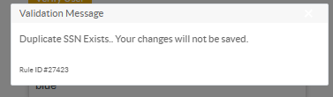
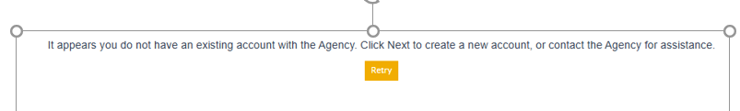

Once you are logged in, if you do not see the “Manage Facilities” option on the left-hand side, please navigate to the Address section and enter your address information.
Please note: Ignore any other options marked in red, as those features are still under development and not yet fully functional.
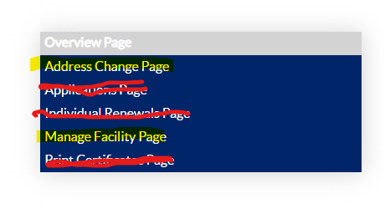
📽️ Video Reference:
How to Add Address Information
If “Manage Facilities” appears, proceed to the next video on how to link your facility.
- If your facility has already been issued a Facility ID, use the Search Facility option.
- If you are a new facility or HCBS provider needing a Facility ID, select Create New Facility.
📽️ Video Reference:
How to Link or Create a Facility
For steps on adding additional Authorized Users to your facility account, please review the video below:
📽️ Video Reference:
How to Add Authorized Users

