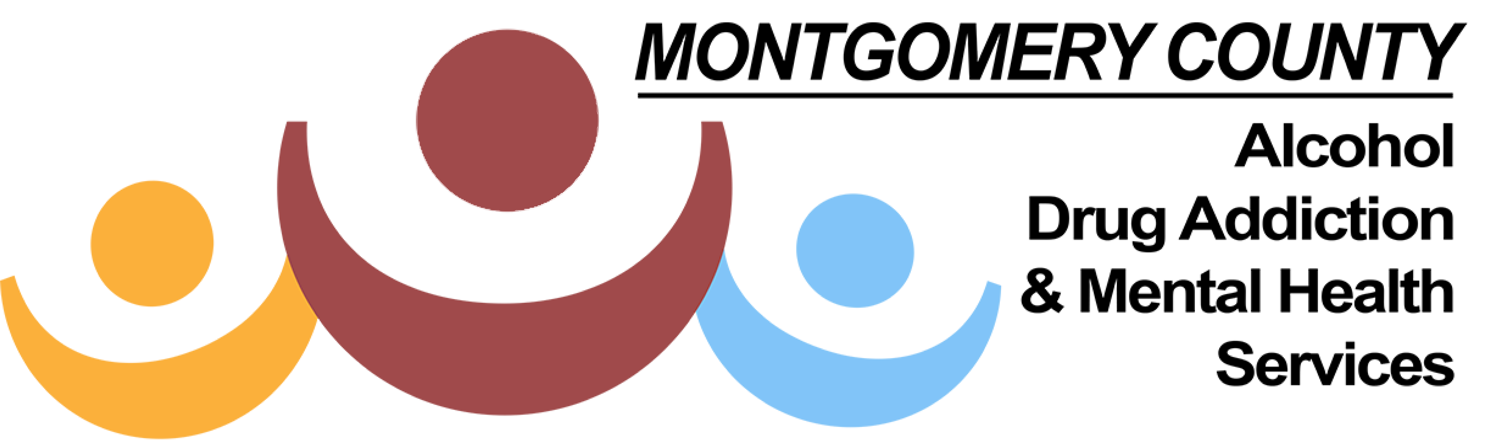
For Immediate Release May 13, 2019
Contact: Paula Cosby 443-0416, ext. 147

ADAMHS Earns Four National Achievement Awards
Montgomery County Alcohol, Drug Addiction & Mental Health Services (ADAMHS) is being recognized with four Achievement Awards from the National Association of Counties (NACo). The awards honor innovative, effective county government programs that strengthen services for residents. The Human Services category focuses on the ability to assist residents, particularly veterans, children, and the elderly and/or disabled residents. Information Technology recognizes creative uses of technology that make county processes more efficient and cost-effective.
“Our goal is to implement innovative programs that enhance and support services,” said ADAMHS Executive Director Helen Jones-Kelley. “By helping to build a healthy, safe and vibrant community we can improve the quality of life for all Montgomery County residents.”
The four honors are:
Montgomery County RX Medication Safety Campaign (category of Human Services): a community-wide initiative to educate individuals how to have a healthy relationship with medication along with the disbursement of 65,000 free medication disposal bags to the community since 2017, resulting in nearly three million pills disposed of properly.

Montgomery County Prevention Coalition (category of Humans Services): mobilizes community collaboration to prevent youth substance use and promote positive mental health through evidence-based prevention strategies. The coalition is working on over forty strategies that will impact behavioral issues such as gambling, suicide prevention and opioid misuse at the county level.

Montgomery County Emergency Room Overdose Notification System (category of Information Technology): service providers receive an emergency room alert for a suspected drug overdose with 24 hours to provide immediate patient engagement, outreach, follow-up and, treatment services. The objective is to quickly re)engage as many ER overdose patients as possible into addiction treatment.

Montgomery County Training Institute (category of Human Services): over 5,000 behavioral health professionals and community volunteers were trained to help others in crisis during 2018. Topics include suicide prevention, mental health first aid, nicotine addiction and smoking cessation.

NACo will recognize ADAMHS at its 2019 Annual Conference in July in Nevada.

# # #
ADAMHS is responsible for the planning, funding and monitoring of public mental health and alcohol and other drug addiction services. Under Ohio law, ADAMHS is the local county entity with responsibility for coordinating the public behavioral health system in Montgomery County. ADAMHS collaborates on the strategic initiatives of the Board of County Commissioners and supports the professional development needs of local governmental departments as well as approximately 30+ community-based organizations.

