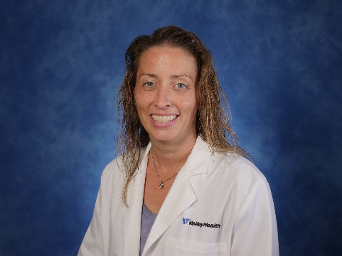
Jill Bethlehem, PA-C sees patients at the following location.

Valley Health Urgent Care | Martinsburg
97 Administrative Drive
Martinsburg, WV 25401
Phone: 304-350-3205

valleyhealthlink.com
Jill Bethlehem, PA-C
Jill Bethlehem, PA-C is a board certified physician assistant with more than 18 years of experience in emergency department and urgent care settings. Jill provides employer health care at Valley Health.

Graduate School: Saint Francis University – Master of Medical Science, Physician Assistant
Undergraduate School: Washington and Jefferson College – Liberal Arts Degree, Biological Science
Board Certification: Physician Assistant (NCCPA)

Certifications:
FMCSA Certified Medical Examiner

Services offered:
- Workplace injury care
  - Injury treatment
  - Medical management
  - Case Management
- Non-injury services
  - Pre-placement, DOT & executive physicals
  - Drug screening
  - Breath alcohol testing
  - Pulmonary function screening
  - Respirator fit testing
  - Audiometric testing
  - Travel health services
  - Vaccinations

