2025 All-American Angus Breeders' Futurity Roll of Victory (ROV) Show
Angus exhibitors led 69 entries at the 2024 All-American Angus Breeders' Futurity Roll of Victory (ROV) Show, June 15 in Louisville, Ky. Chad Ellingson, Bismarck, N.D., evaluated the entries before naming champions.

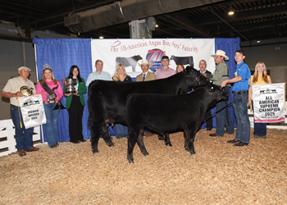 | Grand Champion Cow-calf Pair [Download]  McCauley Stormy L1 won supreme champion overall, receiving the Earl Marshall Award, and grand champion cow-calf pair at the 2025 All-American Angus Breeders' Futurity Roll of Victory (ROV) Show, June 15 in Louisville, Ky. Adam McCauley, Cynthiana, Ky., owns the January 2023 daughter of PVF Marvel 9185. A January 2025 bull calf sired by Connealy Emerald is at side. Chad Ellingson, Bismarck, N.D., evaluated the 69 entries. Photo by Next Level Images.  Click image to view full file size.
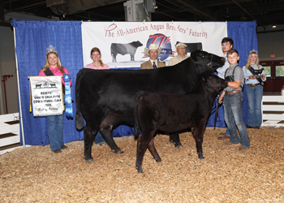 | Reserve Grand Champion Cow-calf Pair [Download]  SE Rita K105 won reserve grand champion cow-calf pair at the 2025 All-American Angus Breeders' Futurity Roll of Victory (ROV) Show, June 15 in Louisville, Ky. Sawyer Eastridge, Taswell, Ind., owns the April 2022 daughter of RVF/SE Captain H103. An April 2025 heifer calf sired by Destinys Back In Black 320 completes the winning pair. Chad Ellingson, Bismarck, N.D., evaluated the 69 entries. Photo by Next Level Images.  Click image to view full file size.
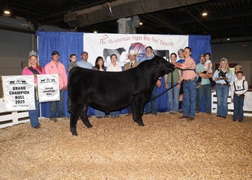 | Grand Champion Bull [Download]  DS Good Times Dandy 46 won grand champion bull and received the Quintin Smith Award at the 2025 All-American Angus Breeders' Futurity Roll of Victory (ROV) Show, June 15 in Louisville, Ky. David Smith, Boulder, Colo., owns the April 2024 son of STAG Good Times 201 ET. He first claimed junior champion. Chad Ellingson, Bismarck, N.D., evaluated the 69 entries. Photo by Next Level Images.  Click image to view full file size.
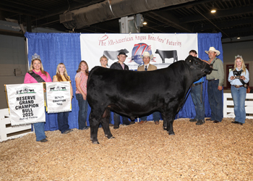 | Reserve Grand Champion Bull [Download]  McCauley Kingsman 1L2 won reserve grand champion bull at the 2025 All-American Angus Breeders' Futurity Roll of Victory (ROV) Show, June 15 in Louisville, Ky. Adam McCauley, Cynthiana, Ky., owns the November 2023 son of Conley Express 7211. He first claimed senior champion. Chad Ellingson, Bismarck, N.D., evaluated the 69 entries. Photo by Next Level Images.  Click image to view full file size.
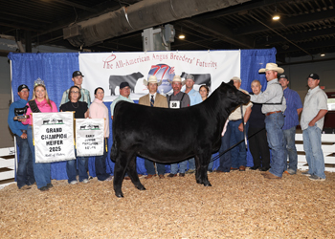 | Grand Champion Female [Download]  JCC Lola 411 won grand champion female at the 2025 All-American Angus Breeders' Futurity Roll of Victory (ROV) Show, June 15 in Louisville, Ky. Josie Phillips, Maysville, Ky., owns the March 2024 daughter of BRDG Mahogany Prime 904B. She first claimed junior champion. Chad Ellingson, Bismarck, N.D., evaluated the 69 entries. Photo by Next Level Images.  Click image to view full file size.
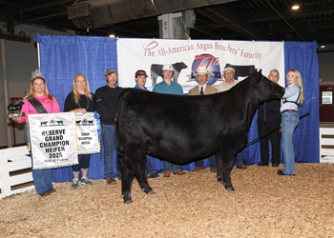 | Reserve Grand Champion Female [Download]  Johnson Blackbird 372 won reserve grand champion female at the 2025 All-American Angus Breeders' Futurity Roll of Victory (ROV) Show, June 15 in Louisville, Ky. Katy Cooper, May's Lick, Ky., owns the October 2023 daughter of SCC SCH 24 Karat 838. She first won senior champion. Chad Ellingson, Bismarck, N.D., evaluated the 69 entries. Photo by Next Level Images.  Click image to view full file size.
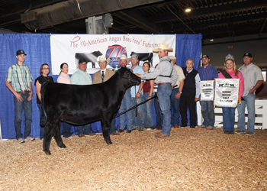 | 3RD Place Overall Female [Download]  BNWZ Saras Dream 4796 won third overall champion female at the 2025 All-American Angus Breeders' Futurity Roll of Victory (ROV) Show, June 15 in Louisville, Ky. Josie Phillips, Maysville, Ky., owns the October 2024 daughter of SCC SCH 24 Karat 838. She first won senior calf champion. Chad Ellingson, Bismarck, N.D., evaluated the 69 entries. Photo by Next Level Images.  Click image to view full file size.
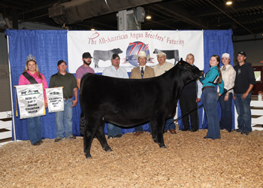 | 4TH Place Overall Female [Download]  BF BCII Sandy Birdie 138 won fourth overall champion female at the 2025 All-American Angus Breeders' Futurity Roll of Victory (ROV) Show, June 15 in Louisville, Ky. Maddilea Shaffer, Pennsboro, W.Va., owns the January 2024 daughter of SCC SCH 24 Karat 838. She first claimed reserve junior champion. Chad Ellingson, Bismarck, N.D., evaluated the 69 entries. Photo by Next Level Images.  Click image to view full file size.
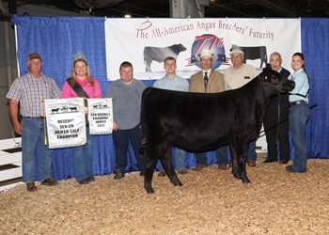 | 5TH Place Overall Female [Download]  SAF Sandy 4120 won fifth overall champion female at the 2025 All-American Angus Breeders' Futurity Roll of Victory (ROV) Show, June 15 in Louisville, Ky. Bryanna Smith, Russell Springs, Ky., owns the September 2024 daughter of PVF DLX King Pin 0058. She first won reserve senior calf champion. Chad Ellingson, Bismarck, N.D., evaluated the 69 entries. Photo by Next Level Images.  Click image to view full file size.

2025 All-American Breeders' Futurity Junior Show
Angus exhibitors led 72 entries at the 2025 All-American Breeders' Futurity Junior Show, June 14 in Louisville, Ky. Mark Davis, Shelbyville, Tenn., evaluated the entries before naming champions.

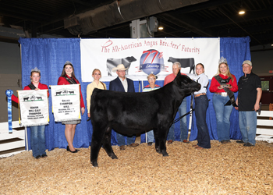 | Grand Champion Bred-and-owned Bull [Download]  DBF Ayers Raphael 472 won grand champion bred-and-owned bull at the 2025 All-American Breeders' Futurity Junior Show, June 14 in Louisville, Ky. Emily Jeffries, Canmer, Ky., owns the October 2024 son of SCC SCH 24 Karat 838. He first claimed senior calf champion. Mark Davis, Shelbyville, Tenn., evaluated the 72 entries. Photo by Next Level Images.  Click image to view full file size.
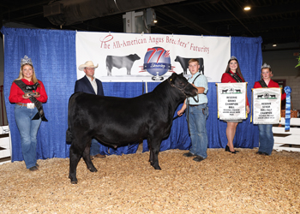 | Reserve Grand Champion Bred-and-owned Bull [Download]  SAF Broker 4143 won reserve grand champion bred-and-owned bull at the 2025 All-American Breeders' Futurity Junior Show, June 14 in Louisville, Ky. Blane Smith, Russell Springs, Ky., owns the September 2024 son of Connealy Commerce. He earlier won reserve senior calf champion. Mark Davis, Shelbyville, Tenn., evaluated the 72 entries. Photo by Next Level Images.  Click image to view full file size.
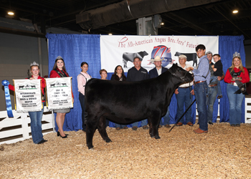 | Grand Champion Bred-and-owned Female [Download]  Voyager Georgina 8611 won grand champion bred-and-owned female at the 2025 All-American Breeders' Futurity Junior Show, June 14 in Louisville, Ky. Jacob Marksbury, Buffalo, Ky., owns the May 2024 daughter of PVF Blacklist 7077. She first claimed intermediate champion. Mark Davis, Shelbyville, Tenn., evaluated the 72 entries. Photo by Next Level Images.  Click image to view full file size.
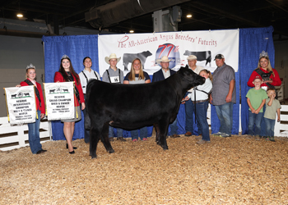 | Reserve Grand Champion Bred-and-owned Female [Download]  KCC Clara 3224 won reserve grand champion bred-and-owned female at the 2025 All-American Breeders' Futurity Junior Show, June 14 in Louisville, Ky. Karlee Kasler, Millfield, Ohio, owns the May 2024 daughter of PVF Marvel 9185. She earlier won reserve intermediate champion. Mark Davis, Shelbyville, Tenn., evaluated the 72 entries. Photo by Next Level Images.  Click image to view full file size.
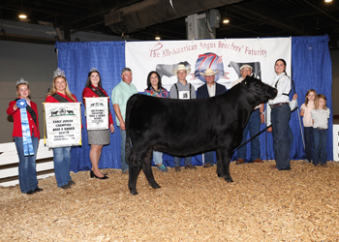 | Third Overall Bred-and-owned Champion Female [Download]  Davis Shadoe 2401 won third overall bred-and-owned champion female at the 2025 All-American Breeders' Futurity Junior Show, June 14 in Louisville, Ky. Maggie Davis, Bidwell, Ohio, owns the February 2024 daughter of SCC SCH 24 Karat 838. She first claimed junior champion. Mark Davis, Shelbyville, Tenn., evaluated the 72 entries. Photo by Next Level Images.  Click image to view full file size.
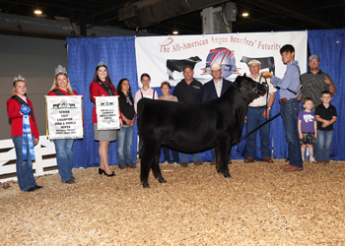 | Fourth Overall Bred-and-owned Champion Female [Download]  Voyager Georgina 8610 won fourth overall bred-and-owned champion female at the 2025 All-American Breeders' Futurity Junior Show, June 14 in Louisville, Ky. Jacob Marksbury, Buffalo, Ky., owns the November 2024 daughter of PVF Marvel 9185. She first claimed senior heifer calf. Mark Davis, Shelbyville, Tenn., evaluated the 72 entries. Photo by Next Level Images.  Click image to view full file size.
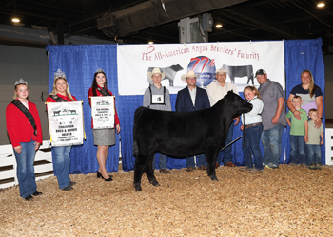 | Fifth Overall Bred-and-owned Champion Female [Download]  KCC Clara 9124 won fifth overall bred-and-owned champion female at the 2025 All-American Breeders' Futurity Junior Show, June 14 in Louisville, Ky. Karlee Kasler, Millfield, Ohio, owns the November 2024 daughter of PVF Marvel 9185. He first claimed reserve senior calf champion. Mark Davis, Shelbyville, Tenn., evaluated the 72 entries. Photo by Next Level Images.  Click image to view full file size.
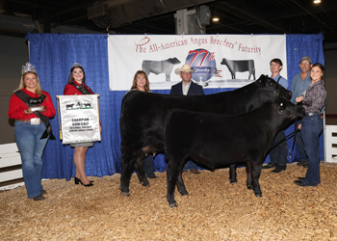 | Grand Champion Cow-calf Pair [Download]  McCauley Stormy L1 won grand champion cow-calf pair at the 2025 All-American Breeders' Futurity Junior Show, June 14 in Louisville, Ky. Adam McCauley, Cynthiana, Ky., owns the January 2023 daughter of PVF Marvel 9185. A January 2025 bull calf sired by Connealy Emerald completes the winning duo. Mark Davis, Shelbyville, Tenn., evaluated the 72 entries. Photo by Next Level Images.  Click image to view full file size.
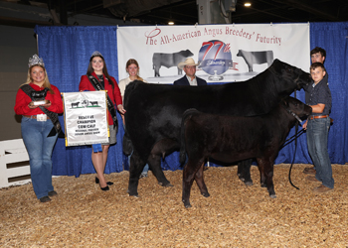 | Reserve Grand Champion Cow-calf Pair [Download]  SE Rita K105 won reserve grand champion cow-calf pair at the 2025 All-American Breeders' Futurity Junior Show, June 14 in Louisville, Ky. Sawyer Eastridge, Taswell, Ind., owns the April 2022 daughter of RVF/SE Captain H103. An April 2025 heifer calf sired by Destinys Back In Black 320 is at side. Mark Davis, Shelbyville, Tenn., evaluated the 72 entries. Photo by Next Level Images.  Click image to view full file size.
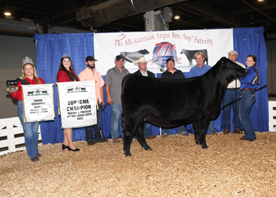 | Grand Champion Owned Female [Download]  BF BCII Sandy Birdie 138 won supreme champion and grand champion owned female at the 2025 All-American Breeders' Futurity Junior Show, June 14 in Louisville, Ky. Maddilea Shaffer, Pennsboro, W.Va., owns the January 2024 daughter of SCC SCH 24 Karat 838. She first claimed junior champion. Mark Davis, Shelbyville, Tenn., evaluated the 72 entries. Photo by Next Level Images.  Click image to view full file size.
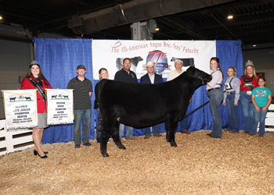 | Reserve Grand Champion Owned Female [Download]  BSMO Kesha 416M won reserve grand champion owned female at the 2025 All-American Breeders' Futurity Junior Show, June 14 in Louisville, Ky. Clara Bishop, Coxs Creek, Ky., owns the February 2024 daughter of STAG Good Times 201 ET. She earlier won reserve junior champion. Mark Davis, Shelbyville, Tenn., evaluated the 72 entries. Photo by Next Level Images.  Click image to view full file size.
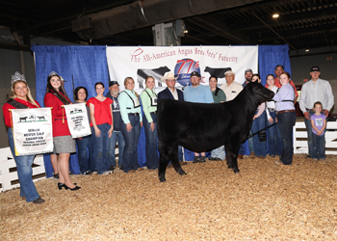 | Third Overall Owned Champion Female [Download]  Henning Lucy 4087 won third overall owned champion female at the 2025 All-American Breeders' Futurity Junior Show, June 14 in Louisville, Ky. Layla Miller, Waterford, Wis., owns the October 2024 daughter of SCC SCH 24 Karat 838. She first claimed senior calf champion. Mark Davis, Shelbyville, Tenn., evaluated the 72 entries. Photo by Next Level Images.  Click image to view full file size.
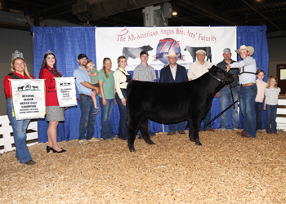 | Fourth Overall Owned Champion Female [Download]  Johnson Nellie 460 won fourth overall owned champion female at the 2025 All-American Breeders' Futurity Junior Show, June 14 in Louisville, Ky. Curtner Bergmann, Vienna, Ill., owns the October 2024 daughter of BNWZ Dignity 8017. She earlier won reserve senior calf champion. Mark Davis, Shelbyville, Tenn., evaluated the 72 entries. Photo by Next Level Images.  Click image to view full file size.
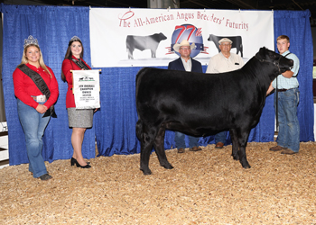 | Fifth Overall Owned Champion Female [Download]  Seldom Rest Pin Up Gal 4146 won fifth overall owned champion female at the 2025 All-American Breeders' Futurity Junior Show, June 14 in Louisville, Ky. Blane Smith, Russell Springs, Ky., owns the July 2024 daughter of KR Casino 6243. She earlier won intermediate champion. Mark Davis, Shelbyville, Tenn., evaluated the 72 entries. Photo by Next Level Images.  Click image to view full file size.
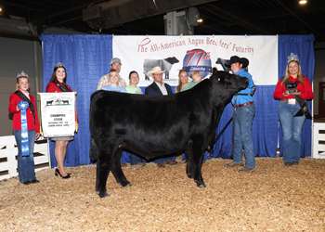 | Grand Champion Steer [Download]  Johnson Hot Rod won grand champion steer at the 2025 All-American Breeders' Futurity Junior Show, June 14 in Louisville, Ky. Seth Chunglo, Harrodsburg, Ky., owns the March 2024 son of Silveiras Style 9303. Mark Davis, Shelbyville, Tenn., evaluated the 72 entries. Photo by Next Level Images.  Click image to view full file size.
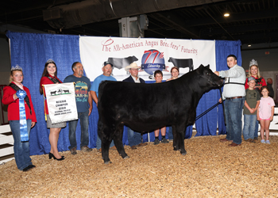 | Reserve Grand Champion Steer [Download]  3ACES Insight 4514 won reserve grand champion steer at the 2025 All-American Breeders' Futurity Junior Show, June 14 in Louisville, Ky. Mayson Toll, Lawrenceburg, Ky., owns the April 2024 son of PVF Insight 0129. Mark Davis, Shelbyville, Tenn., evaluated the 72 entries. Photo by Next Level Images.  Click image to view full file size.

