Carcass Show Attendance Agreement

This contract is an agreement between ____________________________________________, the 21 Central 4-H Program, and the County Fairboard stating that by entering an animal in the Carcass Show contest, the 4-H member agrees to the following statements:

- I, __________________________________, agree that myself and my family are responsible for the delivery of my own animal to the proper packing plant. (Edwards County-Burkhardt Meats, Stafford County-Ellinwood Packing Plant)

- I, __________________________________, agree that the Carcass Show is not a free slaughter spot for my animal, but rather an educational experience that is a privilege for my county to host. Therefore, I agree to attend the Carcass Show that my animal is competing in unless I have a legitimate prior engagement.
  - If you cannot attend the Carcass Show, please list your reason below:

  - _____________________________________________________________________

- I, ___________________________________, agree that if I do not attend the Carcass Show and I do not have a legitimate reason, I will forfeit any prize money that my animal’s carcass earns and any premiums from the contest. I also agree that if there are too many participants for the carcass show the following year, my animal will be the last to be considered for a slaughter spot.

By checking this box, I agree with the above statements.
_________________________________________________________________________________
(4-H Member’s Signature)

By checking this box, I agree with the above statements.
_________________________________________________________________________________
(4-H Member’s Parent/Guardian’s Signature)

______________________________________ ________________________________________
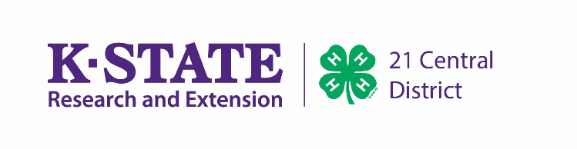
County Fairboard President 4-H Youth Development Agent

