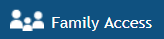
Snoqualmie Valley School District
Family Access Information

Student Name:

Family Access is a web-based tool that allows parents/guardians to view school-related information for their students over the Internet via a secured web connection in real-time. Skyward Family and Student Access include a variety of student information, such as attendance, grades, student schedules and student and family demographics. Because schools differ in their programs, not all access features will be available at all schools.
Access to student information is provided and restricted as required by the Family Educational Rights
Each parent/guardian in the family has their own login and password to gain access into Family Access. Once you log in you should be able to view information for all children for whom you are listed as a guardian regardless of grade level or school of attendance (if you have two or more children you only need one password and user name). If, after logging into Skyward Family and Student Access, you do not see every child in your family, please contact that child's school and corrections will be made.
The district and individual school’s websites have links available to log into the Family Access website. The district website (http://www.svsd410.org/domain/44 ) also has additional information that might be useful as you begin to use this new feature.
Look for the Family Access icon on the district website home page.

Your Family Access login is a combination of the first five letters of the your last name, first three letters of your first name and three numbers assigned by the student information system for each parent. Example: John Smith would login as smithjoh001 (the last three characters are numbers – two zeros and the number one). If you have a last name with less than 5 letters, use spaces to equal the five letters of the last name and then type the first three letters with the numbers assigned by the student system. Example: Mary Lee would login as lee mar000 (two spaces between the “e” and “m” and the last three characters are numbers - zeros).

Family Login Information:
Student  Login:  Password: | Guardian #1  Name:  Login:  Password: | Guardian #2  Name:  Login:  Password:

On the login page type your login and password. The login and password are not case sensitive. You will also need to make sure that any “pop up blocker” in your internet browser is turned off. If you have problems logging in you might try changing your internet browser.

If you provided your email address when you registered your student/s you will be able to use the “Forgot your Login/Password” link on the login page to retrieve your login information. Just type in your email and the login information will be sent to you. It’s important to keep your email updated so that this and other features in Family Access will work. – you can update your email in Family Access or by calling your child’s school

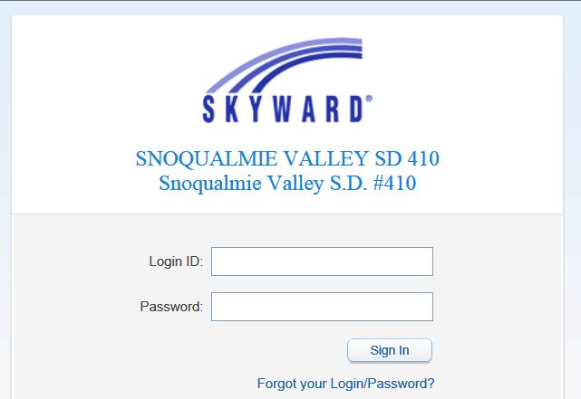

Security: Each user is responsible for their individual login information and should take all reasonable precautions to prevent others from being able to use their account. This includes, but is not limited to, regularly changing the account password and not sharing the password with others.

On the top taskbar of Family Access, you will find Student Selection; this box allows you to toggle back and forth between your students (if you have more than one in the system). By clicking on the drop down box where your student’s name appears, you will find a list of students who are associated with your family key. If you have more than one student enrolled and you do not find all of your students’ names under the drop down box, please contact the school.
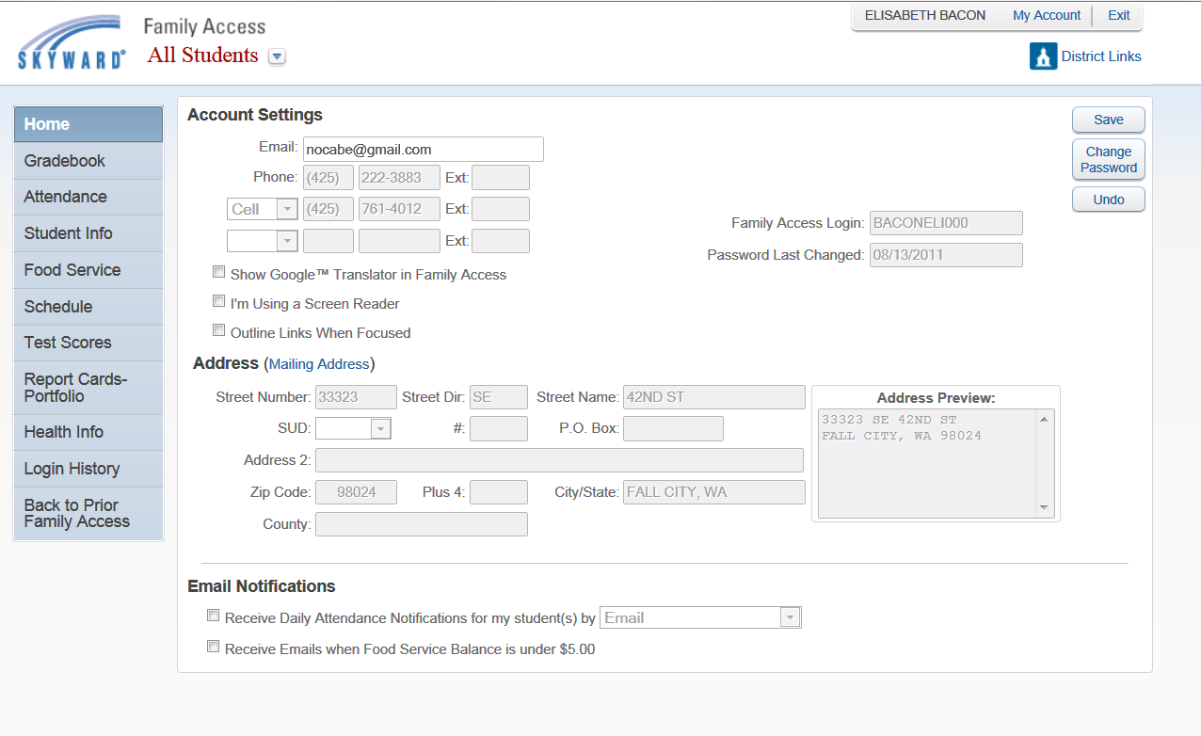

You can change your email and your Family Access password in “My Account”

Features are based on school programs and may not be available for all schools

