 Feel free to get in touch any time — text: (209) 910-4272, email: breyeschow@fprespa.org, or online: @breyeschow and connect with FPC Palo Alto on Twitter and Instagram: @FPCPaloAlto.

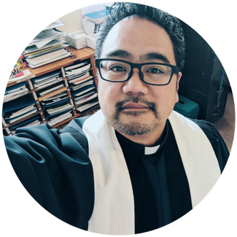

BRIEF STATEMENT OF FAITH

**bruce reyes-chow**

My faith is built on gratitude and trust

that in the life, death, and resurrection of Jesus Christ,

I am made one with God now and forever.

FAITH is what I choose to believe — Fluid. Mysterious. Personal. Political.

JESUS challenges me to live what I believe — Prophet. Pastor. Priest. Poet.

GOD grants me the courage to claim the holy in my life — Love. Life. Power. Creation.

SPIRIT sustains my soul for the adventure — Beckoning. Restoration. Chaos. Calm.

BIBLE — Living. Transformative. Textured. Truth.

BAPTISM — Celebration. Commitment. Community. Claim.

CHURCH — Covenant. Complexity. Interaction. Hard.

COMMUNION — Feast. Messy. Joyful. Equalizing.

CREATION — Urban. Wild. Subtle. Surprising.

DIVERSITY — Breadth. Intention. Holistic. Possibility.

EVANGELISM — Confidence. Story. Essential. Caring.

GENERATIONS — Wisdom. Promise. Hope. Obstacle.

JUSTICE — Harmony. Integrated. Systematic. Particular.

LAMENT — Excruciating. Reality. Stillness. Renewing.

LANGUAGE — Powerful. Expansive. Inspiration. Context.

LAUGHTER — Friendship. Solidarity. Silliness. Life.

ORDINATION — Privilege. Communal. Call. Avocation.

PARENTING — Letting go. Holding on. Chance. Agency.

PEACE — Calm. Storm. Work. Presence.

PLAY — Liberation. Renewal. Oppositional. Constructive.

PREACHING — Convicting. Conversational. Compelling. Journey.

PRESBYTERIANISM — Humbling. Connectional. Foundational. Frustrating.

REPENTANCE — Humility. Conversion. Practice. Change.

SIN — Distance. Separation. Insidious. Corporal.

STRUCTURE — Adaptable. Guiding. Consistent. Genuine.

TEARS — Grief. Rage. Realization. Exuberance.

TECHNOLOGY — Engagement. Enrichment. Intrusion. Distraction.

WEALTH — Morality. Abundance. Gift. Seductive.

WORSHIP — Ritual. Discipline. Respite. Provocative