Festival Use Only
Fee Paid: Pictures:_______ Electricity: _______ Booth #:_______

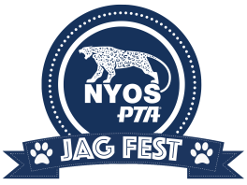
2019 NYOS Jag Fest Vendor Application
Saturday October 19, 2019
Vendor: ______________________________________________________________________________________
Company Name: ______________________________ Phone: ______ - ______ - ______
Address: __________________________________________________ Email: ____________________________
City: ________________________ State: _____ Zip: _______________
Please Mark all that Apply:
□ Student Club/Group Booth - FREE
□ Private Vendor Booth - $50 (check made payable to NYOS PTA)
Electricity needed YES NO
Give a complete description of items to be sold at the NYOS Jag Fest.

I, ________________________________________, hereby release NYOS Charter School and the PTA from any accidents, damages, or theft of the above said property or properties before or at the time of the NYOS Jag Fest.
Vendor Signature: _____________________________________________________________Date: _____________
Application Deadline: October 5, 2019
Return your application to:
MAIL: | EMAIL:
NYOS Charter School PTA  1605 Kramer Lane  Austin, TX 78758 | jagfest@nyospta.org

