Understanding Birmingham Bonus Bucks (BBB)

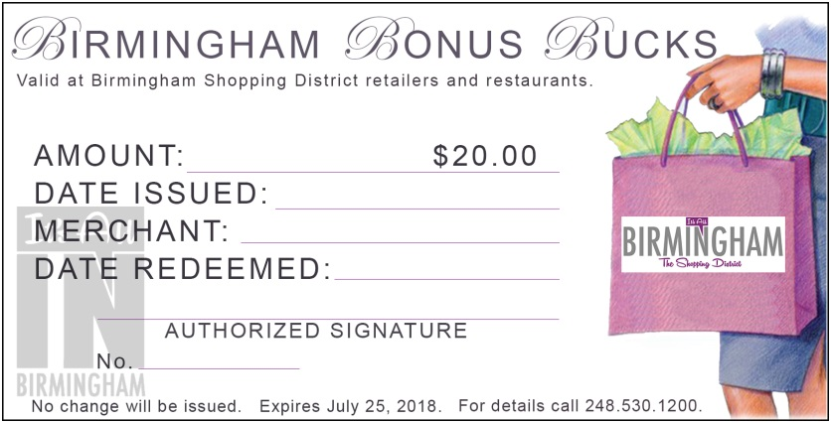

Information for Merchants:

Follow these three steps when a shopper hands you Birmingham Bonus Bucks:

1) All valid Birmingham Bonus Bucks are numbered and embossed with the BSD logo in the lower left corner. Only accept them if they have proper markings.
2) When you receive Birmingham Bonus Bucks, immediately write your store name and date on each BBB.

3) Bring collected BBBs to the BSD office. The BSD will record the number of BBBs redeemed at each store and process reimbursement checks monthly.
Program Overview
$20 in Birmingham Bonus Bucks will be awarded to shoppers for every $100 spent at BSD retailers, and for every $200 spent at BSD restaurants between April 9 and July 15, or until the promotion maximum has been reached. A restaurant is defined as any BSD business that serves food and beverages. Individuals are eligible to earn a maximum of $100 in Birmingham Bonus Bucks each month during the promotional period.

Other helpful information:
- Merchants must turn in Birmingham Bonus Bucks to the BSD office by August 15th for reimbursement – NO EXCEPTIONS.

- Shoppers must redeem Birmingham Bonus Bucks in person for their full $20 value. No change will be given.

- All Birmingham Bonus Bucks expire on July 25, 2018.
- Merchants should direct shoppers to www.ALLINBirmingham.com/BBB for details about how to receive their BBBs.

For more information contact the BSD office at 248-530-1200.

