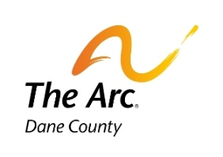

2023 Halloween Dance Party

Sponsored by The Arc-Dane County and Pooley’s Sports Bar & Grill
WHEN: SUNDAY, October 15, from 1:00 to 4:00 pm
WHERE: Pooley’s Sports Bar and Event Center, 5441 High Crossing Blvd, Madison
COST: $10.00 (includes admission, dancing, snacks, & a drink.)
Tickets must be pre-purchased from The Arc-Dane County for each person.

Tickets will be mailed or emailed out before the event. Tickets must be preordered by October 10th
Sorry, no free tickets for staff, attendants, or family members.

YOU CAN ALSO
REGISTER ONLINE USING THE LINK AT ARCDANECOUNTY.ORG

DUE TO CHALLENGING SITUATIONS, attendees must carry emergency contact information with them unless accompanied by staff or family
at all times. Help us make this a fun and safe event for all.

………………………………………………………………………………………………………...
2023 Halloween Ticket Order Form

NAME:_____________________________________________ AGENCY:_____________________________

ADDRESS:_____________________________CITY:__________________STATE:___ZIP:________

EMERGENCY INFO & PHONE #:______________________________________________________

Do you need a nametag with this information to be picked up upon check in? ______yes _____no

EMAIL:______________________________________________________________________________

Please check one.
Email my tickets emailed to the above address: ______
Mail my tickets to the above address:_________

________TICKETS @ $10.00)………………………………………………….$__________________

Register online using the link at arcdanecounty.org or

SEND FORM & PAYMENT payable to The Arc-Dane County
The Arc-Dane County WEB: www.arcdanecounty.org
402 Gammon Place Suite 360 PHONE: 608-833-1199
Madison, WI 53719 E-MAIL: arcdanecounty@gmail.com

