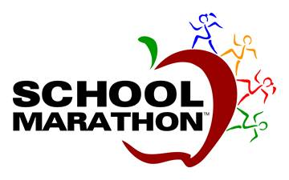
Dear Parents,
I am so excited to launch the School Marathon Program for the Lower School. Our start date will be January ^{th}!
School Marathon is a group running program for children which will take place at school during recess. The students will complete 26.2 miles (the length of a full marathon) over a 9-week period. The 26.2 mile "marathon experience” is a daily event and follows a structured process and pre-determined schedule. This program includes incentives for milestones to keep students motivated along the way.
School Marathon offers kids the ability to achieve an adult-sized goal by breaking it into smaller achievable goals. This program is a duplication of a marathon; however. the mileage is completed over a longer period of time, at school, kid style.
Of course, we will finish with a big celebration!

If you are interested in your child participating please fill out the permission slip below and return to Mrs. Schneider.
---------------------------------------------------------------------------------------------------------
By signing this form, I hereby grant permission for ___________________ to participate in the School Marathon program. I understand that the school will do everything within its power to provide for individual child safety and that the school cannot assume responsibility for injury, which might result during the course of this program.

Shirt size Please circle one – Youth Small Youth Medium Youth Large

Parent Signature________________________
Date: _______________________________

