




4518 Taylorsville Road
Dayton, Ohio 45424
P (937) 236-8805
F (937) 233-2016
www.bowser-morner.com

June 23, 2026

Bowser-Morner Celebrates 115 Years of Science, Engineering, and Commitment to Integrity
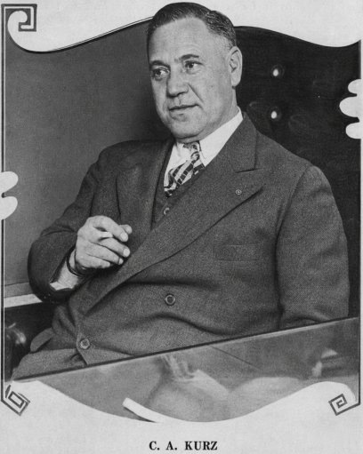
The exact anniversary date of Bowser-Morner, Inc. has been lost to history, so the company has chosen to celebrate its 115th anniversary on a day all Americans recognize and cherish—Independence Day.
Figure 1 - Charles A. Kurz, Sr.
The business that is now Bowser-Morner, Inc. was founded in Dayton in 1911 by chemist Charles A. Kurz, Sr. (left) as Kurz Chemical Laboratories.
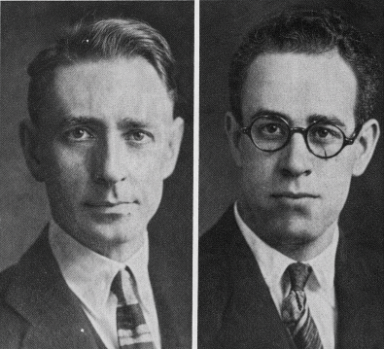
The company originally specialized in analyzing materials that fueled American industry: iron, steel, coal, cement, and oil. Mr. Kurz also used his chemistry skills to producer consumer-grade items of the day, such as face powder, metal polish, waterless soaps and perfumes. Ever the entrepreneur, Mr. Kurz and sons also formed several other businesses with other partners between 1913 and 1916, venturing into the manufacturing of early plastics and composites used for cookware, buttons for military uniforms as well as industrial gases.
Figure 2 - Arnold L. Morner (L) and Raymond R. Bowser ®
In 1925, Raymond R. Bowser (right) and Arnold L. Morner (left) purchased the original laboratory business from C.A. Kurz and renamed it Bowser-Morner Testing Laboratories. When Bowser and Morner acquired the company, they pivoted the company’s mission away from the potential liability of consumer products and back toward traditional laboratory materials quality control and performance testing.
Among Bowser-Morner Testing Laboratory's early notable achievements was testing of metal used in the Spirit of St. Louis, the aircraft flown by Charles Lindbergh on the first nonstop transatlantic flight from New York to Paris in May 2027.

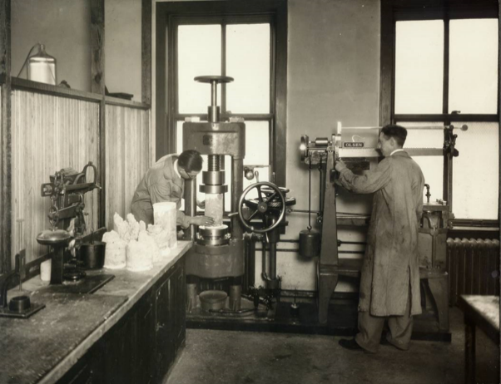
Also in 1927, Bowser-Morner began testing the compressive strength of concrete—a service the company continues to provide over a century later. Metallurgical testing was added in 1937, followed by subsurface exploration services in 1941.
As the country emerged from the Great Depression, a period of rapid industrialization emerged with an ever-widening array of consumer products. However, along with this rapid growth came uncertainty in product quality as some manufacturers began to set up their own internal labs or hire unaccredited operations to rubber-stamp quality claims about their products. This created an era of misleading product certifications and pseudo-science in advertising. Other manufacturers subsidized public university or public agency laboratory labs to produce favorable findings regarding their products. In 1937, Bowser-Morner along, with a group of 19 other independent laboratories representing a wide range of industries and geographic regions met in Chicago, Illinois to found the American Council of Commercial Laboratories, now known as the American Council of Independent Laboratories. Together, these laboratories helped establish the ideals that laboratories should be:
- Independent of the manufacturers and clients whose products they evaluate.
- Professionally managed (by appropriate engineers or technical leaders).
- Subject to quality and ethical standards.
- Recognized as expert third-party evaluators.
By working to establish these concepts, Bowser-Morner and ACIL helped to establish independent testing as a cornerstone of public trust in engineering, environmental science, product safety and industrial quality control. Today, remains an active member of ACIL and it continues to dedicate itself to being “committed to integrity.”
Local, state, and federal transportation agencies, along with private industry clients, relied on Bowser-Morner to verify the quality of roads, bridges, concrete, aggregates, and other construction materials. Through decades of infrastructure development, the company earned a reputation for providing reliable data and trusted technical expertise.
In 1989, the company relocated its headquarters to its current facility on Taylorsville Road in Dayton. Three years later, Bowser-Morner established its Radon Reference Laboratory, featuring an environmental chamber similar to those used by the U.S. Environmental Protection Agency to calibrate radon measurement devices. In 1999, the company achieved full accreditation through the American Association of State Highway and Transportation Officials (AASHTO), further demonstrating its commitment to quality and technical excellence.
Today, Bowser-Morner operates facilities in Dayton, Toledo, and Springfield, Illinois, serving clients throughout the Midwest and beyond.

While the company has evolved significantly since its founding in 1911, the commitment to delivering accurate, dependable information remains unchanged. Bowser-Morner's three primary business divisions — Engineering and Environmental Services, Construction Support Services, and Laboratory Services—provide a comprehensive range of technical solutions to support construction, manufacturing, commerce, and environmental stewardship.
With 120 full-time employees and eight summer interns, Bowser-Morner continues to invest in the next generation of scientists, engineers, technicians, and industry leaders.
For 115 years, Bowser-Morner has helped clients reduce risk, make informed decisions, and achieve successful project outcomes. As the company celebrates this remarkable milestone alongside America's 250th anniversary, company President Richard Allen states that it remains committed to the principles that have guided its success for over a century,
“Bowser-Morner believes that professional services must be forged on a platform of stewardship. The means that we simply do not process samples or execute tasks on behalf of our clients – we must understand their goals, their challenges, and their risk tolerances. Our team must take the time to listen and learn the specific concerns of the people and projects we support, so that we can apply our technical expertise most effectively.”
“When we align our skills and knowledge with our clients’ concerns, we can provide the objective, defensible results they need to move forward with certainty. Integrity is our standard, and stewardship is how we deliver it.”

For more information on the Bowser-Morner, Inc. anniversary: Tracey Hanlin, Marketing Manager
thanlin@bowser-morner.com

Also reach out to members of leadership: Rick Allen, P.E., President & Sr. Geotechnical &
Materials Consultant / Director, Field Services Division
rallen@bowser-morner.com

Karl Fletcher, VP & Director of Construction Materials
& Geotechnical Laboratories
kfletcher@bowser-morner.com

Patrick Loper, P.E., VP / Director, Engineering &
Environmental Services Division
ploper@bowser-morner.com

Kyle Kinney, VP & Chief Financial Officer

Committed to Excellence Since 1911
Dayton, Ohio • Toledo, Ohio • Springfield, Illinois

