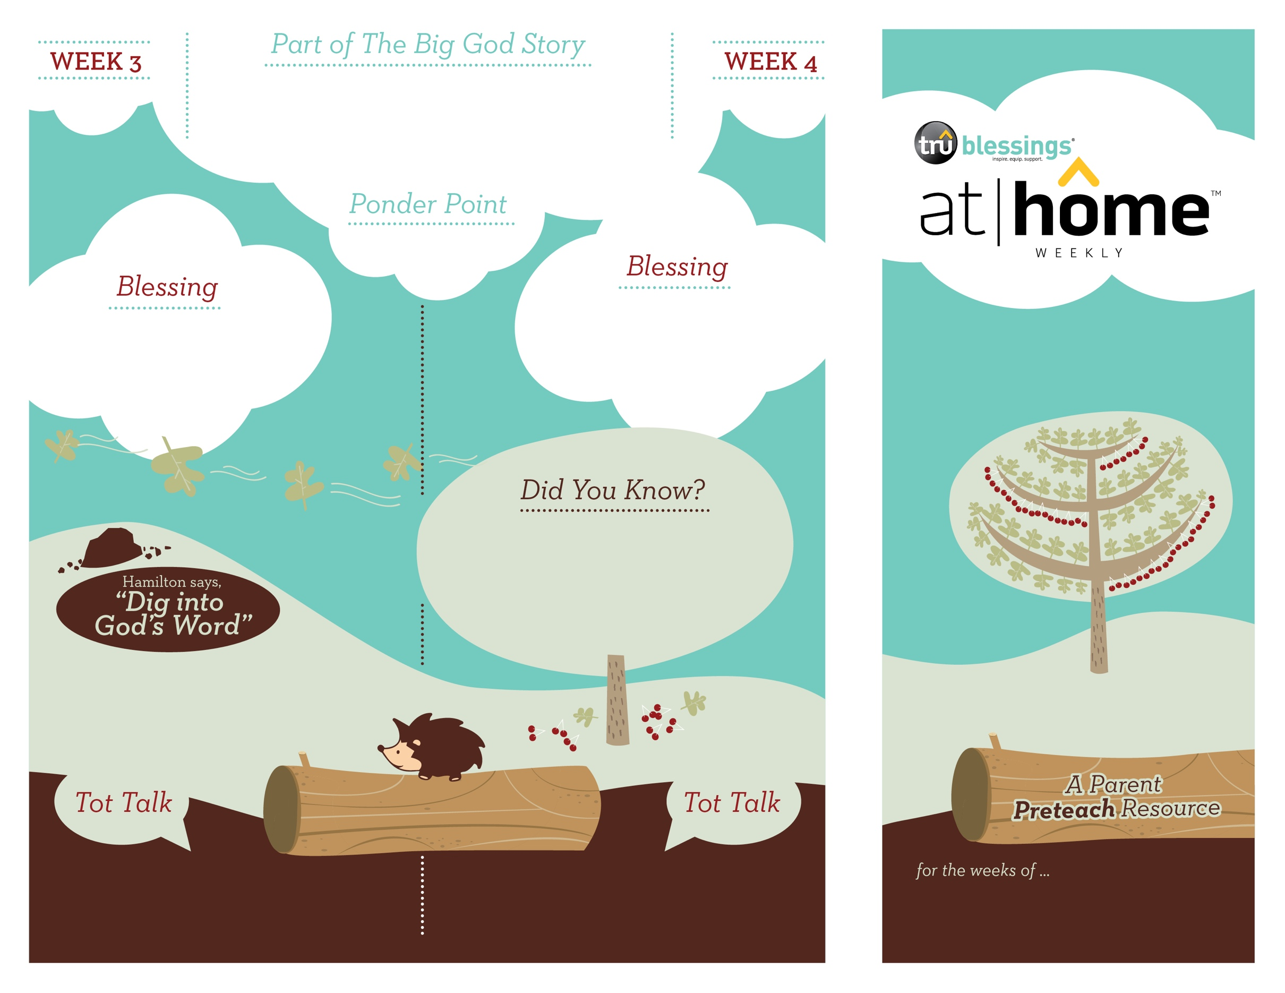

**Jonah 1—4**

God asked Jonah to go to Nineveh and deliver a special message. Instead, Jonah ran from God. He boarded a boat, but God sent a violent storm. Eventually, Jonah was thrown overboard and swallowed by a great fish. After three days in the belly of the fish, God rescued Jonah and he went to

Nineveh to deliver the message.

***Your child may enjoy playing peek-a-boo. As you play and ask, “Where’s baby?” remind your child that there’s nowhere she can hide from God because He is always with her.***

***Read Jonah 1:17—2:10.*** After reading, remind

your child that it was God who saved Jonah from

the belly of the fish.

***OUR GOD SAVES***

Open a Bible and read Galatians 3:26

over your child:

***“So in Christ Jesus you are all children***

***of God through faith.”***

4.8

4.7

(Insert your child’s name), **our God**

**is a God who saves. May you trust**

**in Him alone to save you.**

• Nineveh, where God sent Jonah, was the

capital of Assyria and one of Israel’s

greatest enemies.

• After the fish spat out Jonah, God

asked him to go to Nineveh again. This time,

Jonah did what God asked.

What did Jonah do when he was

inside the big fish? That’s right, he

prayed to God.

How many days did Jonah spend inside the fish?

Three days! Who saved Jonah? God saved him!

Type to enter text

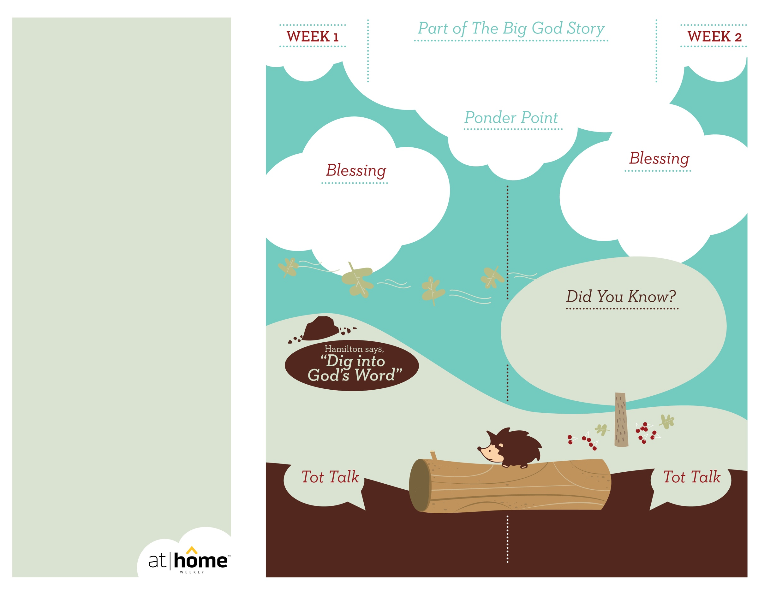

Is God with you when you’re sad?

Yes! Is God with you when you’re happy?

Yes! God is always with us!

***Read 1 Kings 19:11–13a.*** After reading, remind

your child that just as God was with Elijah in the

cave, God is with us.

**1 Kings 19:9–18**

God called to Elijah in a gentle whisper. When Elijah heard this,

he went out to meet with the Lord.

Read Psalm 46:1:

***“God is our refuge and strength, an   
ever-present help in trouble.”***

(Insert your child’s name),

**may you know God is with you**

**all day and night.**

***God has given parents the***

***privilege of being the primary***

***spiritual nurturers of their***

***children’s faith.***

The At Home Weekly is designed to reinforce that truth by encouraging your family to have time in God’s Word **before your child attends** **church each week**. It will provide you with ways to introduce The Big God Story and have age-appropriate conversations with your little one as you prepare her for what she will be experiencing in church for the next four weeks.

Research has shown that children between the ages of two and four learn best through repetition. Because of this, TruBlessings will spend two weeks on the same part of **The Big God Story** and the **Ponder Point.**

Each week you will receive a new **Blessing.** A blessing is a prayer of commission, a portionof Scripture, or words of encouragement andguidance. While giving the blessing, you maydesire to lay hands on your child as you speak theScripture or pray a prayer over him.

**Hamilton the Hedgehog** will play a role in your child’s experience in church each week—be sure to ask about him. He loves to **Dig into God’s Word.** The passage of Scripture provided will assist you as you reinforce the Ponder Point. **Did You Know?** has fun facts about this part of The Big God Story for you to share with your child. And **Tot Talk** is simply a conversation starter to assist you as you spiritually parent.

***GOD IS WITH ME***

4.6

4.5

© 2018 David C Cook. TruResources are developed in   
partnership with **ROCK**HARBOR Church and a   
national network of family and children’s ministry   
leaders. All rights reserved. Reproducible for  
church use only.

• Elijah was in a cave hiding from Jezebel,

King Ahab’s wife, who wanted to have

him killed.

• Elijah was scared, lonely, and sad. Even

at this low point in Elijah’s life, God was

with him!

***Your child is capable of imitating sounds. Use your voice inflection to create a verbal picture of the wind, fire, earthquake, and the whisper of God. Encourage your child to repeat the sounds you make.***

How did Elijah know that God was with

him? He heard His gentle whisper.