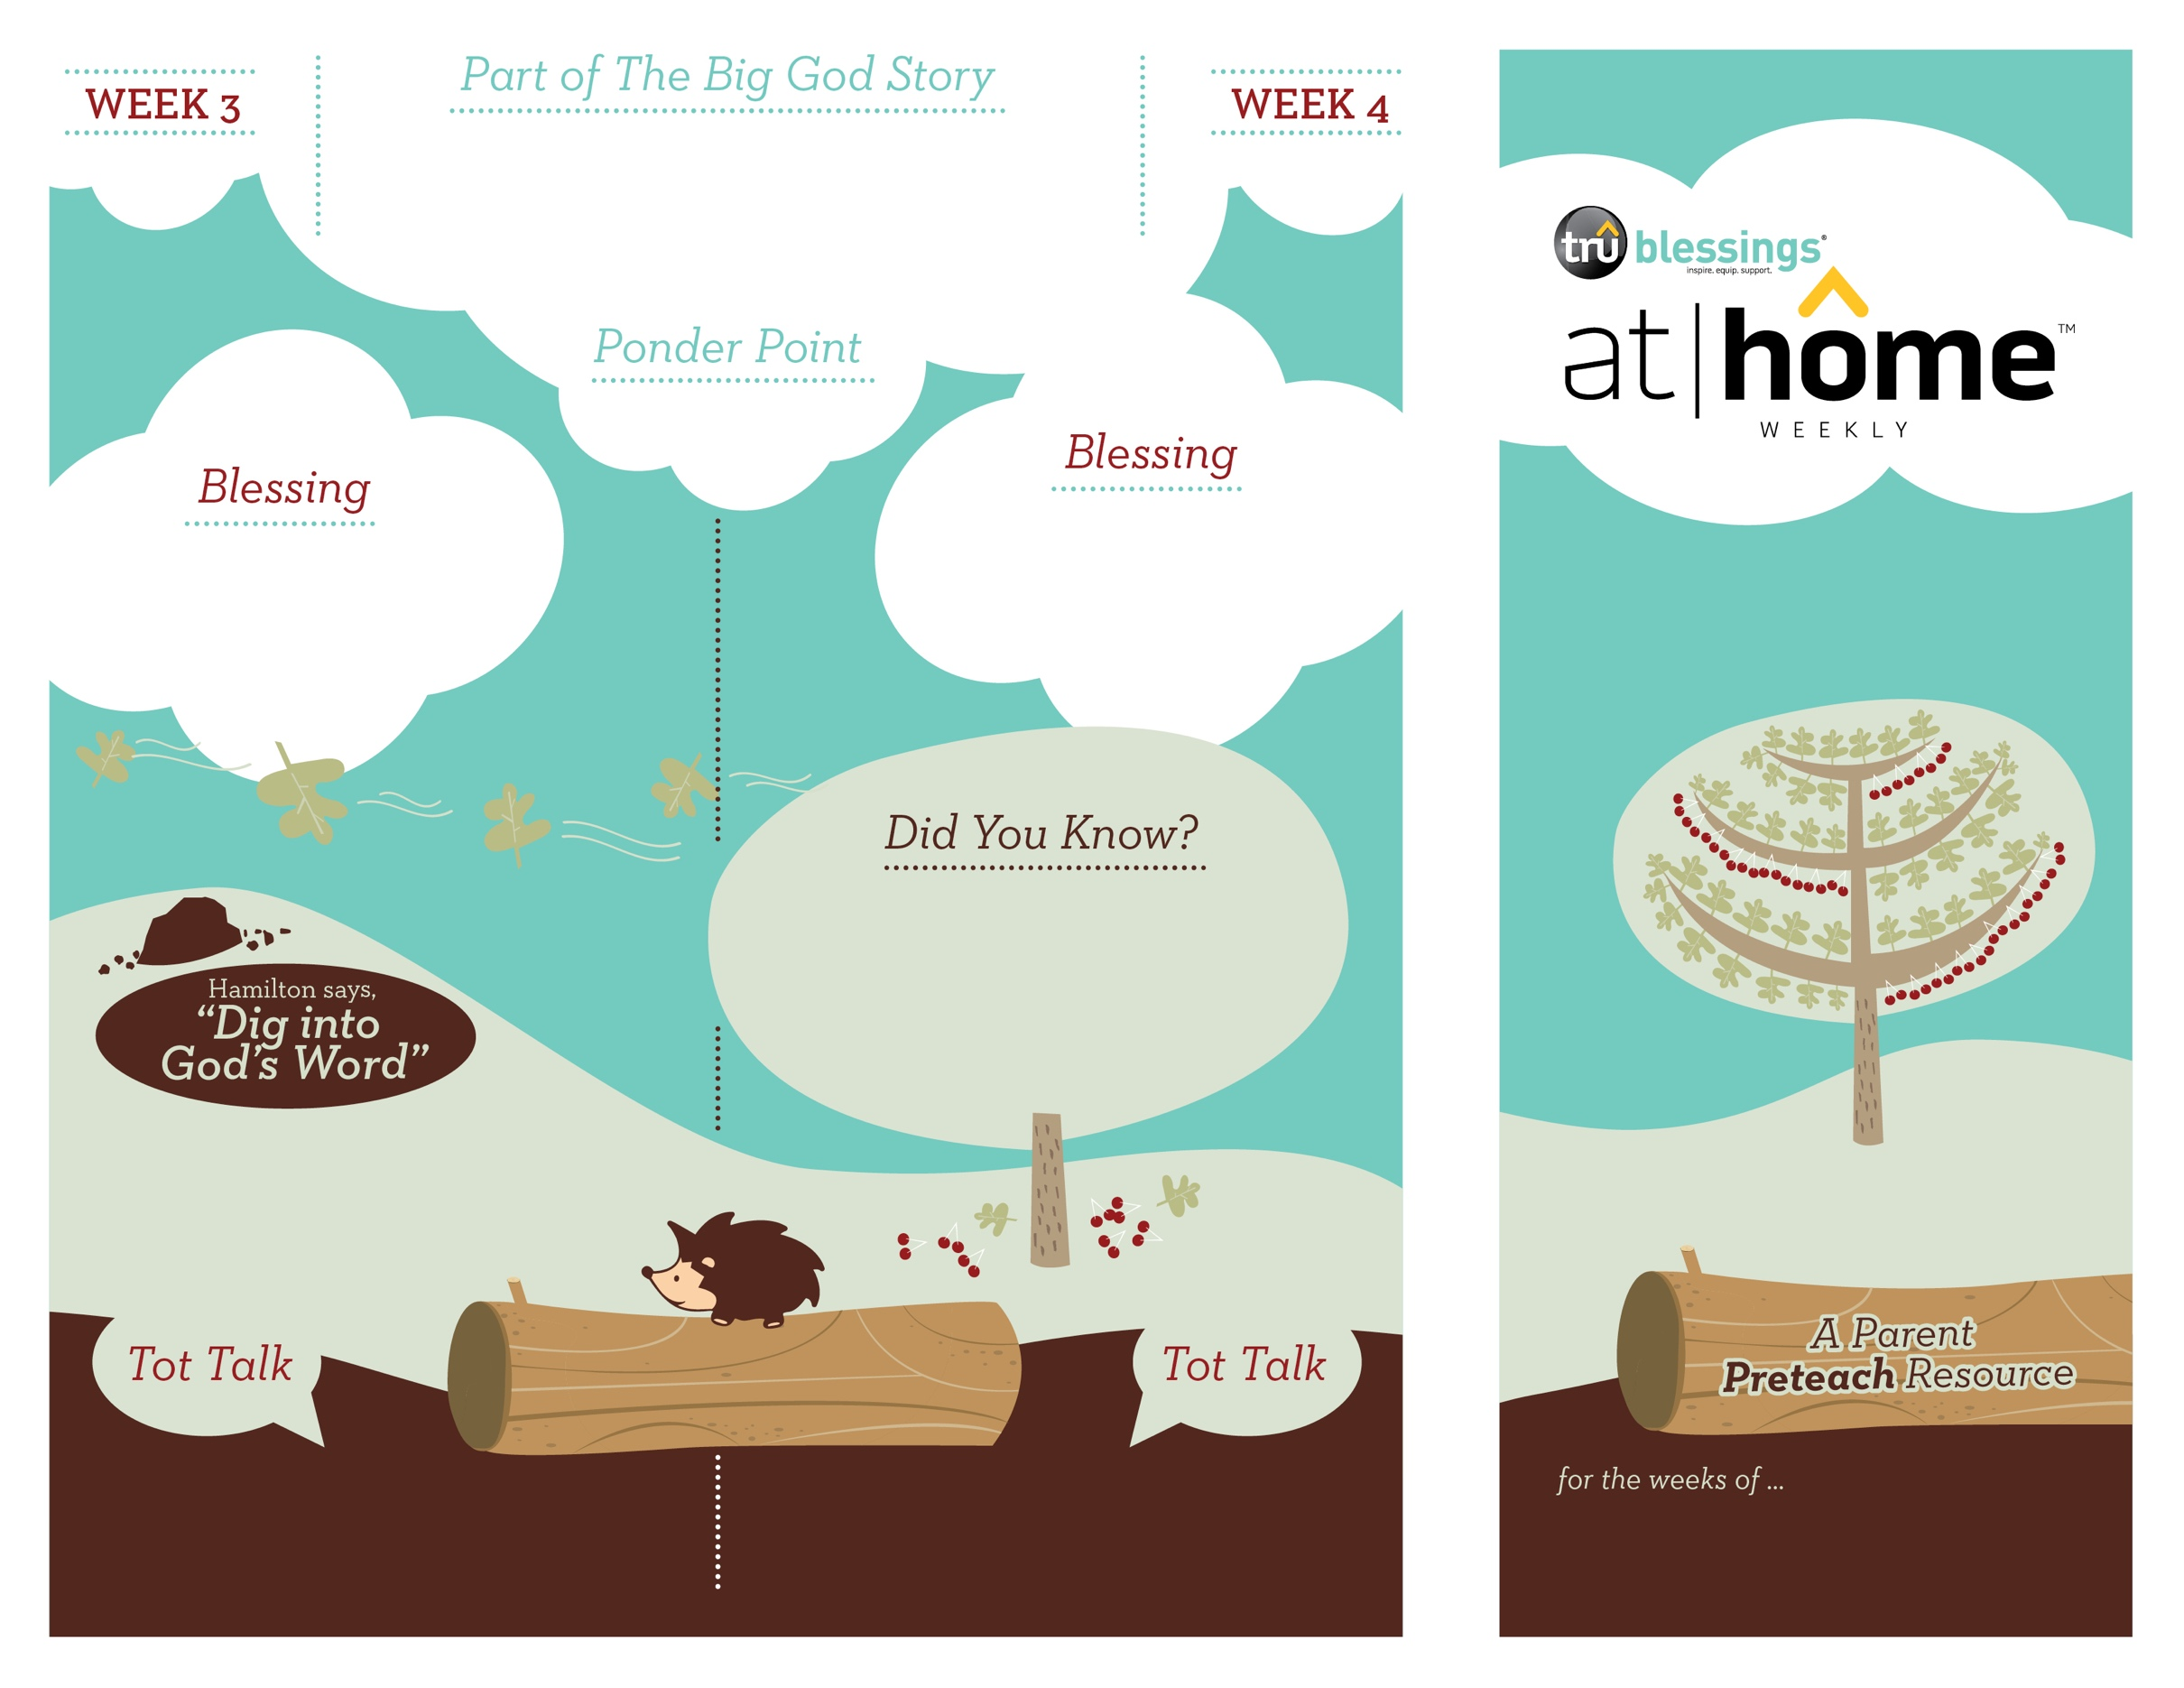

***Your child can distinguish emotions based on facial expressions and can mimic those expressions. As you read Daniel’s story, allow your child to make happy, scared, angry, sad, and surprised faces during appropriate parts of the story.***

***Read Daniel 6:13–23.*** After reading, remind your child that it was the living God who rescued

Daniel from the mouths of the lions.

***GOD IS THE   
LIVING GOD***

4.12

**Daniel 6**

The king passed a new law that forced the people to pray to him only. Daniel loved God and prayed only to *Him*. When the king found out, he had no choice but to put Daniel in the lions’ den. God protected Daniel. He was saved, and the   
living God was praised.

Open a Bible and read Daniel 6:26b

over your child:

***“For he is the living God   
and he endures forever.”***

4.11

(Insert your child’s name)**,** **may you**

**remember that the living God is**

**always with you. He is powerful**

**enough to protect you.**

• Daniel prayed three times a day. He often

prayed for God’s people even though they

had turned from worshipping Him.

• When King Darius ran to the lions’ den to

find Daniel, Daniel was alive and well and

without a single scratch on him!

Did Daniel stop praying to God when

the king made the new law? No, Daniel

continued to pray to God three times

a day!

Who protected Daniel? God did. The king sent a

message to the world telling them that God is the

living God.

Type to enter text

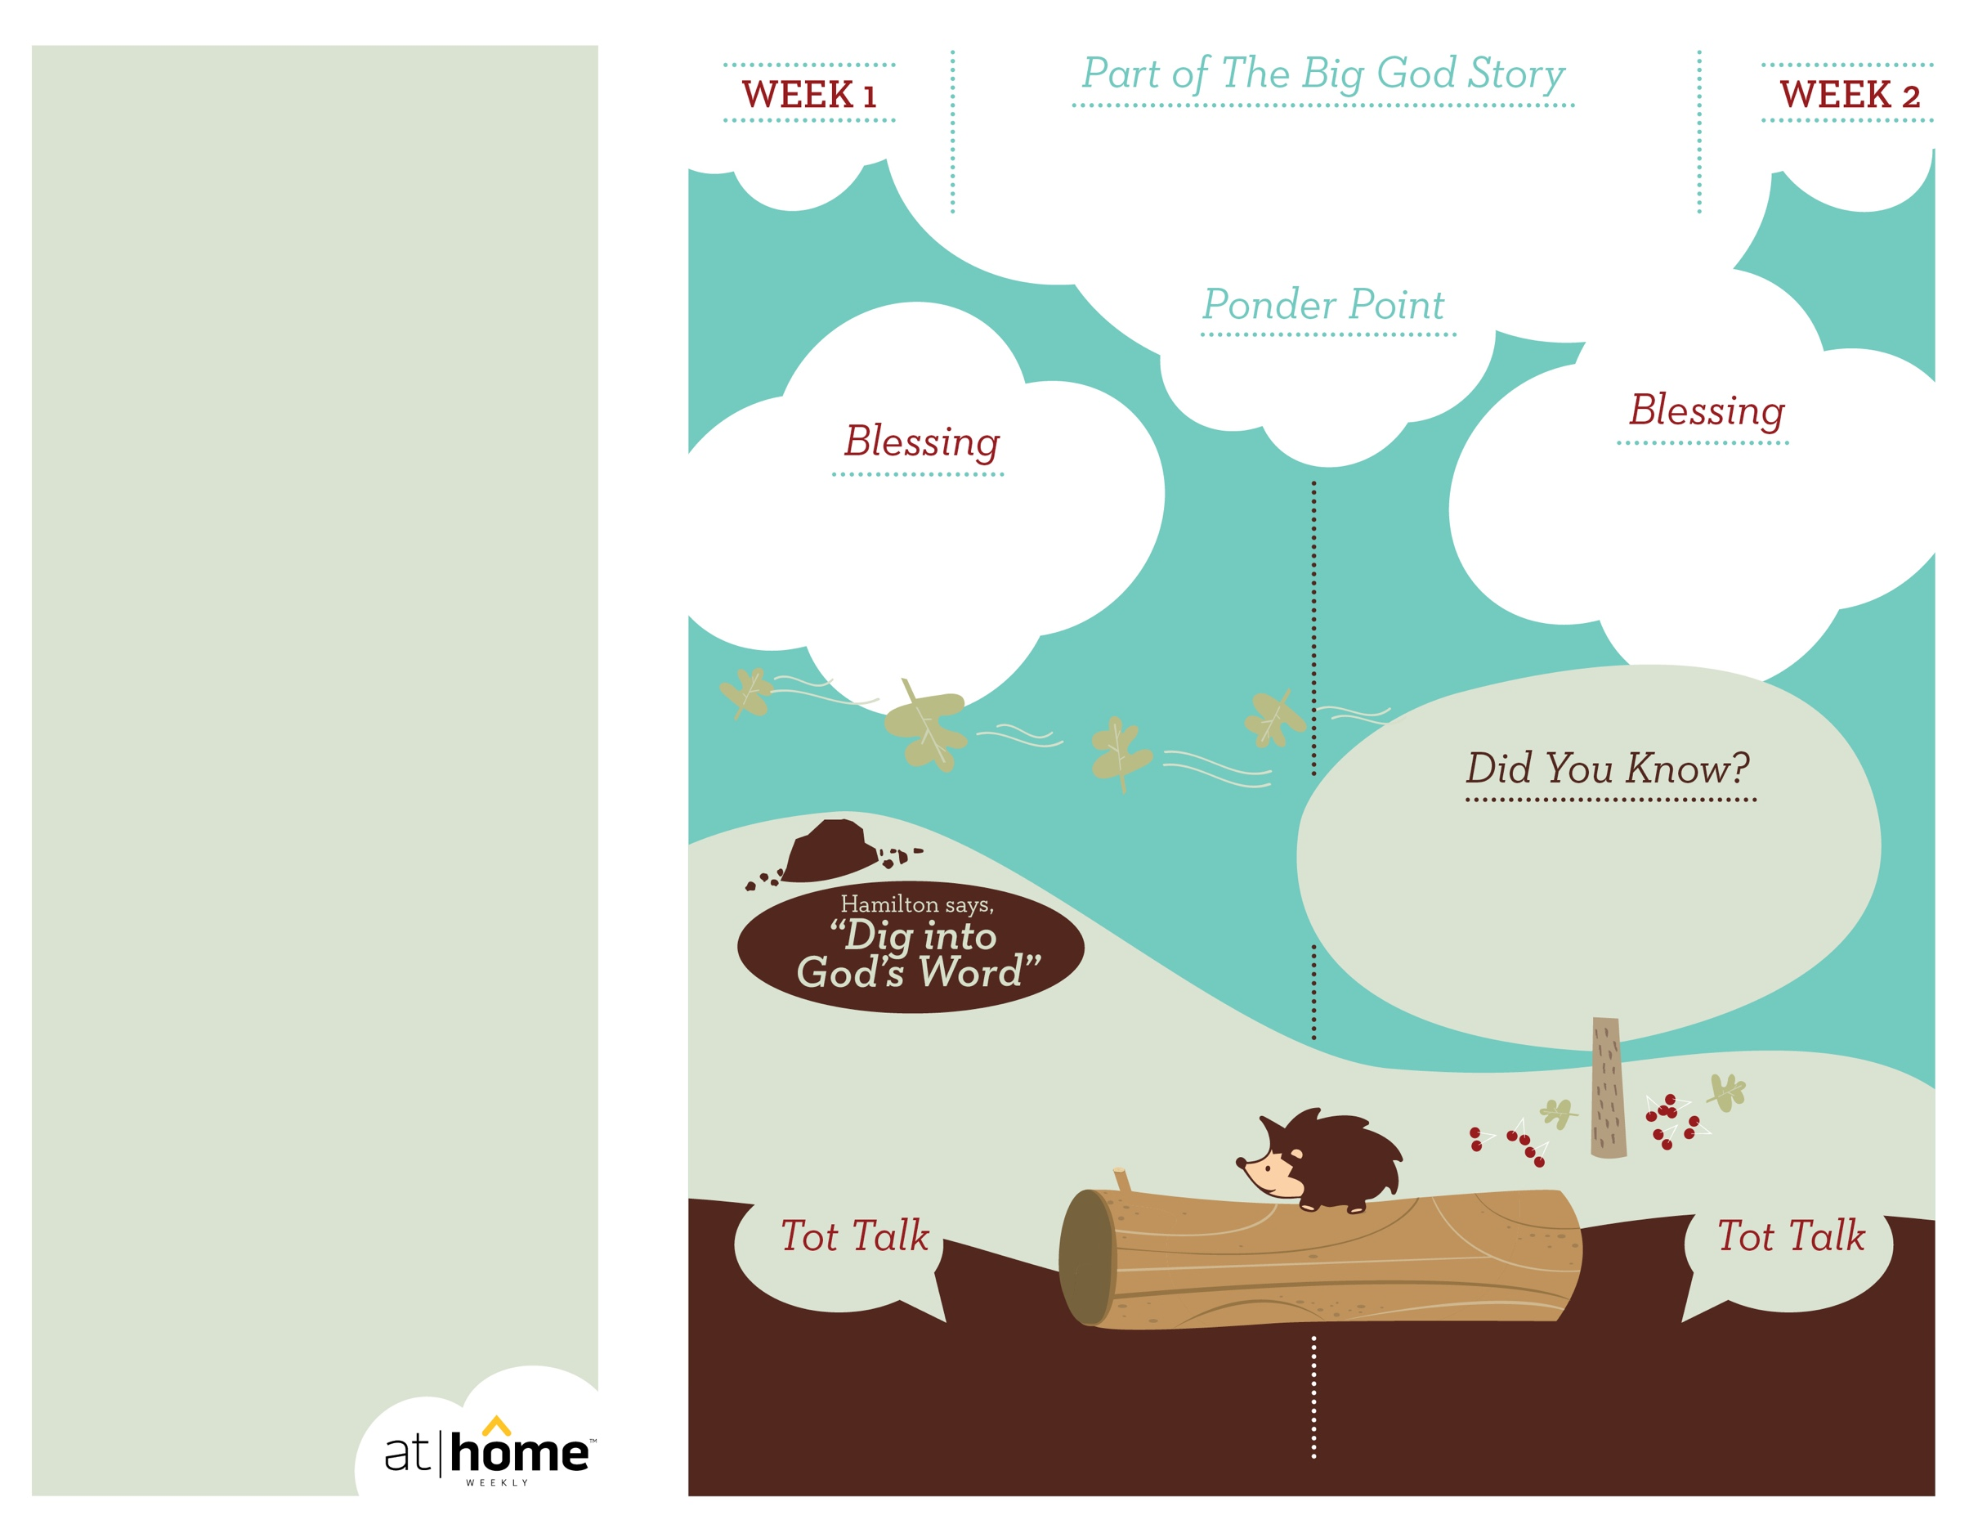

***Your child may enjoy playing with nesting***

***blocks. Choose a few to overturn. Hide an***

***object beneath one and encourage your***

***child to find it. Remind him how Josiah***

***found God’s Word.***

**2 Kings 22—23:23**

Scrolls containing God’s Word were discovered during the

temple restoration. Josiah made sure the scrolls were read to the

people. The powerful words led the people to destroy their

idols and continue to repair the Lord’s temple.

***GOD’S WORD HAS POWER***

Where can we read God’s words?

In the Bible!

***Read 2 Kings 22:8–19.*** After reading, remind

your child that God‘s Word had power in King

Josiah‘s life.

4.10

Open a Bible and read Psalm 119:105a: ***“Your word is a lamp for my feet.”***

(Insert your child’s name)**,** **may**

**God’s Word help you know God**

**and follow Him.**

***God has given parents the***

***privilege of being the primary***

***spiritual nurturers of their***

***children’s faith.***

The At Home Weekly is designed to reinforce that truth by encouraging your family to have time in God’s Word **before your child attends** **church each week**. It will provide you with ways to introduce The Big God Story and have age-appropriate conversations with your little one as you prepare her for what she will be experiencing in church for the next four weeks.

Research has shown that children between the ages of two and four learn best through repetition. Because of this, TruBlessings will spend two weeks on the same part of **The Big God Story** and the **Ponder Point.**

Each week you will receive a new **Blessing.** A blessing is a prayer of commission, a portionof Scripture, or words of encouragement andguidance. While giving the blessing, you maydesire to lay hands on your child as you speak theScripture or pray a prayer over him.

**Hamilton the Hedgehog** will play a role in your child’s experience in church each week—be sure to ask about him. He loves to **Dig into God’s Word.** The passage of Scripture provided will assist you as you reinforce the Ponder Point. **Did You Know?** has fun facts about this part of The Big God Story for you to share with your child. And **Tot Talk** is simply a conversation starter to assist you as you spiritually parent.

God’s Word is so powerful that just

hearing it changed Josiah’s life!

4.9

© 2018 David C Cook. TruResources are developed in   
partnership with **ROCK**HARBOR Church and a   
national network of family and children’s ministry   
leaders. All rights reserved. Reproducible for  
church use only.

• Josiah took the throne as king

when he was only eight years old!

• After hearing God’s Word, Josiah

ordered that all idols and anything

associated with the worship of pagan

gods be destroyed.