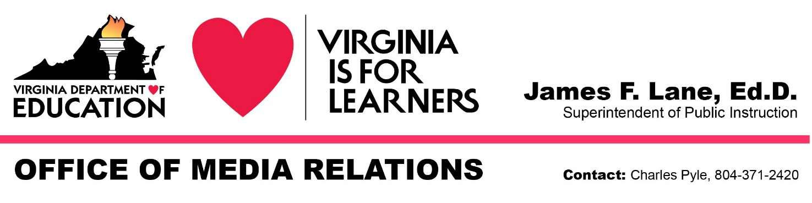
For Immediate Release: August 4, 2020

State Superintendent Waives Accreditation
for the 2021-2022 School Year

RICHMOND — Superintendent of Public Instruction James Lane today exercised emergency authority granted to him by the 2020 General Assembly to waive annual school accreditation for the 2021-2022 academic year. Schools will be assigned a rating of “Accreditation Waived,” the same rating assigned schools for 2020-2021 under a waiver issued in April.

Accreditation ratings are based on performance during the previous school year. The statewide closure of schools in March in response to the coronavirus pandemic resulted in the cancellation of spring Standards of Learning testing. Student performance on SOL tests in English, mathematics and science are key metrics under the state Board of Education’s school accreditation standards.

Without spring 2020 SOL results, there is insufficient data for the Virginia Department of Education to calculate accreditation ratings for the 2020-2021 school year. And because year-to-year growth in English and growth in mathematics are also accreditation metrics, VDOE won’t have sufficient data to calculate ratings for 2021-2022 either, because even if students are able to take tests next spring, the department won’t have baseline data from 2019-2020 for measuring growth.

In April, Lane appointed a task force comprising division superintendents, testing directors, educators, the vice president of the state Board of Education and representatives of education professional organizations to study the impact of the COVID-19 shutdown on the commonwealth’s school accountability system and make recommendations on accreditation determinations for 2021-2022. Waiving accreditation until there is sufficient baseline data to measure student growth was one of two options recommended by the task force.

“Waiving annual accreditation for a second year will allow our schools to focus on assessing the impact of the shut down on students, academically and on their social and emotional well-being,” Lane said. “It will also allow school divisions to make decisions about resuming in-person instruction or reverting to virtual learning that prioritize the health of students and staff, without the added pressure of the possible impact on accreditation. If tests are administered during the upcoming school year, the focus should be on evaluating the impact of the pandemic on student learning and establishing a new baseline for measuring student growth.”

The Virginia Department of Education’s Office of School Quality will continue to support schools implementing improvement plans based on their accreditation ratings for 2019-2020.

# # #

