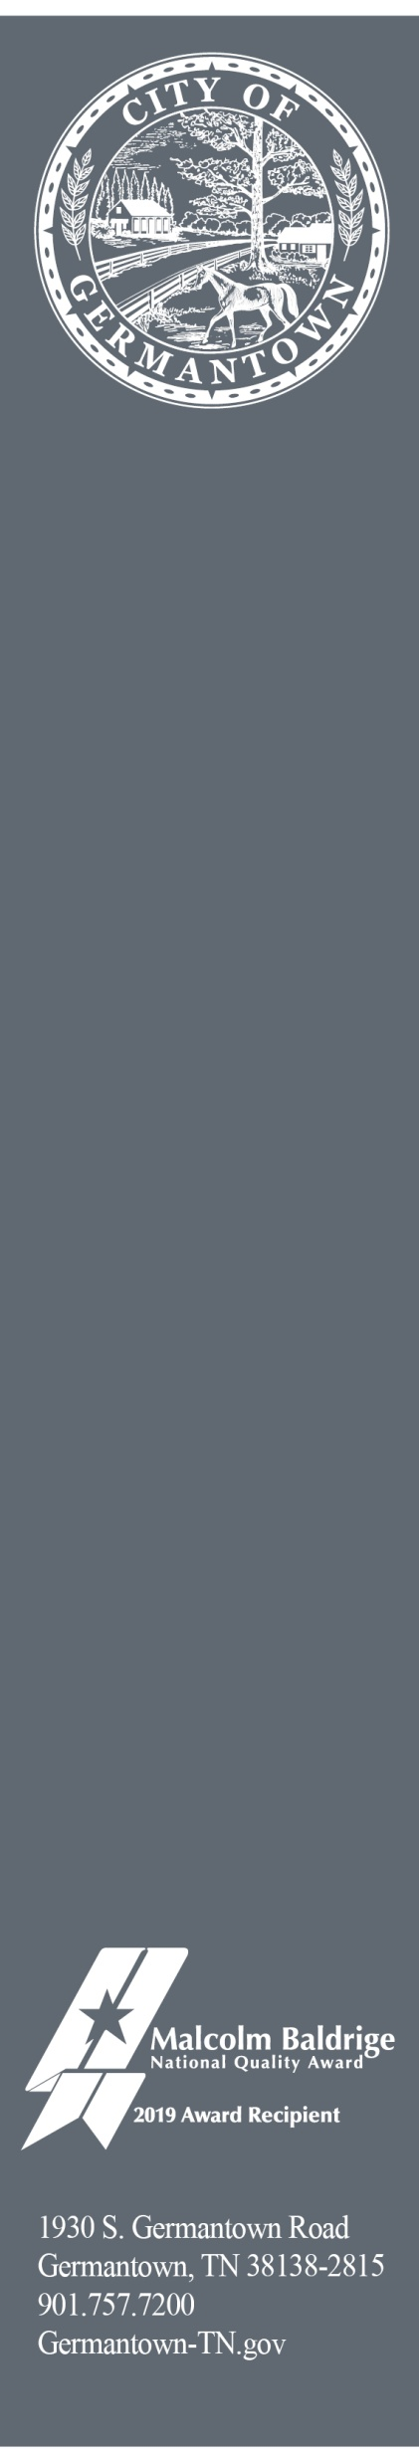

June 24, 2024

To: Germantown Business Owners/Property Managers

From: Economic Development Division of the City of Germantown

Subject: Germantown Sidewalk Sale July 19th through July 21st

The Germantown Area Chamber of Commerce sponsors the annual Germantown Sidewalk Sale as a way to support local businesses for a weekend of sales and fun!

Germantown Code Enforcement relaxes their CODE AND SIGNAGE restrictions during this designated weekend.

Suggestion for attracting customers to your store:

- Use social media to highlight your sale items
- Place some sale items on the sidewalk in front of your store
- Balloons are great to attract attention

(Please remove balloons and signage immediately after the event)

Note: Large scale inflatable items are not appropriate.

Please call us at (901) 757-7281 if you have any questions.

Thank you.

