M&A Deal Activity Snippet:
U.S. Manufacturing

The Council of Industry will periodically provide short snippet posts aimed at addressing questions that members may have related to M&A deal activity. If you would like to submit a question or want more information, please email Tony Fareed from 360ACCEL or Harold King.
Question: How have valuations of U.S. manufacturing companies and related deal activity been impacted through the COVID-19 pandemic?
Quick Stats: U.S. Manufacturing Vertical Deal Transaction Activity (1/1/2019 – 5/31/2022)
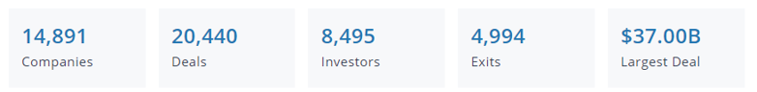
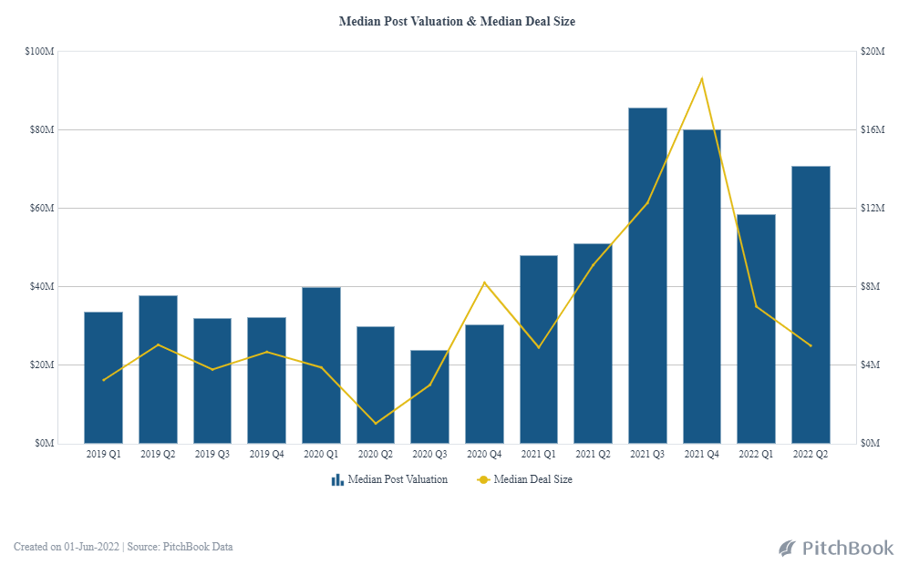
M&A and capital raising activity within the U.S. manufacturing vertical bounced back in 2021 from the pandemic levels experienced in 2020, with median valuations and deal sizes rapidly rising throughout 2021. Deal activity in 2021 was fueled by a perfect storm of dynamics, including historically low interest rates, loads of private equity “dry powder” capital available for investment, and a (seemingly) revived U.S. economy. Megadeals (transactions exceeding $1 billion in deal value) and a record year for IPO activity also contributed to the increased values and deal sizes in 2021.
Valuations and deal sizes have begun to normalize in 2022. Current fears of recession, coupled with continued volatile geopolitical dynamics, increasing interest rates, and continued supply chain challenges and labor shortages will continue to be key deal considerations. Buyers and sellers will likely need to adjust expectations and be thoughtful in determining valuations throughout 2022. Nevertheless, private equity firms and large strategic buyers seem to remain eager for deal opportunities.

Author: Tony Fareed, 360ACCEL

About the Data: The PitchBook database was utilized to generate the statistics and graph used in this post. PitchBook combines human intelligence with technology to filter, collect, and sort the most accurate data available. Search criteria for this analysis included all companies classified by PitchBook within the manufacturing vertical that had a completed transaction during the period 1/1/2019 – 5/31/2022.

