

We are excited to offer you a worry free solution that will allow you to get paid quicker with full transparency and accuracy! Our Ancillary Billing Module was created with ease in mind.
Important Tips:
- All invoices must be submitted into the Ancillary Billing module within 30 days from date of service.
- Invoices do not automatically flow from RDN/MBSi/QB/etc.
- Current invoices should not be emailed to Resolvion as they are to be submitted through the ancillary billing module within required timeframe.
- For invoices reflecting over 30 days past due and/or missing remittances, please email accounts.payable@resolvion.com for assistance.

Get started by following the simple steps below:
https://portal.usa-als.com
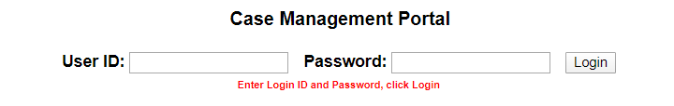
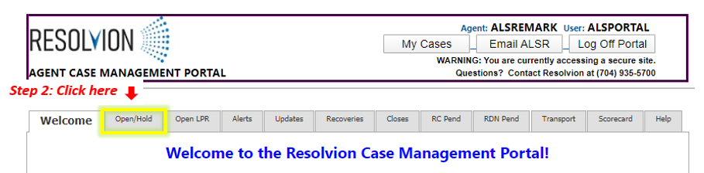
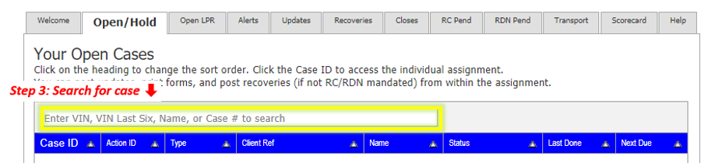

Once case is open, proceed to Step 4:

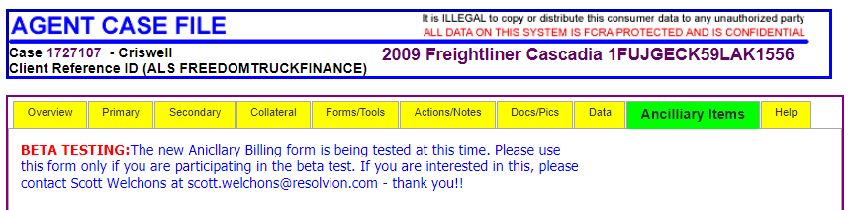

The field below will show your Expense Records for invoices submitted to Resolvion with a status of Authorized, Pending, or Delined. When an invoice is correctly submitted, it will automatically be placed in a Pending Status for review.
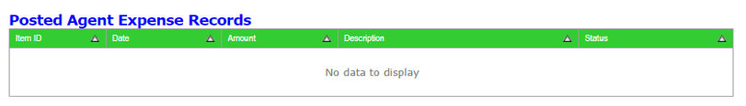
Below is an example of a Pending Expense Record:
- Invoices are reviewed in the order they are received by the Accounts Payable department.
- Invoices will reflect authorized if invoice was submitted correctly and within 30 days from date of service.
- As mentioned above, invoices are paid based on the submitted date for fee in the ancillary billing module. For example, if authorized, the above invoice would be paid within net terms from 2/17/2023.
Below is an example of an Authorized Expense Record:
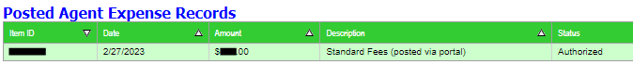
- Invoices labeled as “Standard Fees (posted via Portal) will be your repossession invoice. This is automatically completed at the time of finalizing a recovery within the Resolvion portal.
Below is an example of a Denied Expense Record
- The amount will reflect $0.00 once an invoice is denied.
- Denials are sent to the agents primary email address on file, which is also utilized for all Resolvion email notifications.
- To search for a specific denial, please search “Requested Fee Denied” in your inbox.

The below steps will show how to submit invoices in through either section of the ancillary billing module:
- Pre-Approved and Standard Ancillary Fees
- Unapproved Fees
Please note that the only fee that will be automatically completed in the Resolvion portal will be your repossession fee listed as Standard Fees (posted via Portal). All other fees/invoices must be submitted for payment through the ancillary billing module within the required timeframe.
Pre-Approved and Standard Ancillary Fees:

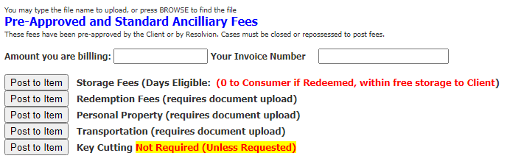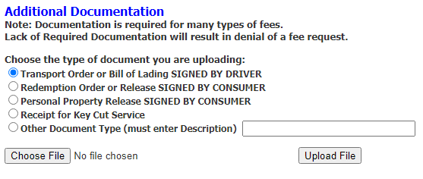
- Invoice numbers are entered by vendors and used for their personal records only.
- If an invoice is denied and requires a revision, this must be completed within the 30 days from date of service timeframe.
- Supporting documents must be uploaded at time of submitting invoices.
- Always review the Expense Records prior to closing assignment to ensure invoice was propertly submitted for payment and reflects Pending.

If the system will not accept an invoice through the section above, please continue to instructions on the next page.

Unapproved Fees:
Below are just a few examples as to when this section of the ancillary billing module would be utilized:
- If an invoice could not be submitted with the above steps.
- To submit a pre-approved flatbed fees, fuel surcharge fees, etc.
- To submit the remainder of a fee that was under-billed in error.
- To invoice for a lower amount than approved (if applicable).
- To utilize a different description for fee type.
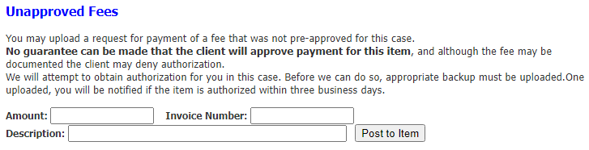
When entering the above information, please keep this information in mind:
- Do not use any punctuation or symbols when entering invoice information
- Keep descriptions simple – ex: Remaining Repo, Bailout, Fuel Surcharge, Bonus, etc.
- If an invoice is denied and requires a revision, this must be completed within the 30 days from date of service timeframe.
- Supporting documents must be uploaded at time of submitting invoices.
- Always review the Expense Records prior to closing assignment to ensure invoice was propertly submitted for payment and reflects Pending.
Additional information:
- Invoices are paid based on when an invoice was submitted into the ancillary billing module only.
- For accurate internal reports, update personal accounting records with date an invoice was submitted into the ancillary billing module within the Resolvion portal.
- If assignment has aged and cannot be viewed to submit a current invoice (such as storage), email a copy of the invoice and supporting documents to accounts.payable@resolvion.com for assistance.
- Click to learn more about our Ancillary Billing Module:
https://www.youtube.com/watch?v=-2hxFJRgiE4

Please note: All POSTED FEES are subject to audit before payment. Failure to provide required documentation or fees charged in excess of allowed amounts will be denied and may not be resubmitted based on time elapsed.

For additional assistance, please reach out to your Vendor Management representative.
Happy Invoicing!

