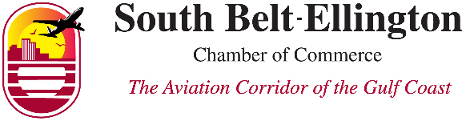
Business of the Quarter
Award Nomination Form 2021

NOMINEE INFORMATION
Business Name
Address
Phone EMAIL
Why would this business be a good choice to be recognized as the South Belt-Ellington Chamber of Commerce Business of the Quarter? Eligible nominees must be considered a successful and professional business in our area, contribute to the community, and actively participate in the Chamber.

IS THIS BUSINESS ACTIVE IN OTHER COMMUNITY ORGANIZATIONS? Y / N
If yes, which ones?

Professional/Community Achievements & Awards

Deadline for nominations is the last Friday of the 2nd month of the quarter.
SUBMIT TO : info@southbeltchamber.com
Mission Statement
To advance the economic welfare, growth, and success of the communities in and around the South Belt-Ellington area.

