

Dear Patricia,
George Floyd and countless others in the black community have died unjust and heartbreaking deaths.
For days I’ve tried to thoughtfully process how I wanted to address the Darkness to Light community at large - processing my grief, individually calling my team members to check in on their mental health and well-being, and gathering together as a team to discuss our course of action moving forward.
For me, it is clear—society's collective lack of commitment to the anti-racist movement impairs our ability to achieve our mission and contradicts our values as an organization. If my individual conversations with the Darkness to Light team made anything apparent, it is that we collectively see the inherent connection between the prevention of child sexual abuse and social justice work in the black community. Child rights are human rights. A black child’s right to a healthy and happy childhood does not stop at the prevention of child sexual abuse, nor does it stop at the age of 18.
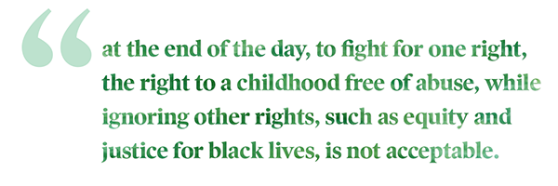
Yesterday we posted to social media, “If we’ve never outright said it, let us be clear: we are committed to social justice and human rights. We stand with our diverse partners, allies, and black communities - we are with you and commit to do our part in promoting anti-racism and equal rights. #blacklivesmatter #justiceforgeorgefloyd" Today, I want to expand on what we mean.
Darkness to Light will not just stand in solidarity with diverse partners, allies, and black communities. We will act in solidarity, demonstrating our commitment to improving access and amplifying black voices and experiences.
- We will be unafraid to take up space on this topic. There may be those who are uncomfortable with our insistence on social justice, but we will remain unapologetic. Darkness to Light’s team has created a Diversity and Inclusion working group, emphasizing inclusion. We will report back, publicly, on the commitments we have made to each other as team members, and to you, our partners, and supporters.

- We will continue to diversify both our team and leadership. We have made strides in cultivating a diverse and inclusive team, but we’re not done. We continue to be committed to representing diverse communities at all levels of our organization.

- We will continue innovating by developing new content. We recognize that our content has been broadly directed at all audiences, and we seek to dig into our organizational value of growth mindset and get specific. The team is establishing a plan on how to improve our resources for black and other vulnerable communities, such as migrant and LGBTQIA+.

- We will amplify the voices of those in the prevention community who are already doing this work. Allies are only as good as their ability to amplify the voices of those who came before them. We commit to strengthening our partnerships with the leaders of prevention in the black community.
The Darkness to Light Board of Directors is committed to holding me accountable. I am committed to holding the Darkness to Light team accountable, and they are ready to move.
For those with whom we partner, who I know are as committed to preventing child sexual abuse as we are, I say to you: ambiguity on racial equity is our common foe. We must use our platforms more effectively. Because at the end of the day, to fight for one right, the right to a childhood free of abuse, while ignoring other rights, such as equity and justice for black lives, is not acceptable.
I, therefore, ask our facilitators, partners, and supporters to join our efforts and to hold each other accountable.
Finally, I want to express my deepest sympathy to the families, friends, and communities that are grieving. I personally commit to you violence will not distract Darkness to Light from supporting peaceful protests and doing our part to change the stark day-to-day reality of so many of our fellow Americans.
Together, we can commit to make the world a safer and more equitable place.
Courageously,
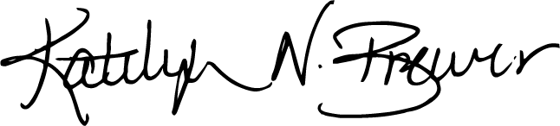
Katelyn N. Brewer
President & CEO
Darkness to Light

