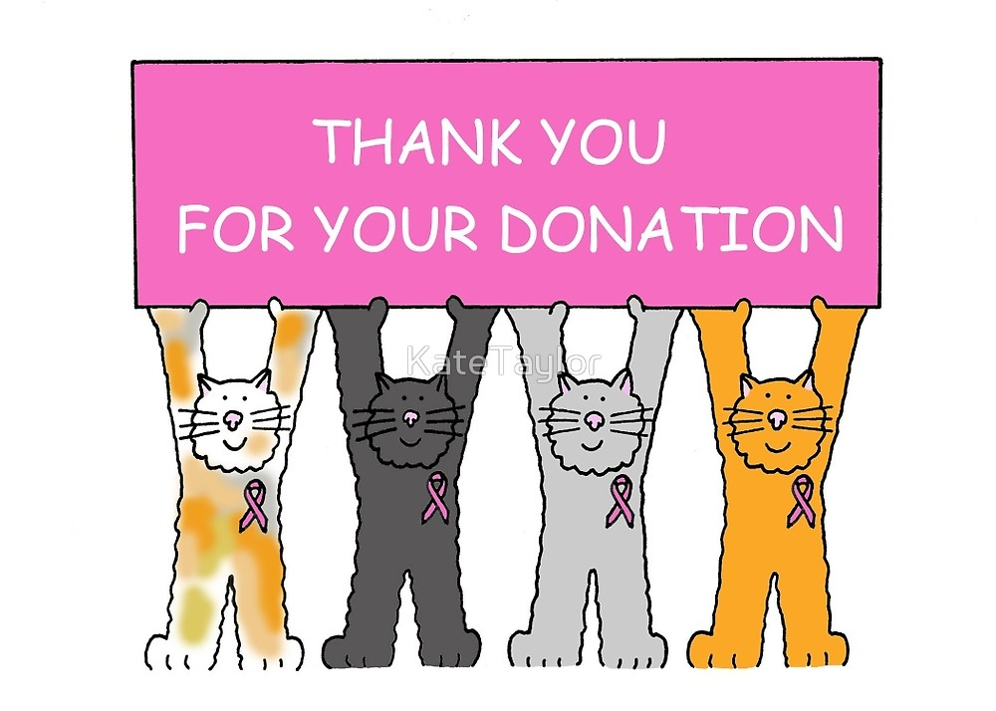

Anonymous 1

Anonymous 2

Agape Storge Christian Center
Greenville, MS

Beverly Rives, FIC
Woodmen Life Representative

Dollar General Distribution Center
Indianola, MS

Inter-Denominational Ministerial Alliance of Greenville and Vicinity

New Jerusalem Missionary Baptist Church - Mission Ministry
Greenville, MS

Pajama Program
New York, NY

Shiloh Seventh Day Adventist Church
Greenwood, MS

Walnut Grove Baptist Church
Greenville, MS

Washington County Visitor’s Bureau
Greenville, MS

