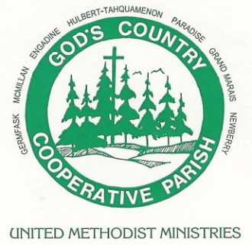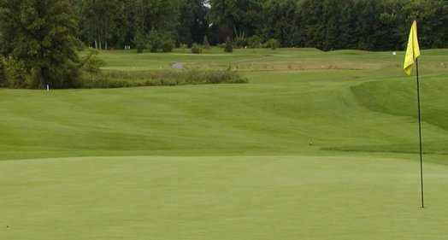

Please Join Us For The:

2nd Annual Golf Outing
to benefit our
God’s Country Mission Team

Sunday, June 23, 2019
Riverbank Golf Course
24095 Currie Road South Lyon

Scramble Format Shotgun Start at 1:30 p.m.
Check-In Opens at 12:30 p.m.

Individual Golf Package for $100 Includes:
18 holes of golf with cart, dinner and gift bag.
There will also be on-course contests.

Not a golfer but want to support us? Come for the dinner at 6:00 pm!
Dinner Only $40 per person

All skill levels welcomed and encouraged! Enjoy great fun with great people for a great cause! Men’s, women’s and mixed groups are all encouraged to come out. Don’t have a full foursome? No problem! We will match you up. Registration form and fee due by June 1st.

For questions: Please contact Henry Schlusler at 231-388-0755 henryschlusler@gmail.com
or Dave Smith at 520-668-7358 or daveandkathysmith@yahoo.com

- - - - - - - - - - - - - - - - - - - - - - - - - - - - - - - - - - - - - - - - - - - - - - - - - - - - - - - - -
Registration Form

Name: _____________________________ No. of Golfers: ___ No. for Dinner Only: ___

Phone No: __________________________ Total Amount Enclosed: ________
(make check payable to First United Methodist Church)

Detach and return this registration form by June 1st to:
Dave Smith @ First United Methodist Church 640 S Lafayette South Lyon, MI 48178

