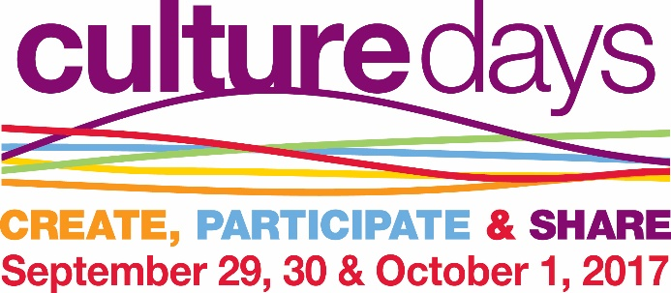

**Culture Days September 29, 30, October 1 2017**

**Grant application for Culture Days Projects or Programs**

# Applications must be received by July 14, 2017 to be considered

Need help funding your **Culture Days** Program? The Saskatchewan Library Association is offering ten **$300** grants to Saskatchewan member libraries to help celebrate **Culture Days.** Applications will be juried by members of the Culture Days Committee, and all decisions will be final. Please note that SaskCulture has very generously provided extra funds, **this year only** in order to increase Culture Days grants to **$300**.

**Please note: Culture Days Grants are not intended to pay for library equipment, staff wages or books except where specific books relate to a Culture Days presentation or event. SLA will pay exact costs, with receipts up to $300. To see what others are doing or look for ideas, please visit the** [**Culture Days website.**](http://sk.culturedays.ca/en/activities/results/grid?location=province&postal_search=&postal_radius=25&province=SK&city_search=&city_radius=25&region_search=4701&day=&day%5B%5D=2015-09-25&day%5B%5D=2015-09-26&day%5B%5D=2015-09-27&start_time=&end_time=&name=)

* To receive a grant you MUST hold a membership – one of the following; an individual membership, or be a voting delegate for the single or group institutional membership, or be employed by an institution that holds a group membership.
* The event or program MUST be culturally focused e.g. Program for newcomers, specific multicultural groups, Aboriginal peoples, local culture
* Please create a plan for your project-the successful applications are usually well thought out and planned.
* Libraries that demonstrate how their proposed activity responds to the specific needs of their patrons will be given preference.
  + The event or program can also include other disciplines beyond literary. For example, you could hire a dance troupe, plan a cultural dinner, hire a musician or an artist to demonstrate a technique. If you are thinking about using the services of an artist please invite artist/writer/performer ahead of time to ensure availability. If using artist/writer/performer, please use the appropriate recommended pay scale.
* The program or activity MUST be held during Culture Days, September 29, 30, or October 1 2017, to receive this funding.
* Proposals must be submitted by the deadline of July 14, 2017. Final reports must be complete and submitted no later than November 17, 2017 to receive the grant.

Your library will be reimbursed after your program has taken place, and upon receiving the Culture Days reporting form with receipts. All decisions of the Culture Days Committee are final.

**Culture Days Grant Application**

**You understand that if your application is successful, SLA will reimburse your library up to $300 AFTER you submit your final report and receipts for the program or event. No funds will be issued after November 17, 2017.**

Please provide us with your full contact information:

Name:

Library

Address

Phone number Email address

Membership: ___Individual

___Institutional – please indicate your employing institution _____________________

1. Provide a brief description of the Culture Days Program or Project you are planning and how you anticipate using the Grant.

1. On which date will the program or project be held?

1. Explain how this project is relevant to your community.

1. Explain if and how this program or project will add something new to the cultural experiences in your community or build on something existing.

1. Which segment of the community will this appeal to:

1. In what ways will you include volunteers and community involvement?

What kind of programming ideas are you including in your **Culture Days Program** plan**? Please check all that are applicable:**

⃝ Author reading

⃝ Performance-Dance, Theatre, Music

⃝ Visiting artist/instruction

⃝ Cultural connection with another community organization

⃝ Film presentation

⃝ Host a local poet/author

⃝ Local history event

⃝ Public lecture

⃝ School visits

⃝ Storytelling sessions

⃝ Virtual event

⃝ Food Related event-cooking demonstration, dinner

⃝ writing workshop with a teacher/writer/poet

⃝ other (please give a brief explanation)

What types of social media (if possible) will you use to promote your event?

⃝ Facebook

⃝ Twitter

⃝ Email

⃝ Instagram

⃝ LinkedIn

⃝ Blog

⃝ Pinterest

⃝ Other

What type of library are you?

⃝ Public

⃝ Academic

⃝ Special

⃝ Health

⃝ School

⃝ Government

⃝ Other

Please send (fax, mail or email) to:

Anne Pennylegion , Program Coordinator

Saskatchewan Library Association 15-2010 7th Ave. Regina, SK S4R 1C2 P:(306) 780-9409 F: (306) 780-9447

slaprograms@sasktel.net