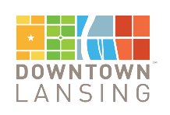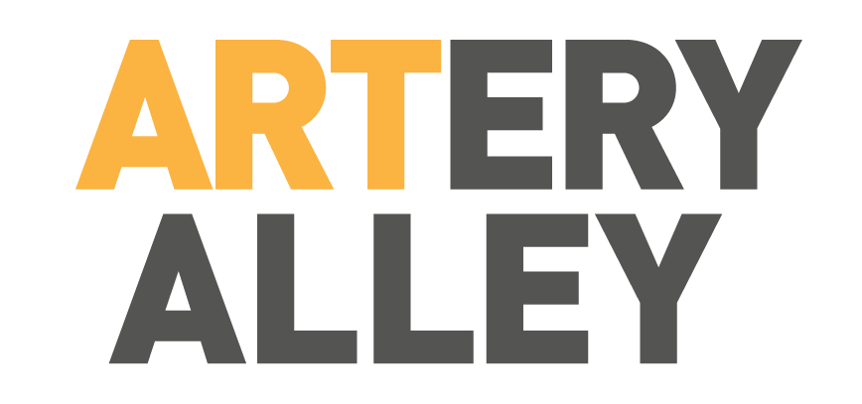

Dear Artist,

Downtown Lansing Inc. invites you to participate in an alley transformation project, to create a more vibrant and inviting community space in the heart of our downtown district. Not only are we looking to create a stronger sense of place through mural art, but we are also looking to lift up local artists while linking Lansing’s history to our future!

Participation as a mural artist would require:
- Completion of a preliminary design for a wall selected by Downtown Lansing Inc. (DLI) who will provide to the artist appropriate size and scale specifications, plus information about the surface and the location. Preliminary design will be delivered to (DLI) no later than February 12, 2021 as designs will need to be pre-approved by the property owner and DLI Design & Public Spaces team.
- Please provide a list of necessary materials, including any required rental equipment for successful on-site mural completion, with your design concept.
- The ability to travel to Lansing, MI to begin art April 19 (weather permitting) for mural completion by April 23 (weather permitting). Downtown Lansing Inc. will provide a $500 stipend to each artists to cover the cost of paint supplies. In addition, DLI will also pay $1,000 to the selected artist, as well as cover any food expenses and lift costs (if needed).

Additional information can be found in the accompanying Mural Artist Agreement Form. If you are interested in participating in this exciting project please submit the Mural Artist Application and your designs no later than January February 12, 2021.

If you have any questions please do not hesitate to reach out to us at the phone number below. We look forward to hearing from you soon.

Warm Regards,

Cathleen Edgerly Downtown Lansing Inc. (517) 487-3322
cathleen@downtownlansing.org

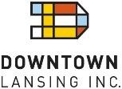
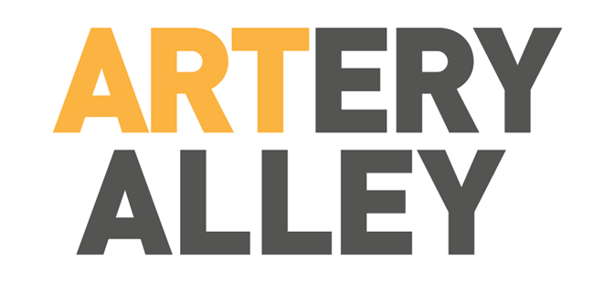

MURAL ARTIST APPLICATION

Artist Name:

Company Name:

Street Address:

E-mail Address: Phone:

Website:

Social Media:

Examples of Previous Work: (Please include digital images with e-mailed application or fill in links to online images below.)

Artist Bio: Include information about yourself, your training, previous projects, etc.

Please e-mail completed form, and any accompanying images, to Cathleen Edgerly, Director, cathleen@downtownlansing.org

MURAL ARTIST AGREEMENT

AGREEMENT, made this day of in the year 2021, by and between Downtown Lansing Inc.. ("DLI”) and ("Artist”).

Downtown Lansing Inc. is contracting with Artist to complete an exterior mural on 1 of our designated buildings in downtown Lansing, Michigan as part of the ARTery Alley Project April 19-23.

- ARTIST RESPONSIBILITIES. Artist agrees to paint a Mural in the designated space during the Project dates. Artist agrees to work diligently and with his/her best efforts to complete the murals within the timeframe allotted. Artist agrees to participate in aspects of the Project that help promote the event and engage the community, so long as these events do not prohibit Artist from completing the Mural within the time allotted.

- MURAL CONTENT. The mural content will be the Artist’s discretion but must not contain images or text depicting violence, nudity, profanity, political statements, or content that could be construed as an advertisement for the business operating in the building. Murals will be placed in a public space and content is to be appropriate for public consumption of all ages. The DLI team will review mural designs for appropriate content prior to completion.

- MURAL LOCATION. Artist agrees to paint on the wall assigned by DLI, as permitted by Building Owner and described below. Artist will only paint in designated areas on the wall. No windows are to be painted.

_

DLI RESPONSIBILITIES.
DLI is responsible for procuring all necessary City of Lansing approvals and Building Owner permissions. DLI will provide access to the space to allow Artist adequate time to complete the work.

EXPENSES.
DLI will provide lodging (if necessary), lunch, dinner, and water for the Artist during the project period. DLI will make available to Artist equipment necessary for completion of the Mural. Required materials must be pre- approved and agreed upon prior to the ARTery Alley production week (no later than April 2, 2021). DLI will provide to Artist a stipend of $500 to cover any paint materials can be used by Artist as he/she see fit. The

$1,000 artist payment, in addition to the $500 stipend to cover materials will be paid within 1 week of completion of the project. DLI will not be responsible for expenses that are not agreed upon in advance.

CONDUCT.
Artist shall conduct their work so as to maintain goodwill with the community and comply with City of Lansing regulations and all other applicable laws.

RISK OF INVOLVEMENT.
Artist understands that the activities involved in the Project are physically and mentally intense. Artist represents that he/she is physically fit, in good health, and has no physical or mental problems which would hinder the completion of work for which he/she is being contracted. Artist represents that he/she is sufficiently trained and experienced enough to understand the risks involved in the Project.

ASSUMPTION OF RISK.
Artist understands and accepts that participating in the Project may involve dangerous activities and there exists the danger of encountering known and unknown risks, including the significant risk of serious bodily injury, illness, disability, emotional trauma, damage to property, and death (“Injuries”). Artist expressly and voluntarily assumes full responsibility for these risks, from any cause including, without limitation, negligence, gross negligence, defective products, unknown obstacles, equipment malfunction, inadequate training, failure to supervise, and failure to warn of potential risks. ARTIST HEREBY ASSUMES ALL OF THE RISKS OF PARTICIPATING IN THIS PROJECT, including by way of example, and not limited to, any risks that may arise from negligence or carelessness on the part of the persons or entities being released from dangerous or defective equipment or property owned, maintained, or controlled by them, or because of their possible liability without fault.

LIABILITY WAIVER, RELEASE AND PROMISE NOT TO SUE.
In consideration of Artist’s participation in this Project, Artist hereby takes action for his/herself, his/her personal representatives, heirs, next of kin, successors, and assigns as follows:

  - Artist WAIVES, RELEASES, AND DISCHARGES from any and all liability, including but not limited to, liability arising from the negligence or fault of the entities or persons released, for death, disability, personal injury, property damage, property theft, or actions of any kind which may hereafter occur to Artist including travel to, during and from the Project, THE FOLLOWING ENTITIES OR PERSONS
(collectively, the “Released Parties”): Downtown Lansing Inc., the City of Lansing, Project holders (i.e., the persons and entities who participate as event locations and destinations), Project sponsors, Project volunteers, location/property owners, Project participants, their respective directors, officers, members, employees, volunteers, representatives, and agents, and their heirs, personal representatives, successors and assigns;
  - Artist AGREES TO INDEMNIFY, DEFEND, HOLD HARMLESS, AND PROMISE NOT TO SUE the Released Parties from any and all liabilities or claims made as a result of participation in this Project.
  - Artist unconditionally and irrevocably waives liability and promises never to sue, forever discharges and relinquishes any and all rights, claims, demands, suits, actions, losses, damages, costs and expenses, including attorneys’ fees and costs that Artist may incur or have against Released Parties arising from or related to participating in the Project, including, without limitation, any claims arising from or related to: (i) the actions or omissions of any of the Released Parties, other participants, spectators, or other third parties; (ii) the inadequacy of any training or supervision; (iii) failure to investigate, keep safe or to warn of hazards known or unknown; (iv) any defect in or failure of the operation, installation, manufacture, and/or design of any equipment, stage sets, or wardrobe; (v) the conditions on or about the premises; (vi) the breach of any implied or express warranty and/or representation of any of the Released Parties; (vii) transportation; (viii) weather

conditions; and/or (ix) any other operations associated with the Project and, with respect to each of the foregoing, whether based on tort (including, without limitation, acts of negligence and gross negligence), contract or any other theory of recover in law or equity, whether for compensatory or punitive damages, equitable relief or otherwise, and whether now known or unknown, suspected or unsuspected (all of the foregoing shall be collectedly referred to as the “Released Claims”).

DISCLAIMER OF DAMAGES.
DLI shall have no liability to Artist for any special, incidental, exemplary, or consequential damages.

INDEMNITY.
Artist indemnifies and holds harmless each of the Released Parties from and against any and all Released Claims, and any and all third parties’ claims, arising from or in connection with:
- any breach or alleged breach of this contract;
- Artist’s participation in the Project, including, without limitation: (i) any injuries to Artist; (ii) any injuries to third parties directly or indirectly arising from Artist’s participation in the Project; and (iii) any other loss or damage that Artist may directly or indirectly cause to any real or personal property.

CONSENT TO MEDICAL CARE.
Artist authorizes each of the Releasees to call for medical care or transport Artist to a medical facility at Artist’s expense, if medical attention is needed. Artist also authorizes any physician or other medical provider or facility to provide any emergency medical/surgical care. Artist acknowledges and agrees that none of the Releasees is under any legal obligation to render assistance to Artist.

INSURANCE.
DLI and its affiliates will maintain general liability insurance for the Project, as required. Artist is responsible for maintaining any personal health or liability insurance he/she see fit.

RIGHT TO USE NAME AND LIKENESS.
Artist irrevocably grants to DLI, its affiliates and each of their licensees, successors and assigns, and each of the authorized photographers acting on their behalf, without additional compensation, the unrestricted right to photograph, videotape, film, and portray Artist and Artist’s actions, voice and other sound effects while present at the Project. Artist irrevocably grants to DLI and its affiliates the exclusive right to use Artist’s name, image, likeness, voice and biography for any purpose and in any manner, including, without limitation, in connection with the distribution, advertising, promotion, commercial tie-in, or other ancillary exploitation of the Project, and any entertainment programming related thereto, in whole or in part, in all media and by all means now known or hereafter devised and in all languages, throughout the universe in perpetuity. Artist’s participating in the Project will be deemed a “work-made-for-hire” specially commissioned by DLI within the meaning of all applicable laws and, accordingly, DLI and its affiliates will be the sole and exclusive owner thereof for all purposes. To the extent necessary, Artist hereby irrevocably assigns to DLI and its affiliates all of the rights, title, and interest of every kind or nature which Artist may have or hereafter acquire. If Artist receives any print, negative, tape or other copy from the Project, Artist will retain it for personal use only, and will not license or authorize its use by anyone else for commercial or private purposes. Artist waives all rights under the Visual Artists Rights Act.

MAINTENANCE.
The Building Owner, on which the mural is painted, will have sole responsibility for the maintenance of the building, with the understanding that no changes will be made to the wall containing the mural for a minimum of twelve (12) months. In the event of required repairs following that twelve (12) month period, and if the integrity of the mural cannot be maintained, the Building Owner may remove the entirety of the mural.

ADVERTISING AND PROMOTION.
All advertising shall comply to DLI and Project identity standards. Artist is encouraged to utilize social media to promote the Project and HMS will provide a variety of branding tools which Artist is entitled to use. Artist may promote his/her involvement in the Project for personal promotion.

TERMINATION.
This Agreement and the relationship created by it may be terminated by either party at any time upon 30 day notice given to the other; or immediately when the termination is for cause. Expenses incurred will be the responsibility of the terminating party.

BREACH OF CONTRACT.
Any violation of any provisions herein by Artist constitutes breach of contract. In the event that a breach of contract is committed by Artist, Artist will be responsible for reimbursement of expenses incurred by DLI, per EXPENSES paragraph of this agreement.

NON-ASSIGNABILITY.
This Agreement is by and between DLI and Artist. Neither party has the right to assign its rights to another party.

ENTIRE AGREEMENT.
This Agreement constitutes the entire agreement between the parties in connection with its subject matter. This Agreement supersedes any and all other agreements, either oral or written, between parties with respect to its subject matter.

ACKNOWLEDGEMENT.
The signatures below are acknowledgement of receipt of this Agreement. Artist acknowledges that this contract will be used by the Project holders, sponsors, and organizers of activities, and that it will govern Artists actions and responsibilities at said activity or event. Artist acknowledges and understands that this Agreement is a legal document, and by signing this document Artist is waiving substantial legal rights to recover damages for Injuries or losses. All parties sign it voluntarily and without inducement of any nature and intend for it to be enforced to the greatest extent allowed by law.

ARTIST:
Signature: Print Name: Date: Mailing Address: Phone: Email:

DOWNTOWN LANSING INC.
Signature: Printed Name: Title:

Mailing Address:
401 S. Washington Sq. Ste. 101
Lansing, MI 48933 www.downtownlansing.org

