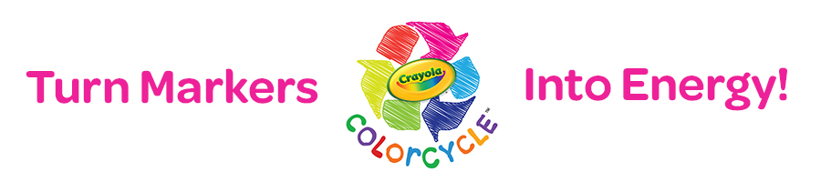

Dear Parents,

I’m excited to tell you about a very special program I’m coordinating at our school in conjunction with Crayola. It’s called Crayola ColorCycle – an amazing new program devised to turn used markers into energy!

All around [Your School’s Name] students and teachers will be collecting used markers that are ready to be discarded. The markers will be sent to a facility where they will be converted into clean fuel. This fuel can be used to power vehicles, heat homes, cook meals and more!

Please help support our efforts by sending your kids in with any used markers you may have around the house – even non-Crayola brands. Drop-off boxes will be located around the school for your child to deposit the markers.

Thank you in advance for participating! With the help of parents like you across the country, the Crayola ColorCycle program can keep tons of plastic out of landfills each year.

Remember, don’t throw out that used marker—ColorCycle it!

Sincerely,

[Your name and signature]

Learn more at http://www.crayola.com/colorcycle

