St. Ignatius Home & School Association Newsletter
SEPTEMBER 2017

Back to School Uniform Exchange
Thank you to everyone who helped set-up and run our Back-to-School Uniform Exchange. A special thank you to our HSA members, parent volunteers and grandparents, especially Charlotte Miller, Eran Stirr, Mary Elizabeth Yuhasz and Grandma Cindy Allen. Look for our next Uniform Exchange during Catholic Schools Week!

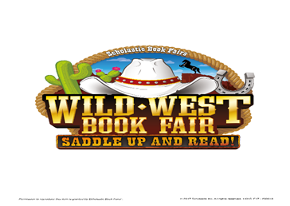
Wild West Book Fair
Our Wild West Book Fair is right around the corner! The Book Fair will be held September 18-September 21, 2017. We will be open Monday, Tuesday, & Thursday from 8am-3:30pm and Wednesday from 8am-6pm. Look soon for your child’s preview and purchasing schedule. Come and round up some good reading!

Upcoming HSA Restaurant Fundraisers

A portion of your purchase will be donated to St. Ignatius HSA!

↪ 9/27: Sweet Frog Frozen Yogurt, Wyomissing 4:00-close
↪10/18: PJ Whelihans, West Lawn 5:00-close

Fall Fundraiser
The fall Fundraiser through Cherrydale Farms will kick off on September 28th. A fundraiser packet will be sent home with every family. This year there is a new exciting opportunity for students to create their own personalized message online to notify family and friends and promote online sales. N.U.T (No Uniform Today) passes and gift card prizes will be awarded for levels of participation in the fundraiser. Please look for more details to follow.

KidStuff Coupon Books
The KidStuff coupon book sale will run during the month of September. Coupon books cost $25.00 each and St. Ignatius HSA earns $12.50 from each book that is purchased! Make checks payable to St. Ignatius HSA. All orders are due by 9/29! Contact Jen Smith jrsm452@gmail.com for more information.
St. Ignatius Home & School Association Membership
HSA is always looking for new members! If you are interested in learning more about HSA, contact Diane Buerke!
2017-2018 HSA Officers
President: Diane Buerke (buerkebunch@earthlink.net)
Vice President: Jen Smith
Treasurer: Troy Pankowski
Secretary: Kristin Herbein
Have a wonderful school year!

