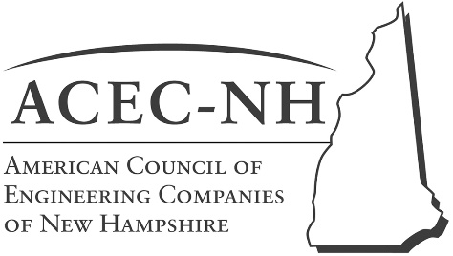

**Possible 2019-2020 ACEC/CQI CQI Topics for Consideration**

|  |  |  |
| --- | --- | --- |
| **NHDES Outreach** | **Technical Topics** | **General Interest Topics** |
|  |  |  |
| * Organizational Updates | * PFAS | * Energy Issues |
| * Rule Making Status | * Limited Reuse Soils | * Working/Strategy Sessions |
| * AFFF Take Back Program | * New Commissioner Update |  |
| * Submittal Quality Review | * GW Discharge Permitting |  |
| * EMD update | * DW Source Protection |  |
|  | * Dam Safety |  |
|  | * Air Division updates |  |
|  | * GWDW Trust Update |  |
|  |  |  |

Meeting Dates

9/20/2019

10/18/2019

11/15/2019

12/20/2019

1/17/2020

2/21/2020

3/20/2020

4/17/2020

5/15/2020

6/19/2020