To receive your Points, you may enter completed activities on your web account. If you prefer to send the
Go365® Biometric Screening

form, you must send valid proof of participation and the completed form within 90 days of completing the activity.
Please keep a copy of the form and proof for your records. Doctor, clinic or provider signature is required if proof is not submitted.

Member Instructions:
- Set up your appointment with the provider of your choice*. When you make your appointment tell the provider what measurements you need. Those measurements include Body Mass Index, Blood Glucose, Total Cholesterol, and Blood Pressure.
* Use this form at the doctor’s office, clinic, or health facility of your choice. You can get a Biometric Screening when you visit your doctor as part of your annual wellness visit check-up. You can also obtain your Biometric Screening from a Go365 participating provider near you.
NOTE: You may incur out of pocket costs depending on your plan benefits. Ask your doctor for more information.
- Fill out Section A: Member information/Attestation
- Take this form with you and give it to your provider
- Send the completed form to Go365®. You can ask your provider to send it for you, but you are responsible for making sure Go365 receives the form.
Section A: Member information – please print
First name:
Last name:
Member / Subscriber (Sub) ID#:
Date of birth (MM/DD/YYYY):
Phone number:
Attestation / Consent to release and use of information
I consent to the release of my fitness / medical information and test results (if applicable) to Go365. A photocopy of this consent shall be as effective and valid as the original. This consent shall be considered valid for one year from the date signed.
Included with this form is a Notice provided to me by Go365 that explains completion of my biometric screening is voluntary. I have read and accept this Notice.
I understand and agree that Go365 has the right to confirm the accuracy of the information received and we may review your submission at any time. Invalid or inaccurate submissions will result in the denial or removal of Bucks and/or Points.
Member signature:
Date (MM/DD/YYYY):
Provider Instructions:
1. Fill out Sections B, C and/or D and E. Fill out Section C or D depending on the measurements or tests the patient needs.
Hand-write the measurements or test results on the form. Proof of the patient’s measurements or test results does not need to be submitted.
Section B: Provider information – please print
Doctor/practice/facility name:
Address
National provider ID# or CLIA#:
Phone number:
Section C: Body and blood pressure measurements
Date of measure (MM/DD/YYYY):
Height (inches): Weight (lbs):
Waist circumference (inches):
Systolic blood pressure (mmHg):
Diastolic blood pressure (mmHg):
Section D: Clinical laboratory test results*
Blood glucose (mg/dL):
Total cholesterol (mg/dL):
LDL cholesterol (mg/dl):
HDL cholesterol (mg/dL):
Triglycerides (mg/dL):
Optional* HbA1c (%)
* The HbA1c test is needed only if it is part of your active recommended activity to get your blood glucose in healthy range. There may be a cost associated with this test. Ask your provider for more information.
Section E: Certification of results – please print
I certify I personally tested this individual and attest to the accuracy of results reported herein.
First / last name of person conducting measure / test:

Title:
Provider signature:
Date (MM/DD/YYYY):
** The values submitted on this document will also update the Go365 Health Assessment. If you are working on a recommended activity and only want that information updated on the Go365 Health Assessment, only enter the new information.

GCHJLWGEN 1018 Page 1 of 3

Go365® Biometric Screening
Send the completed form any of these ways:
Online: Sign in to Go365.com. In the top navigation, click on Quick Links, then Forms.
Fax: 1-877-250-7814
Mail: Go365
P.O. Box 14613
Lexington, KY 40512-4613
Important Note: Adult children are not eligible to earn Points for biometric screening completion or healthy in-range results.

NOTICE REGARDING WELLNESS PROGRAM
Go365 is a voluntary wellness program available to all eligible Go365 members. The program is administered according to federal rules permitting wellness programs that seek to improve health or prevent disease.¹ If you choose to participate in the wellness program you will be asked to complete a voluntary health assessment or “HA” that asks a series of questions about your health-related activities and behaviors and whether you have or had certain medical conditions (e.g., cancer, diabetes, or heart disease). You will also be offered the opportunity to complete a biometric screening, which will include a blood test for cholesterol and glucose levels. You are not required to complete the HA or to participate in the blood test or other medical examinations.
However, individuals who choose to participate in the wellness program will receive various incentives (Points) for completing a range of activities promoting health. Although you are not required to complete the HA or participate in the biometric screening, only individuals who do so may be eligible to receive the Points associated with those activities.²
Additional Points are³ awarded for individuals who participate in health-related activities or achieve certain health outcomes. If you are unable to participate in any of the health-related activities or achieve any of the health outcomes required to earn the Points, you may be entitled to a reasonable accommodation or an alternative standard. You may request a reasonable accommodation or an alternative standard by calling the number on the back of your Member ID card.
The information from your HA and the results from your biometric screening will be used to provide you with information to help you understand your current health and potential risks, and may also be used to offer you services through the wellness program, such as health coaching. You also are encouraged to share your results or concerns with your own doctor.
Protections from Disclosure of Medical Information
We are required by law to maintain the privacy and security of your personally identifiable health information. Although Go365 [and your employer, if applicable] may use aggregate information collected to design a program based on
identified health risks in the workplace, Go365 will never disclose any of your personal health information either publicly or to the employer, except as expressly permitted by law. Medical information that personally identifies you that is provided in connection with the wellness program may not be provided to your supervisors or managers and may never be used to make decisions regarding your employment.
Your health information will not be sold, exchanged, transferred, or otherwise disclosed except to the extent permitted by law to carry out specific activities related to the wellness program, and you will not be required to waive the confidentiality of your health information as a condition of participating in the wellness program or receiving an incentive. Anyone who receives your information for purposes of providing you services as part of the wellness program will abide by similar confidentiality requirements. The only individual(s) who will receive your personally identifiable health information are those who you authorize to receive the information such as a registered nurse, a doctor, or a health coach.
Please refer to the Go365 Notice of Privacy Practices for additional information on ways Go365 uses and protects your confidential medical information. You may not be discriminated against in employment because of the medical information you provide as part of participating in the wellness program, nor may you be subjected to retaliation if you choose not to participate. If you have questions or concerns regarding this notice, or about protections against discrimination and retaliation, please contact your Human Resources professional at your place of work.
¹ For employees whose employers have provided Go365 as part of the employer-sponsored wellness program, these laws include the Americans with Disabilities Act of 1990, the Genetic Information Nondiscrimination Act of 2008, and the Health Insurance Portability and Accountability Act, as applicable, among others.
² Points are not rewarded for eligible adult and minor children of Go365 members who complete the HA or biometric screening, and who achieve certain outcomes on the biometric screening.
³ See footnote 2.

GCHJLWGEN 1018 Page 2 of 3

IMPORTANT!
At Humana, it is important you are treated fairly.
Humana Inc. and its subsidiaries do not discriminate or exclude people because of their race, color, national origin, age, disability, sex, sexual orientation, gender identity, or religion. Discrimination is against the law. Humana and its subsidiaries comply with applicable Federal Civil Rights laws. If you believe that you have been discriminated against by Humana or its subsidiaries, there are ways to get help.
- You may file a complaint, also known as a grievance:
Discrimination Grievances, P.O. Box 14618, Lexington, KY 40512-4618
If you need help filing a grievance, call 1-877-320-1235 or if you use a TTY, call 711.
- You can also file a civil rights complaint with the U.S. Department of Health and Human Services, Office for Civil Rights electronically through the Office for Civil Rights Complaint Portal, available at https://ocrportal.hhs.gov/ocr/portal/lobby.jsf, or by mail or phone at U.S. Department of Health and Human Services, 200 Independence Avenue, SW, Room 509F, HHH Building, Washington, DC 20201, 1-800-368-1019, 800-537-7697 (TDD).
Complaint forms are available at https://www.hhs.gov/ocr/office/file/index.html.
Auxiliary aids and services, free of charge, are available to you.
1-877-320-1235 (TTY: 711)
Humana provides free auxiliary aids and services, such as qualified sign language interpreters, video remote interpretation, and written information in other formats to people with disabilities when such auxiliary aids and services are necessary to ensure an equal opportunity to participate.
Language assistance services, free of charge, are available to you. 1-877-320-1235 (TTY: 711)

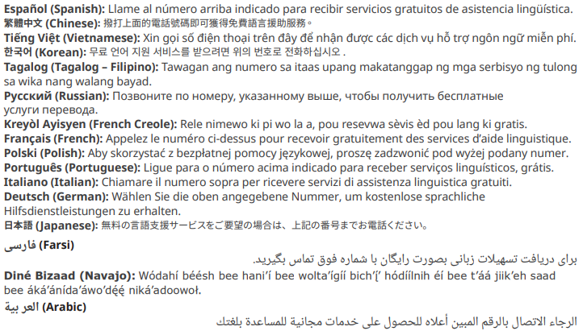

GCHJLWGEN 1018 Page 3 of 3

