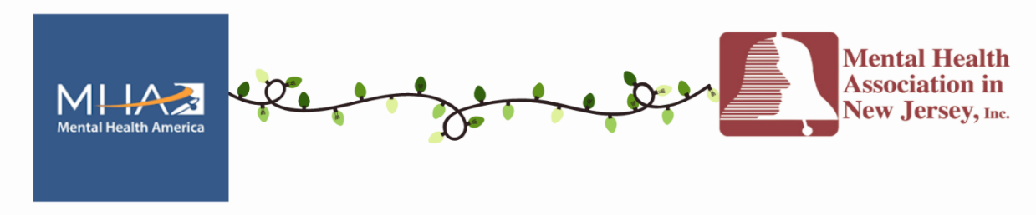

Light Up Green Across New Jersey 2025 Mental Health Awareness Campaign

Registration Form
The purpose of this form is to register your business, organization or landmark for the Light Up Green Across New Jersey for Mental Health Awareness Campaign during May, Mental Health Month, presented by both the Mental Health Association in New Jersey and Mental Health America.

Please fill in the items below and email back to Merrill Altberg at maltberg@mhanj.org.
If you have any questions, please call her at 732-604-5388.

Target deadline to register is April 21, 2025 but we will accept registrations after that date.

Your Name:

Your Email Address: Your Phone Number:

Contact Name for Lighting Up Green:

Contact Email Address: Contact Phone Number:

Name of Company or Landmark written as you would like to have it appear in publicity:
Address of Participating Building or Landmark:

Dates You Will Participate:

Do you have someone who can take photos and email them to maltberg@mhanj.org?

Permission -- I hereby irrevocably consent to and authorize the use and reproduction by the Mental Health Association in New Jersey, Mental Health America or anyone authorized by you, including the news media, of any and all photographs and/or video and name and location of the facility/landmark or business regarding the 2025 Light Up Green campaign. This may include but not be limited to on-line social media and Websites posts, press releases, news media and print or online publications.

__Yes, I grant permission to use the photos, video and identifying information as noted above.

Please print and sign your name:

