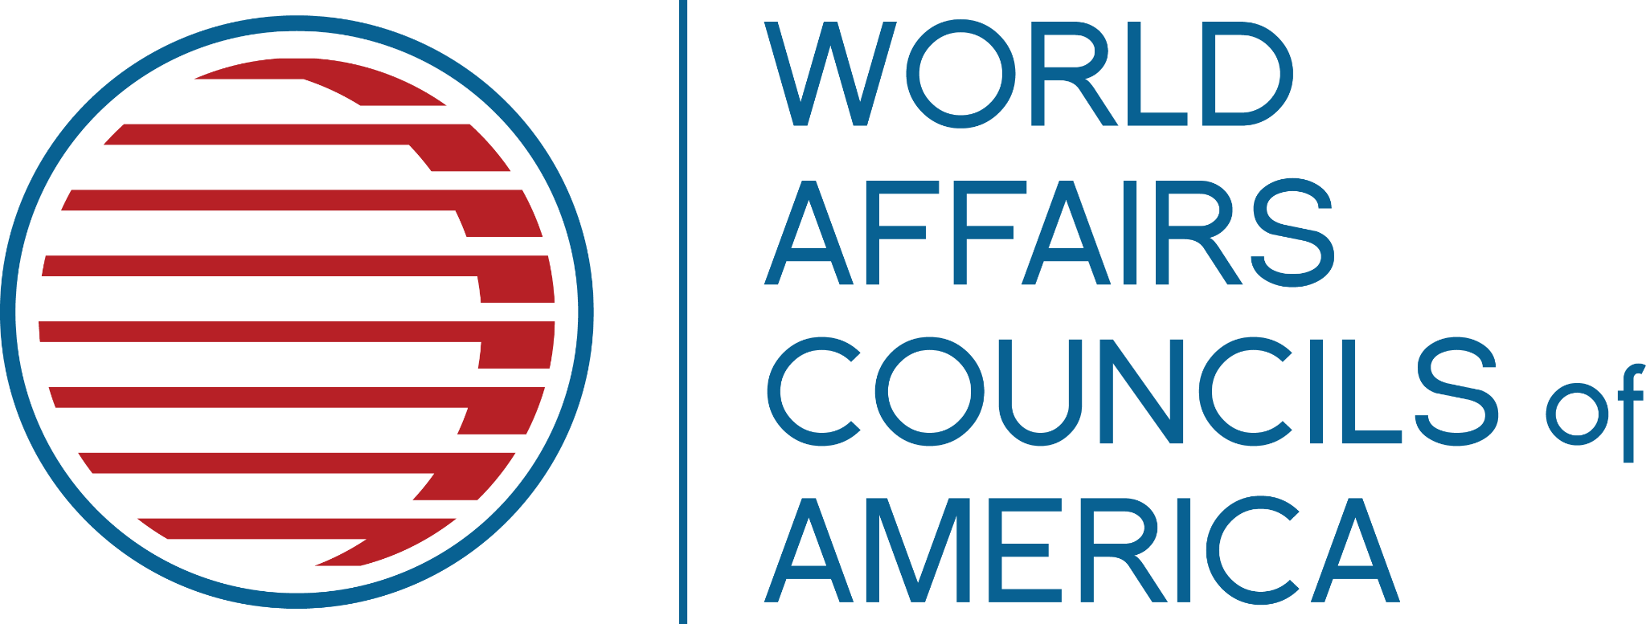
Internship Description
Communications Intern
Washington D.C.

WHO WE ARE
The World Affairs Councils of America is a nonpartisan nonprofit organization dedicated to engaging the public and leading global voices to better understand the world, the United States’ international role, and the policy choices that impact our daily lives and our future. Based in Washington, DC, WACA supports 90 World Affairs Councils across the United States and promotes their programs and educational initiatives for diverse, multi-generational audiences. We bring the world to classrooms and C-suites, and to conferences in the nation’s capital and town hall-style forums in communities across the country.
POSITION SUMMARY
WACA is looking for a mission-driven Communications Intern. The Intern will support the Communications and Marketing Manager on external communications (including press releases, newsletters, website updates, and social media) – and other initiatives to support WACA and our Council Network.
ESSENTIAL DUTIES AND RESPONSIBILITIES
The Communications Intern will be responsible for contributing to our organization in the following ways:
- Support the creation of marketing collateral for WACA and its programs
- Manage and improve social media, photo, and video communications
- Assist in the organization's proper utilization of brand standards and maintain the WACA Style Guide
- Provide logistical support to WACA’s upcoming Academic WorldQuest National Competition
- Adhere to World Affairs Councils of America performance standards, employee policies, and procedures
- Support the Operations and Programs Associate as needed
- Other duties as assigned

REQUIREMENTS
The successful candidate must be currently enrolled in an undergraduate or graduate level program or have graduated within the last calendar year. Candidates are expected to commit 20-25 working hours per week to the internship. Interns must be based in Washington, D.C. and will work at least two days per week in the office (interns will be on-site for WACA’s 2023 Academic WorldQuest National Competition, April 28-29). The internship period will run from February to early May 2023.
KNOWLEDGE, SKILLS, AND ABILITIES REQUIREMENTS
- Ability to write in a creative, descriptive, and factual manner
- Strong skills with social media and creating graphics
- Highly professional demeanor and ability to communicate clearly with a wide variety of stakeholders including Council leaders and staff, national Board Members, donors, volunteers, and professional consultants
- Self-starter ability, taking initiative to tackle new projects and manage current ones with minimal supervision, handling multiple priorities and tasks to succeed in a deadline-driven environment
- Ability to maintain consistent, organized, and meticulous records
- Proficiency/experience with the Google Suite, Microsoft Office 365, Constant Contact and other communications/event-marketing services, and media-tracking and content-management platforms
- Integrity, trustworthiness, flexibility, compassion, and humor are necessary to address the practicalities of a growing nonprofit, along with the creativity and persistence required to elicit new thinking and change
TO APPLY
Please submit the following to krider@worldaffairscouncils.org by Friday, January 20, 2022
- Resume
- Cover Letter

Due to the number of applications we typically receive, we are unable to acknowledge each applicant personally. Only those selected for an interview will be contacted.

