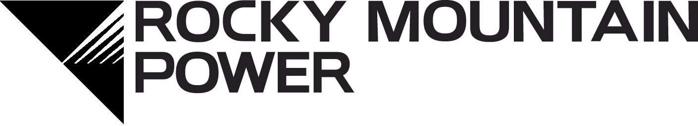
Plug-in Electric Vehicle
General Application – LIVE ELECTRIC
participant information
(Check will be issued to the participant business name and address listed below unless the payment release section below has been filled out)
Participant is (check all that apply) ☐ Customer ☐ Facility owner ☐ Tenant/Electricity user

Participant business name (As shown on income tax return):
Mailing address: |  | City: | State: | Zip:
Contact name: |  | Contact title:
Contact telephone number:  ( ) | Cell number:  ( ) | Contact email address:
Taxpayer Identification: Participant Federal taxpayer ID number (EIN) or SS#:
Please check the appropriate box:
☐ Individual or Sole Proprietor ☐ LLC, LLP or Partnership ☐C Corporation ☐ S Corporation ☐ Trust/Estate ☐ Exempt Payee
Please provide a description of your project so we may better help you:
☐ PEV Fleet Buy Down | Additional project information: (scope and schedule) ADD ATTACHMENT  Please read the LIVE ELECTRIC Mission Statement.  Write your program description scope and proposed schedule-

Buy down assignment (Complete only if buy down is to be assigned to someone other than participant above)
Check should be made payable to:
Mailing address: | City: | State: | Zip:
Contact name: | Contact telephone:

APPLICATION ACKNOWLEDGEMENT
By my signature below, I certify that all information provided for participation will be accurate including but not limited to supplemental material and claims of participant and vehicle information. I confirm I have read, understand and agree with the Terms and Conditions and agree to be bound by them. I authorize Rocky Mountain Power to provide my electric account information and electric vehicle charging information to consultants associated with the Plug-in Electric Vehicle program.
Certification of Taxpayer Identification: Under penalties of perjury, I certify that: 1) The Taxpayer Identification number is correct, and 2) I am not subject to backup withholding due to failure to report interest and dividend income and 3) I am a U.S. citizen, resident alien or other U.S. person. The Internal Revenue Service does not require your consent to any provision of this document other than the certifications required to avoid backup withholding.

 | Signatory name & title (please print) |  | Participant signature |  | Date

Mission Statement

Live Electric Is A Community Partnership Dedicated To The Accelerating Electric Vehicle Adoption, Zero-Emission Strategies And Smart Mobility Transportation Choice To Promote Clean Air, Innovation And Economic Vitality In The Intermountain West.

PEV Fleet Scope and Schedule Description:
- Please write a brief description of your program and how your sustainability goals would be supported by electric vehicle adoption and workplace charging infrastructure. Refer to our LIVE ELECTRIC mission statement above and address the main points as they apply to your business or agency. (Word limit 300).
- Please feel free to attach your Corporate Sustainability Plan (CPS) or other sustainability objectives you may have.
- Complete the above and send to tammie.cooper@utahcleancities.org

Terms and Conditions

How to participate:
EV Buy Down:
- Pre-qualification is recommended but not required.
- Purchase qualifying vehicle.
- Complete general application and Electric Vehicle Buy-down Checklist.
- Submit application and all required supplemental forms to Project Manager.

Buy down assignment to third party: In the event that Rocky Mountain Power does not pay the buy down as a result of the participant’s failure to comply with the terms and conditions, the assignee’s sole recourse shall be against participant.

Inspections and analysis: Participant agrees to cooperate with Rocky Mountain Power and its consultants to conduct energy analysis and inspections at the participant’s site. Rocky Mountain Power reserves the right to inspect qualifying vehicle/electric vehicle charging vehicle measures, which may include a telephone survey, site visit, and/or the installation of temporary monitoring vehicle at any time up to 36 months after installation for quality control or program performance evaluations.

Tax liability: Neither Rocky Mountain Power nor its Program Administrator is providing tax advice or responsible for any tax liability which may be imposed on the participant as a result of any buy down payment. Participant may be responsible for the tax reporting to the IRS of any buy down payments directed to third parties.

Buy down limitations & limitation of damages: Participant shall independently evaluate any advice or direction given by Rocky Mountain Power or its consultants. In no event will Rocky Mountain Power be liable for any personal injury or harm to participant’s facilities of any kind, or for any incidental or consequential damages of any kind. Rocky Mountain Power is not responsible if a third party provides inaccurate information about the amount and/or conditions of the actual buy down and Rocky Mountain Power will not pay buy downs for vehicle that is mislabeled or misrepresented by third parties regarding buy down qualifications.

Buy down offer: The buy down offer is an estimate. The final buy down will be based on actual vehicle purchased. Participant agrees to provide any reasonable documentation to allow Rocky Mountain Power to determine actual costs incurred.

Transfer of environmental attributes: Participant hereby transfers to Rocky Mountain Power all "Environmental Attributes" attributable to the installation of the qualifying vehicle or its operation. Environmental Attributes include any and all credits, benefits, emissions reductions, offsets and allowances, howsoever entitled, resulting from the avoidance of the emission of any substance to the air, soil or water at or by the company’s generating facilities, through reduced generation of energy or other savings or offsets on account of the qualifying vehicle. Participant will not claim ownership of any Environmental Attributes. As long as participant at the same time states the qualifying vehicle was made possible with funding from Rocky Mountain Power, participant may claim that it is facilitating the production of the Environmental Attributes attributable to the qualifying vehicle.
Additional details: Buy down qualifications and amounts are subject to change and termination at any time.

