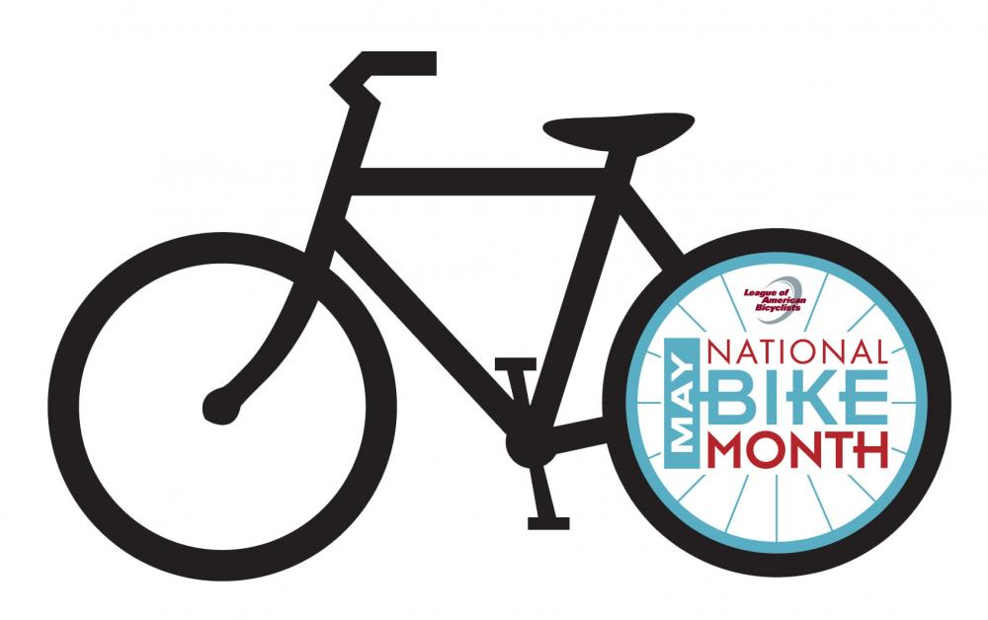
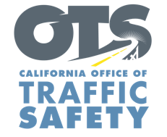
ENTER AGENCY LOGO
FOR IMMEDIATE RELEASE
Enter Month and Day, 2022
Enter First Name, Last Name, Phone Number and Email

May is Bicycle Safety Month: Share the Road and Look Out for One Another

Enter City, Calif. — May is National Bicycle Safety Month, and Enter Agency name reminds drivers to follow the speed limit and look out for people on bike rides.

“The days are longer, and the weather is pleasant, making for ideal conditions to go on a bike ride,” Enter Title, First Name last name said. “Drivers, please share the road so we may all get places safely.”

*Law Enforcement Only.* Delete if not applicable To help keep people biking or walking safe, the Enter Agency name will conduct a traffic safety operation Enter date(s) and time(s) from a.m. to p.m. or p.m. to p.m. or if unknown, say “throughout the month” focused on the most dangerous driver behaviors such as speeding, making illegal turns, failure to yield to bicyclists or pedestrians, and stop sign/red light running.

Enter Agency Name suggests the following safety tips for bicyclists and drivers:
Drivers
- Slow down and follow the speed limit. Be careful traveling through intersections.
- Look carefully for bicyclists and pedestrians before making a turn or opening a car door near streets or bike paths.
- Be patient when traveling behind a bicyclist. Maintain at minimum three feet of space when passing or overtaking a bicyclist.
- Never drive distracted or impaired.
Bike Riders
- Use lights at night (at minimum, a front white light and rear red reflector).
- Although not required for riders 18 and older, always wear a properly secured helmet. Helmets significantly reduce the chance of a head injury in the event of a crash.
- Bicyclists must travel in the same direction of traffic and have the same requirements as any slow-moving vehicle.
- Yield to pedestrians, just as a driver would. Pedestrians have the right-of-way within marked crosswalks or within unmarked crosswalks at intersections.

Funding for this program is provided by a grant from the California Office of Traffic Safety, through the National Highway Traffic Safety Administration.
# # #

