711 Empty Chairs: State and Local Organizations Honor Victims of Traffic Violence at World Day of Remembrance Event
Emily Shane Foundation, California launch “Empty Chair Club” to raise awareness about impact on friends, families, and communities
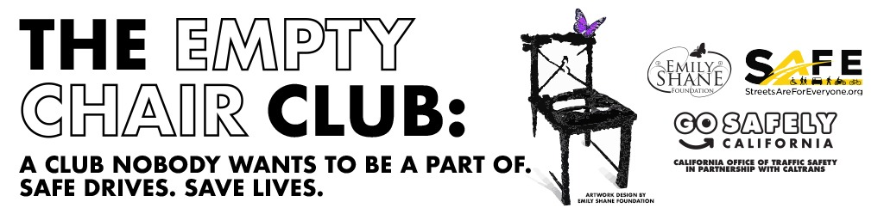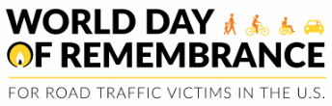

WHAT YOU NEED TO KNOW: State and local leaders joined traffic safety organizations in downtown Los Angeles during World Day of Remembrance for Traffic Victims (WDoR) today to honor the hundreds of people across Los Angeles County and thousands statewide killed in traffic crashes every year.

LOS ANGELES – The California Office of Traffic Safety (OTS), California Department of Transportation (Caltrans), Streets Are For Everyone (also known as SAFE), Emily Shane Foundation, Auto Club of Southern California (Auto Club) and other traffic safety organizations gathered in downtown Los Angeles for this year’s WDoR to honor road traffic victims and unveil an art installation that served as a tribute to people killed in traffic crashes.

Titled “711 Empty Chairs,” rows of 711 chairs were adorned with a single yellow rose to represent every person killed due to traffic violence in Los Angeles County over the past year.

Families of victims were invited to honor their loved ones by bringing a photo or personal memento, or by writing their loved one’s name on a remembrance card to place on one of the empty chairs.

Families like Michael Gast, whose son Nick was tragically struck and killed on July 28, 2024, while crossing the street outside the Elysian Theater in Los Angeles.

“His potential to improve the lives around him was endless,” Michael Gast, Nick’s father said. “His loss still ripples across the lives of so many people.”

Around the empty chair installation, a “Remembrance Village” offered grief support services, traffic safety information booths and an area to reflect on the victims and the broader impact of traffic violence on communities.

WHY IT MATTERS: Held annually on the third Sunday in November, WDoR is a global event to remember the millions of people who have been killed and seriously injured in traffic crashes worldwide and acknowledge the pain suffered by victims, their friends, families and communities.

THE EMPTY CHAIR CLUB – A CLUB NOBODY WANTS TO BE A PART OF: To raise awareness about the impact on traffic victims and their loved ones, the Emily Shane Foundation, OTS, Caltrans, and SAFE have launched the “Empty Chair Club” initiative, which recognizes those left behind by traffic violence through the image of an empty chair. The artwork was developed by the Emily Shane Foundation to serve as a symbol for people who unwillingly find themselves in the Empty Chair Club. Friends and families of victims killed are encouraged to share their story and support safer streets so the Empty Chair Club stops growing. Social media messages will run statewide through the Thanksgiving holiday featuring an image of an empty chair, a stark reminder of what can be an especially painful time of year for members of the Empty Chair Club.

WHAT OTS DIRECTOR STEPHANIE DOUGHERTY SAID: “Too many people are being killed on our roads in preventable traffic crashes. In an instant, friends and family are forever part of a club they want no part of – the Empty Chair Club. If it is your dinner table, one empty chair is one too many. This moving event is a call to action to support safer streets and end this club for good.”

WHAT CALTRANS DIRECTOR DINA EL-TAWANSY SAID: “At Caltrans, safety is our top priority. On this World Day of Remembrance, we want to commemorate those who have lost their lives on the road. Every life lost on the road is a story that is unfinished. This event reminds us that we all have a shared responsibility to keep our roads and each other safe.”

WHAT SAFE EXECUTIVE DIRECTOR DAMIAN KEVITT SAID: “Today, victims of traffic violence, advocacy organizations like SAFE, and local and state agencies join together for the first time at World Day of Remembrance for Road Traffic Victims to say ENOUGH IS ENOUGH! Seven hundred eleven lives — and thousands more seriously injured — were lost in LA County last year. Each of these collisions, and every person injured or killed, was preventable. It’s time we start prioritizing the safety of everyone using our roads and stop ignoring dangerous drivers and dangerous streets.”

WHAT EMILY SHANE FOUNDATION CO-FOUNDER MICHEL SHANE SAID: “No family should have to set one less place at the table because of a preventable tragedy. Every empty chair represents not just a life lost, but dreams unfulfilled and love interrupted. The Emily Shane Foundation believes the only acceptable number of empty chairs at our tables is zero. No more empty chairs.”

WHAT AUTO CLUB TRAFFIC SAFETY & COMMUNITY PROGRAMS MANAGER TIFFANY STANLEY SAID: “Dangerous behaviors like speeding, impaired driving, texting, running red lights, failing to wear seatbelts, and aggressive driving claim far too many lives on our roads. Every one of these crashes is preventable. By slowing down, staying focused, and showing care for others, drivers can protect themselves and the people they love.”

CALIFORNIA PUTTING SAFETY FIRST: The state is committed to make roads safer through new and innovative investments in transportation safety, education and enforcement programs.
- 30% by 2035: Last month, the state set an interim goal to cut deadly and serious injury crashes by 30% by 2035 as part of a new statewide policy on road safety to address California’s highest-risk areas. Two designated priority safety corridors - Avalon Boulevard in Los Angeles and State Route 91 in southeast Los Angeles County – will have a series of planned safety upgrades that address community safety needs.
- Nearly $5 billion to Enhance Bicycle and Pedestrian Safety: Last month, $4.9 billion was awarded statewide to fund new alternative transportation options and local projects to expand safe biking and walking options.
- More than $1 billion annually in safety improvements on State Highway System: Caltrans has invested an average of $1.1 billion annually over the past seven years in safety investments across the State Highway Operations and Protection Program (SHOPP), SHOPP Minor, and Highway Maintenance programs. Projects include median barriers, roundabouts, lane narrowing, improved lighting and crosswalk visibility, and dedicated bicycle lanes and walkways.
- Pacific Coast Highway (PCH) Master Plan Feasibility Study: Caltrans launched a PCH Master Plan feasibility study to identify priority areas, long-term safety measures, and safer travel options to improve safety on PCH in Malibu for pedestrians, cyclists, and transit users.

To share your victim story and learn more about the Empty Chair Club initiative, visit gosafelyca.org.
To get involved as a “traffic safety champion” and support safe streets for your family and community, visit gosafelyca.org/get-involved.
###

