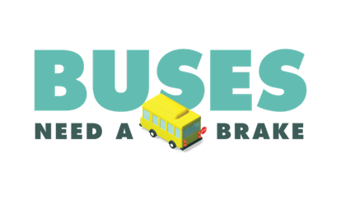
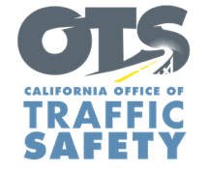
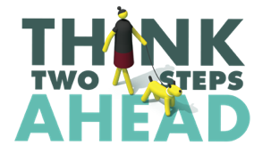
Add Agency Letterhead/Logo

For Immediate Release Enter Month, Day and Year
Enter First Name, Last Name, Email and Phone Number

As Schools Reopen for In-Person Learning, Enter Your Agency Name Encourages Drivers, Parents and Students to “Go Safely”

Enter Your City, Calif. – As students and staff return to schools for in-person instruction, the Enter Your Agency Name reminds everyone to keep the safety of students in mind when traveling around schools.

This includes stopping for school buses. California law requires drivers to stop when a school bus is in front of them and extends its stop sign with flashing red lights. Drivers must remain stopped as long as the red lights are on. Drivers in both directions must stop on any two-lane road without a median or two-lane road with a center turn lane.

“Please drive carefully in school zones,” Enter Agency Name, Rank or Title, First Name, Last Name said. “Let’s help keep students safe to ensure as smooth a transition as possible back to in-person learning.”

The Enter Your Agency Name offers the following tips for drivers, parents and students:
- Walk on sidewalks and use marked crosswalks, preferably at stop signs or signals.
- Watch for cars entering/backing out of driveways or leaving parking spaces.
- If you need to walk into the street to maintain social distancing, remember to look both ways for cars.
- Always look left-right-left before crossing the street. Make sure cars see you. Continue scanning for cars when entering the crosswalk.
- Do not listen to loud music or use a phone when crossing the street.
- Drivers: slow down in school zones. Anticipate more foot and car traffic around schools for drop-off and pick-ups.
- Drivers should do their best to avoid blocking the crosswalk when making a right-hand turn
- Parents: Follow any school guidance related to dropping off or picking up students, as well as social distancing and face covering requirements.

Delete if not applicable Funding for this program was provided by a grant from the California Office of Traffic Safety, through the National Highway Traffic Safety Administration.

###

