For Immediate Release
May 15, 2024

Contact: Tim Weisberg, OTS Marketing and Public Affairs
916-708-5128, timothy.weisberg@ots.ca.gov

Let’s GO! California Office of Traffic Safety Encourages Everyone to Join the “Go Safely Movement” One Year into Road Safety Call to Action
Be a “Traffic Safety Champion,” join the hundreds who have already committed to safer roads for their community

ELK GROVE – The California Office of Traffic Safety (OTS) is launching a “Let’s GO” call to action in celebration of the one-year anniversary of the impactful “Go Safely Movement.” This dedicated initiative has galvanized interest in taking specific actions that contribute to safer roads and communities statewide.

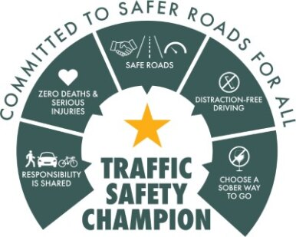

“Let’s GO” is a renewed call for Californians to join the movement for safer roads. Today through the Memorial Day Weekend, the OTS will have a series of social posts running in English and Spanish encouraging people to commit to responsible road behaviors and join the movement as a traffic safety champion. A toolkit of resources will also be available for organizations, businesses and community-based organizations to amplify support for safer roads.

Since its launch on May 15, 2023, the movement has gained substantial momentum, with its achievements serving as a testament to its success in promoting traffic safety awareness and advocacy at the individual and community level.

Over the past year, the Go Safely Movement has actively involved nearly 2,500 individuals through its community call-to-action survey, amplifying the voices of Californians committed to creating safer roads for all. Notably, more than 300 dedicated individuals have responded to the call by signing up as traffic safety champions. These champions play a crucial role in driving proactive involvement and community-led change.

"The success of the ‘Go Safely Movement’ over the past year speaks volumes about Californians' dedication to prioritizing road safety,” OTS Director Barbara Rooney said. “As we continue working towards our shared goal of safer roads for all, it is important to create a safety culture where zero deaths is the only acceptable number. Let's work together to keep the momentum going and make sure that every Californian reaches their destination safely and without incident."

Central to the movement’s achievements is the Traffic Safety Champion Program, a cornerstone initiative empowering Californians to effect positive change within their communities. By participating in the program, individuals gain access to resources, including webinars and informational sessions, equipping them with the tools needed to effectively advocate for safer roads.

As the Go Safely Movement enters its second year, the OTS invites all Californians to join the cause by pledging to become a traffic safety champion. Through collective action and unwavering commitment, Californians can help make roads and communities safer for generations to come.

Become a Traffic Safety Champion Today

Join the Go Safely Movement and pledge to be a traffic safety champion. Together, we can create safer roads for all. Visit gosafelyca.org to sign up and learn more.

# # #

