OTS, Caltrans Kick Off Bicycle and Pedestrian Safety Public Awareness Campaign
September is California Pedestrian Safety Month

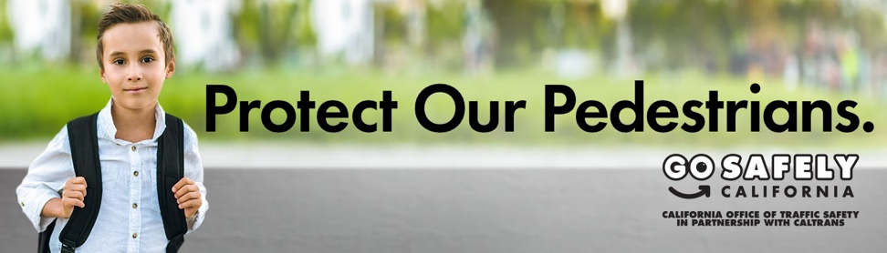
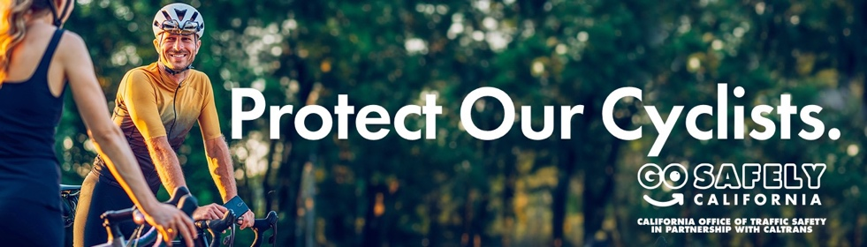
WHAT YOU NEED TO KNOW: The California Office of Traffic Safety (OTS) and California Department of Transportation (Caltrans) are launching a statewide initiative calling on drivers to protect people walking and riding on our state’s paths and roads.

SACRAMENTO – The OTS and Caltrans today kicked off the ‘Protect Our Pedestrians. Protect Our Cyclists.’ campaign. The public service announcements (PSAs) call on drivers to slow down, look out for people walking and riding, and drive like it is their friend, family member, or colleague walking or riding on paths and roads. According to this year’s California Traffic Safety Survey, 40.5% of survey respondents listed “cars going too fast” and “cars not stopping” as safety problems experienced while walking or biking.

WHAT OTS DIRECTOR BARBARA ROONEY SAID: “Everybody moves, and not always by car. ‘Protect Our Pedestrians. Protect Our Cyclists.’ is a call to action for all Californians to establish a strong traffic safety culture where everyone using our state’s paths and roads can go to and from places safely. Bicyclists and pedestrians do not have the same protections provided to drivers and passengers, which is why we must look out for one another.”

WHAT CALTRANS DIRECTOR TONY TAVARES SAID: “Pedestrians and cyclists are the most vulnerable travelers on our roadways. This month, we are reminded that safety is a shared responsibility and everyone, regardless of their mode of travel, deserves to arrive at their destinations safely. Slow down, never drive distracted or impaired, and always be alert for the people whose safety is most at risk on our transportation system.”

WHY IT MATTERS: In California, 1,158 people were struck and killed by vehicles in 2022 alone, accounting for 26% of all traffic deaths. With one out of every four people killed walking on California roads, pedestrians are experiencing unsafe conditions that put lives at risk.

FOR NEWS MEDIA: Video PSAs

CAMPAIGN INFORMATION: The PSAs emphasize that drivers must look out for pedestrians and bicyclists – parents, friends, colleagues, students, children and providers – who use our paths and roads and must get home safely. Audio messages encourage drivers to be responsible and treat other people on paths and roads as their closest friends and family. Social media messages encourage drivers to be mindful and responsible around bicyclists and pedestrians who also want to be safe. The campaign runs through Sept. 22.

Visit www.gosafelyca.org for more traffic safety information.

###

