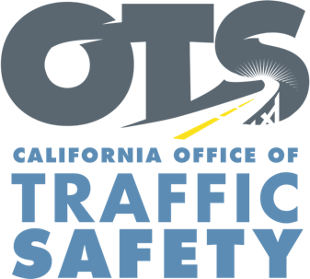

OTS Marketing and Public Affairs Activities
April 2021

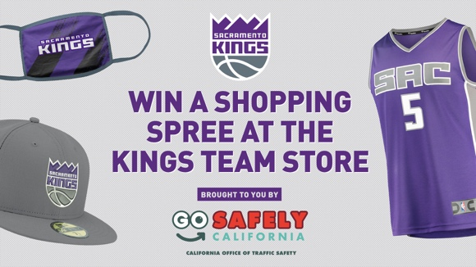
April 5: Kings Team Store Shopping Spree Sweepstakes
Kicks off April 5th and will be promoted through e-mail and social media. Each entrant will be asked and required to answer a survey question related to traffic safety. The question is: What proposed solutions to improve traffic safety do you believe are the most effective? Entrants will be asked to enter their own solution or check all the following solutions they believe apply: enforcement of traffic laws (speeding, distracted and impaired driving, etc.), Education and awareness of traffic laws, stiffer financial penalties for traffic violations, roadway design changes that lower speed and enhance bicycle/pedestrian access.
April 5-April 18: Distracted Driving Awareness Month Paid Media Campaign
Targeted messaging across multiple platforms (TV, radio, digital/streaming, social media, out of home digital billboards/transit shelters, convenience store/gas station TV. The campaign’s goal is to raise awareness about the dangers of driving distracted. the penalties for driving distracted and provide pointers that encourage the public to put down the phone and just drive.
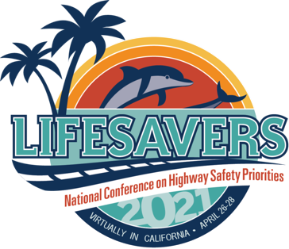
April 26-28 Lifesavers Conference
The OTS will play virtual host to the 2021 Lifesavers Conference. OTS Director Barbara Rooney will be one of the Opening Plenary Speakers April 26, along with CalSTA Secretary David Kim, discussing the impact and challenges of the COVID-19 pandemic on traffic safety. Registration is still available online.

