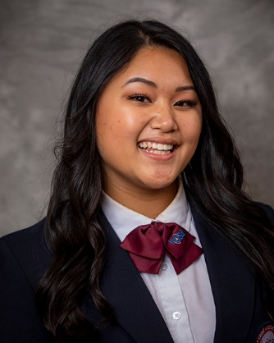
Professional appearance is important. It is the first thing people see. Professional dress gives a favorable opinion of your student and HOSA.

Fall Leadership
Appropriate Not Acceptable
HOSA Casual—polo with a collar T-shirts, tank tops, cut offs,
Khaki/Dress pants denim, short skirts (touch
Casual dress shoes top of knee or longer), sun
HOSA Uniform dresses, sandal, flip flops,
Tennis shoes etc.

Regional Conferences
Appropriate Not Acceptable
Professional Dress per industry T-shirts, tank tops, cut offs,
Standard. Example: scrubs for nurses denim, short skirts (touch,
HOSA uniform optional top of knee or longer), sun
Professional dress and shoes dresses, sandal, flip flops,
Tennis shoes etc.

State Leadership Conference
Appropriate Not Acceptable
Professional Dress per T-shirts, tank tops, cut offs,
Industry Standard denim, short skirts (touch,
Professional dress required for top of knee or longer), sun
events that do not have industry dresses, sandal, flip flops,
standard dress Tennis shoes etc.
Note: HOSA uniform required on stage

ILC (Refer to national standards per guidelines)
HOSA Uniform
Men and Women:
Black or Navy blazer with emblem
White blouse or dress shirt with buttoned collar and:

Men | Women
Navy or maroon long tie | Matching navy slacks or skirt
Matching navy slacks | Blue or black closed toed shoes
Dark socks | Maroon scarf optional
Black Dress Shoes | Stockings optional

