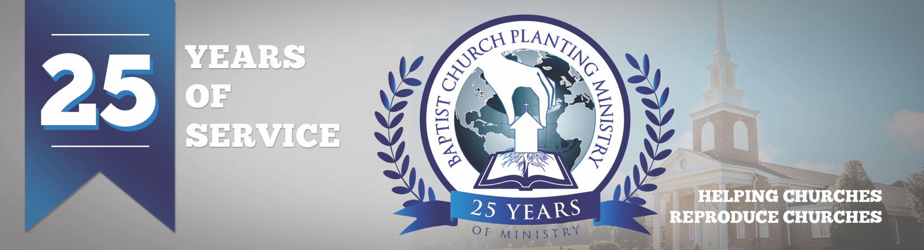

February 2018

The Lord blessed the recent church plant in Hartford, AL in a wonderful way. The Get Acquainted Meetings for Lighthouse Baptist Church were held January 21-25 with over ten churches attending to help with the services. These meetings were such an encouragement to Pastor Aaron Pack and those from the community as they helped build the foundation and provide credibility for the new church. Most of the guests returned for the first official Sunday and mentioned that they would be back. Pray for the Lord to continue to build this baby church in the needy area of Hartford, AL. The next church plant BCPM will assist with will be in Naples, FL, the fastest growing area in the country. The Get Acquainted Meetings for Bible Baptist Church will take place February 25 – March 5. Pray for the evangelism over the next four weeks and that the Lord would stir the community.

The Lord has opened the doors over the years for BCPM to have a global impact in church planting and has allowed us to assist in ten other countries other than the US. Now the Lord has opened the door into Italy. BCPM will hold its first “European Church Planting Conference” February 8-9 in Reggio Emilia, Italy. Missionary Brandon Cook will be the host pastor and there will be several pastors from the region and other countries attending. Please pray for this important conference and for fruit that will impact Europe by multiplying churches.

We are just six months away from BCPM’s 25th anniversary service and we are excited for this historic occasion. We will be recognizing all the church planters and reproducing pastors who have used BCPM. We will thank the Lord for how he has blessed the ministry in the past and also share what we believe the Lord will do in the future. It will be held at 7pm on July 31 at South Haven Baptist Church in Springfield, TN.

Thank you for your continued support! Your investment is making a difference in world-wide church planting. Please make note of the new US mailing address for BCPM. All US support and mail should be mailed to our new mailing address at PO Box 387 Greenbrier, TN 37073.

Advancing in Christ,

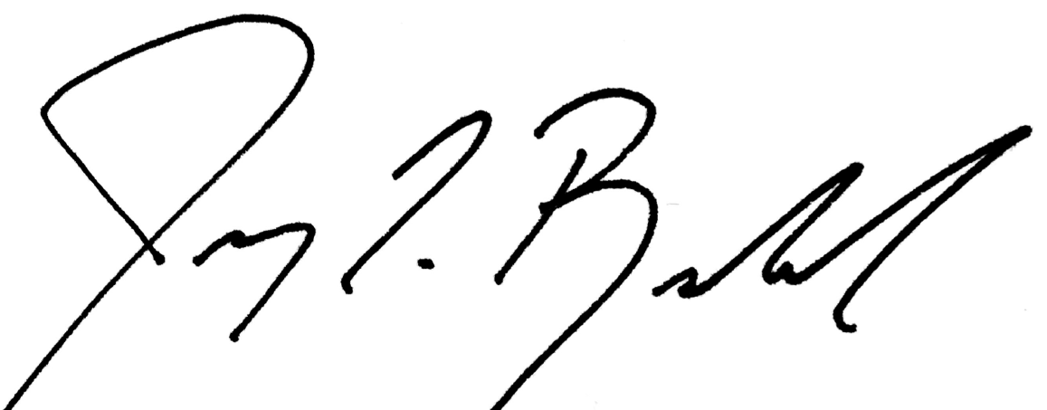

Jeremy Rowland,
General Director

