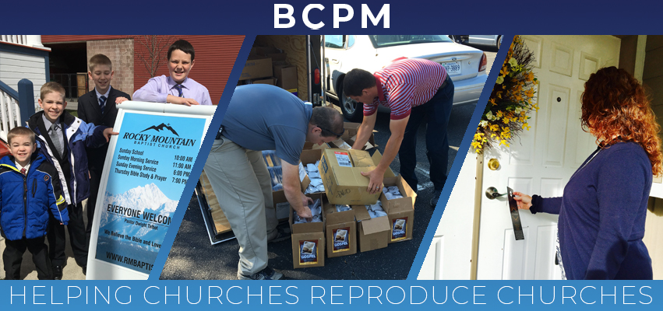

September 2019

We praise the Lord for churches focusing on reproducing other churches. BCPM has assisted with the delivery of 174 baby churches over the last twenty-six years, and we are about to help with two more in the next two months. The first will be in Sarnia, Ontario, Canada with the Get Acquainted Meetings set for September 8-12. The reproducing church is Bible Baptist in St. Thomas under the leadership of Pastor Johnny Yeomans. The church planter is Pastor Bruce Cook. The Sarnia area has been saturated with John and Romans, invitations, signs, social media blitzes, and radio spots. Brother Cook has been contacted daily with people interested in the new church. There have been almost two dozen churches and pastors involved with this effort in Sarnia, and it is good to see the cooperative spirit. Pray for these efforts and that we will have the Lord’s power and blessing in Sarnia. The second church plant will take place in Leawood, KS with the Get Acquainted Meetings set for October 20-25. We will have more on this church plant in next month’s prayer letter. It’s been a joy to see the Lord work in all the preparations and we are anticipating His blessing on each of these church plants.

Pray that the Lord will give us safety in traveling as September through December are very busy with extensive travel. Continue to pray for Brother Rick Rust and Brother Brian Thiessen and their need to raise personal support. It is imperative that they reach full support level so that they can then help with the load of the ministry.

Thank you for your prayer and financial support as the Lord continues to bless BCPM and open doors that will further the cause of church planting world-wide. The need is great, but our God is greater!

Advancing in Christ,
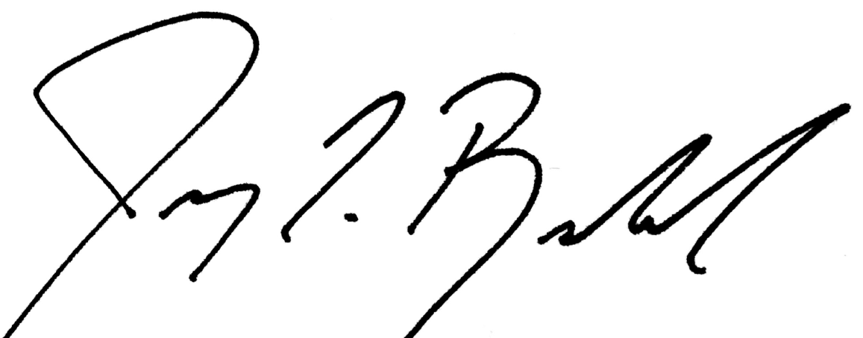

Jeremy Rowland,
General Director

