July, 2017
As many already know, on June 15th , BCPM lost a co-laborer, friend and dedicated servant of the Lord. Matt Hill went home to be with the Lord after a tragic car accident. He will be remembered as a true servant of the Lord who was dedicated to his work, church, and family. Thank you for all those who prayed, sent gifts, and personally helped during this difficult time. Please continue to pray for Kim Hill and her family as they need God’s wisdom and strength in the days ahead.

Although the passing of Brother Hill weighed heavy on our hearts, we were still able to hold our annual board meeting and staff retreat June 19-23. The Lord has definite direction for BCPM, and we were able to spend quality time discussing the future plans. On August 1, BCPM will enter its 25th year of ministry, and we have exciting plans as we celebrate 25 years of the Lord’s hand and blessing. We will announce the specifics in the next few prayer letters.

After the passing of Dr. Jessup last August, we began to pray about filling the vacant position of assistant director to help with the ministry load. The Lord has answered those prayers and BCPM is excited to announce our newest staff member, Pastor Rick Rust. Pastor Rust has worked closely with BCPM for over 20 years and has recently resigned as pastor of Liberty Baptist Church in Toledo, OH, where he served for over ten years. He brings a wealth of hands-on experience and knowledge and will be a great help as the Lord continues to prosper the ministry.

Pray for the next three church plants. We will keep you updated and informed.
- Jerez, Mexico - August 25-27
- Hartford, AL – September 10-14
- Big Timber, MT – October 1-4

If there was ever a time when North America and the world needs new, vibrant, Bible-preaching churches, it’s now! We are asking the Lord to use us more to advance His cause and we are thankful for your prayer and financial support. Your partnership helps multiply the efforts of planting churches in needy areas.

Advancing in Christ,

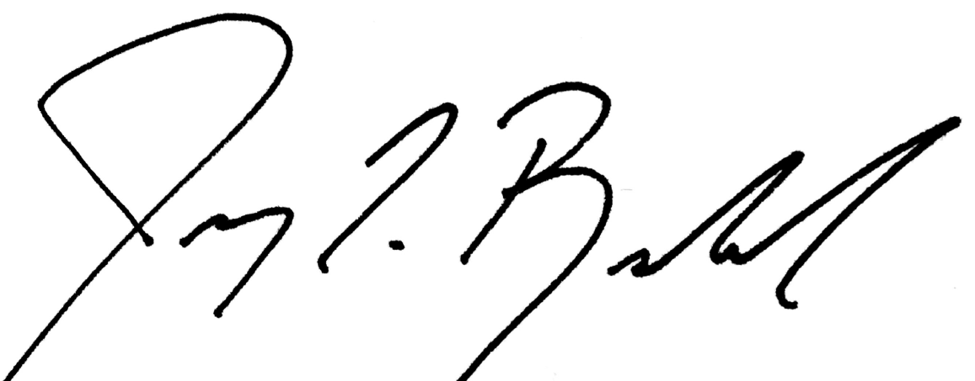

Jeremy Rowland, General Director

