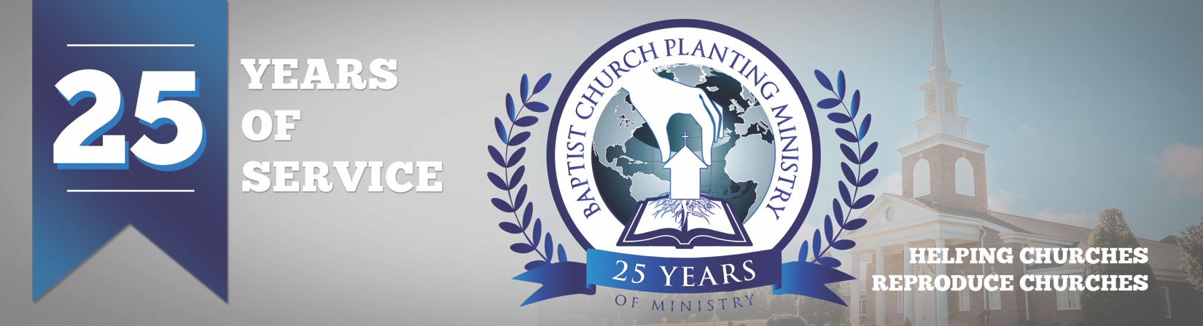

November, 2018

Thank you for praying for the church plant in Castelo Branco, Portugal. It was a joy to help Brother Mark Pereira with the establishment of another Independent Baptist Church in that country. We passed out 12,000 John and Romans, held special opening meetings, witnessed an early Sunday morning baptism, and saw the church organized with eleven founding members. What a thrill to see another church birthed and established! Brother Pereira also showed us another nearby city of more than 50,000 people that needs a local church and he shared his desire to reach it. Pray for Portugal and that God would use the burden of Brother Pereira and other pastors to reach these needy cities.

Please join us in prayer as we have a critical prayer request. BCPM spends an average of $2500 on each church plant for the John & Roman printing and shipping and we need to raise enough to cover the next six church plants which will equal a total of $15,000. The John and Romans play a key part in each church plant as they clearly and thoroughly explain the gospel and also convey to the community that the new church is a Bible-believing church. Many, many, people have been reached through these and have been very appreciative that they received one. Please pray about this urgent need and that the funds would be raised to meet this essential part of the church plants. Along with a mailed check, donations to this Seed Bank Offering can be given online at bcpm.org and by clicking on “donations” and then “Seed Bank”.

BCPM is helping churches establish other strong churches that are making an impact in this dark and needy world. We are passionate and determined to advance the cause of Christ around the world. Thank you for partnering with us as we seek to exalt Christ in carrying out His mission on earth.

Advancing in Christ,

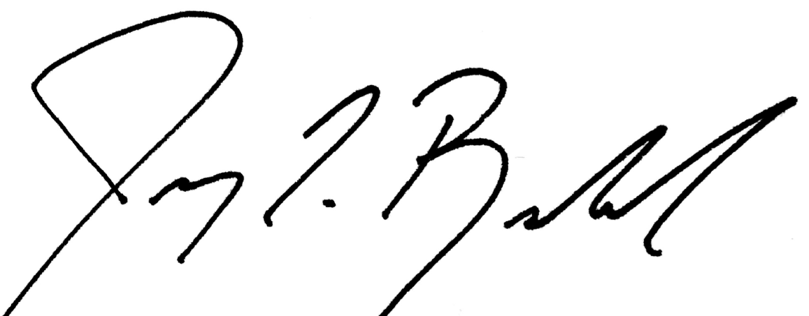

Jeremy Rowland,
General Director

