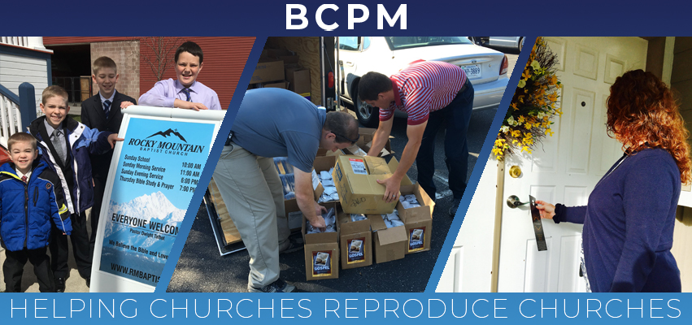

June 2019

June 2019

The last few months have been very busy with our ministry. BCPM assisted with four church plants in Phoenix, AZ; Reggio Emelia, Italy; Dayton, OH; and Shrewsbury, MA. We are amazed at how the Lord has worked in each of these projects and how He continues to build His church in these needy areas. BCPM is currently working on two more church plants in 2019 and on five for 2020. Pray with us and for these church plants!

- Sept 8-12 - Sarnia, Ontario Canada (Bruce Cook / Reproducing church is Bible Baptist in St. Thomas, Canada with Pastor Johnny Yeomans)
- Oct 20-25 – Leawood, KS (Keith Drinkard / Reproducing church is South Knollwood Baptist in Topeka, KS with Pastor Jeremiah Metsinger)

I am thankful for the travel staff the Lord has given to our ministry as they help to “multiply” the efforts. Rick Rust in the US and Brian Thiessen in Canada have been traveling extensively promoting the need for church planting and raising their support. Pray for them to raise their full support so they can concentrate on handling more of the work load of the ministry.

The need to plant churches has never been greater. Our culture needs the local church where people can receive God’s truth, be saved, and grow in the Lord. Pray with us that local churches will be planted all over North America and around the world! Thank you so much for your investment in BCPM and in helping churches reproduce churches.

Advancing in Christ,
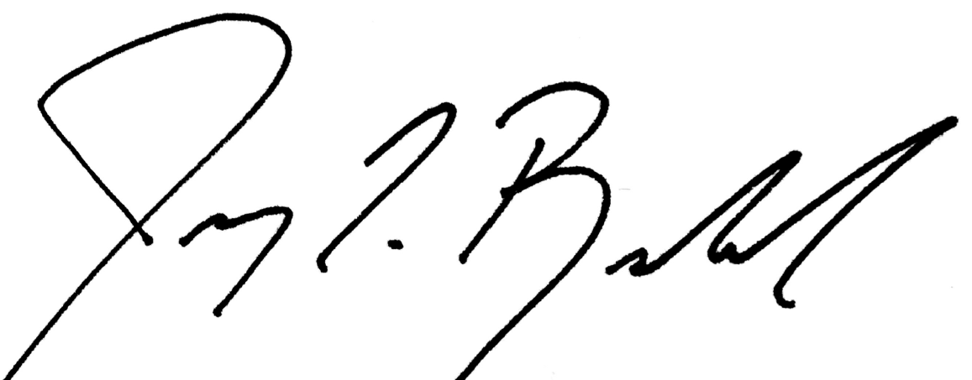

Jeremy Rowland,
General Director

