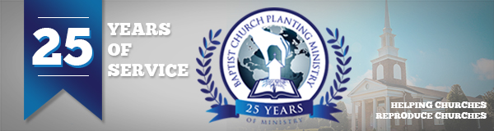

August, 2017

On August 1 BCPM began its 25th year! The Lord certainly has been good to prosper the ministry and to make an impact in church planting world-wide. BCPM has had the privilege of assisting in 164 church plants in nine different countries and these new churches are giving over $4,000,000 to world-wide missions every year! We are rejoicing in what the Lord has done and we want you to celebrate this special 25th anniversary year with us.

1. Pray – Prayer is essential if we are going to saturate communities with aggressive church planting. Although many are praying for BCPM on a regular basis we are designating the 25th of each month to special prayer asking God to impact the world through church planting. Mark your calendar and watch for specific requests that will be sent out each month asking you to earnestly pray and seek the Lord to further church planting.

2. Attend – Join us on July 31, 2018 at 7pm for a special 25th anniversary service. We will recognize all the reproducing pastors, church planters, and those who have worked closely with BCPM since the beginning. This will be held at South Haven Baptist Church in Springfield, TN. Please mark your calendar and don’t miss this historic event.

3. Give – Prayerfully commit to the special 25th anniversary offering. There is so much work to be done and the financial demands to advance church planting are ever increasing. A special letter and brochure will be sent out in September outlining the needs and goals of this offering and we hope you will start praying about how you can be involved.

Pray for the next three church plants. We will keep you updated and informed.
- Jerez, Mexico - August 25-27 (Reproducing church is Beacon Baptist, Phoenix, AZ – Pastor Nathan Massey; New church is Iglesia Bautista Biblica – Pastor Ramon Acevedo)
- Hartford, AL – September 10-14 (Reproducing church is Grace Baptist, Ozark, AL – Pastor Doug Crosby; New Church is Lighthouse Baptist – Pastor Aaron Pack)
- Big Timber, MT – October 1-4 (Reproducing church is Calvary Baptist, King, NC – Pastor Kevin Broyhill; New church is Bible Baptist – Pastor Trevor Martin)

With over 5000 churches closing their doors every year, society becoming increasingly secular, and the invasive growth of false religions, the need for new, solid, Bible-believing churches has never been greater! Thank you for your loyal support to BCPM. Your investment is making a difference!

Advancing in Christ,

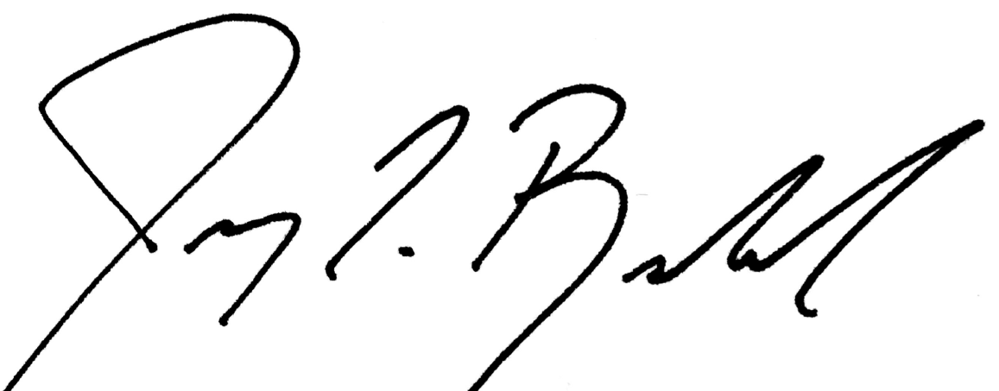

Jeremy Rowland, General Director

