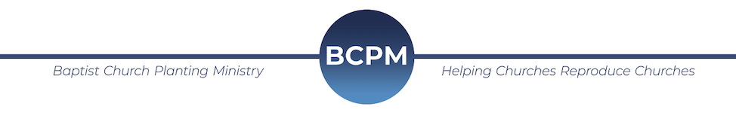
March 2020

We are asking for special prayer over our “Spring Seed Bank Offering." BCPM invests over $4000 in each new church plant. We are currently working on ten new projects, and, as you can tell, this carries a heavy financial load. The Seed Bank was started to help offset the costs of every church plant project. These funds will go to help:
- Print and distribute God’s Word and gospel literature to every household in the new communities
- With the travel, lodging, and meals so that we are not a burden on the new churches
- Provide needed resources so that each church plant can get off to a strong start, mature, and reproduce more churches.
We simply cannot do this without special offerings from God’s people. Here are the specifics in how you can participate:
- Click - on the Seed Bank tab at BCPM.org. The video displayed will briefly explain the need for the offering.
- Show - the video and take a special offering. This can be during a church service, special meeting, or any way God leads.
- Give – online or through the mail. If sending a check, make it out to BCPM and notate it for the Seed Bank.

Please pray about participating in this much-needed offering. Our goal is to raise at least $20,000 to help offset the costs.

The need to plant churches has never been greater, and the new churches are carrying the Light of Jesus Christ into dark and needy areas all over the world. Thank you for partnering with BCPM as we help advance these new works.

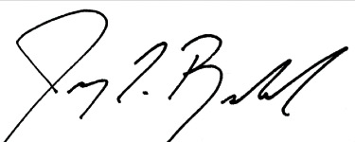
Jeremy Rowland
General Director

