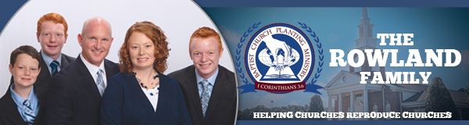

May 2017

Two more healthy churches have been born! Rocky Mountain Baptist Church was born on April 27 in Cranbrook, British Columbia, and New Beginnings Baptist Church was born on May 11 in the inner-city of Charlotte, North Carolina. It was a joy to see the Lord bless these churches and to watch Him work in unique ways. Both of these plants had excellent cooperative support from area churches who were able to assist with the evangelism, financial expenses, and serve in the Get Acquainted Meetings. Pray now for these churches to flourish as they advance the cause of Christ.

Pray also for the preparations of our future church plants. We are presently working on three that will take place in the next five months in Jerez, Mexico; Hartford, AL; and Big Timber, MT. We are also working on several for 2018 and 2019 including Seattle, WA, and the country of Portugal. The Lord has truly blessed our efforts, and we need your prayers so that we can be efficient and effective as we assist in the birth of these new churches.

As I mentioned in the last letter, please pray for BCPM’s upcoming board meeting and staff retreat in June. This is our annual meeting where we will meet and work on ways to better our efforts to assist churches in church planting. The Lord has blessed BCPM, and we want to be diligent in carrying out His plans for the future of the ministry. Among several topics, we will be planning for the 25th anniversary of BCPM, which will start August 1. We have several things planned for this special year, and we will announce these in the future letters. We cannot thank you enough for your investment in BCPM and in partnering with us as we help churches reproduce churches. Only eternity will tell of the souls saved and lives changed because of your prayer and financial support.

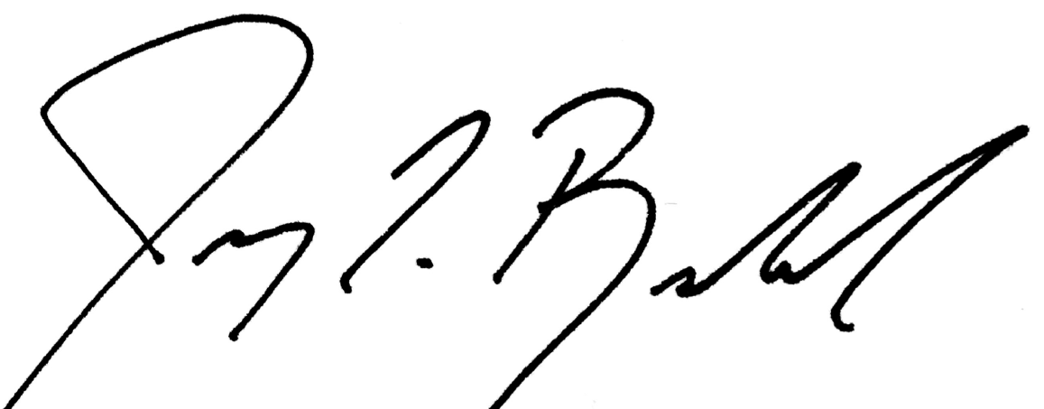

Jeremy Rowland, General Director

