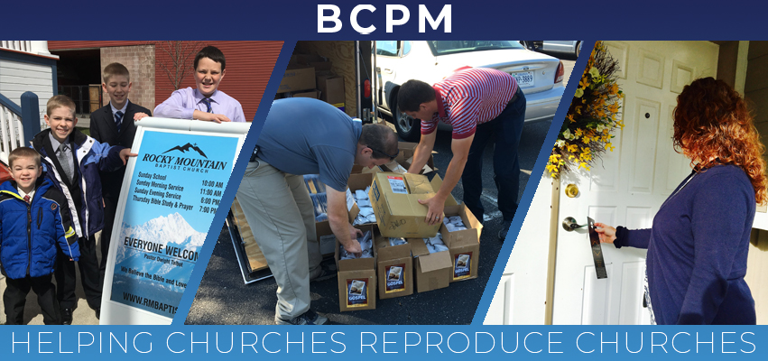

November 2019

The Lord did a wonderful work during the church plant in Leawood, KS! The Get Acquainted Meetings took place on October 20-24, and each night was uniquely blessed. Every night a group from South Knollwood Baptist, the reproducing church under the leadership of Pastor Jeremiah Metsinger, traveled over one hour to assist. There was also tremendous involvement from at least eighteen area pastors and churches. The nightly attendance averaged over eighty with visitors each service. The first Sunday went well with forty-five in attendance and with thirteen first-time guests. Please pray for Brother Keith Drinkard, the new pastor, and the establishment of Ironwood Baptist Church in Leawood, KS.

I am pleased to announce "BCPM Planting Point," a weekly podcast to help encourage Independent Baptists to plant churches. "BCPM Planting Point" podcasts have helpful sessions and interviews from experienced church planters and reproducing pastors. Listen now to nine preset sessions. On Thursday, Nov. 14, at 1 pm EST, a $10 coffee gift card will be given to the first five people who listen to the release of "From Pioneer to Pastor." Just text me and let me know of one help you received from the session. The first five will receive a $10 coffee gift card of choice. You can find “BCPM Planting Point” on most podcast venues.

I am especially thankful this month for your investment in BCPM! Your prayer and financial support continue to help establish churches in dark and needy areas. Thank you for partnering with BCPM!

Advancing in Christ,
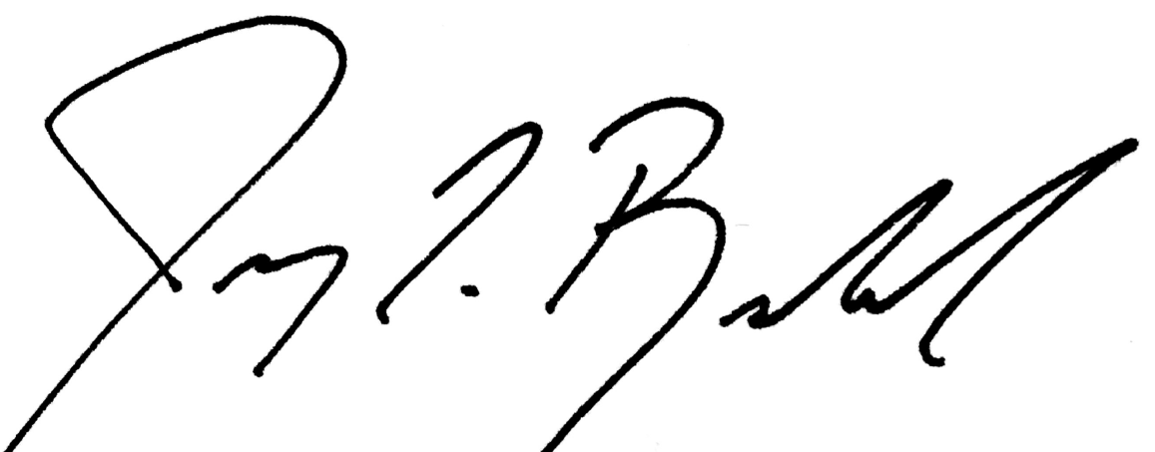

Jeremy Rowland, General Director
9412286523

