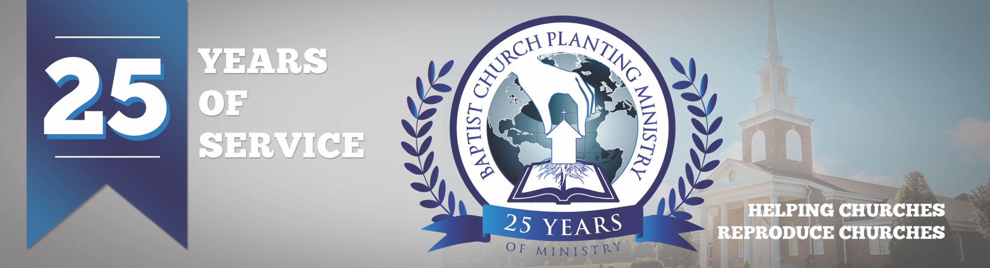

June 2018

We are now working on a church plant in Shrewsbury, MA. The church planter is Pastor Phil Gage, and the reproducing church is Carpenters House Baptist Church in Germantown, OH, with Pastor Keith Wallace. Pray for the preparations with this church plant as housing and meeting facilities are expensive in the Shrewsbury area. Pray also for the additional six church plants we are assisting with. We will send additional info on these soon.

In just two months, BCPM will celebrate its’ 25th-anniversary service, and we have had a wonderful response from pastors who plan to attend. We will be recognizing all the church planters and reproducing pastors who have used BCPM. We will also thank the Lord for what He has done and prayerfully will do through our efforts. The special event will be held at 7 pm on July 31 at South Haven Baptist Church in Springfield, TN. We would love to see you there so please email one of our staff or sign up online.

We are excited to host our first “Pre-plant Conference” on August 1 and 2 in conjunction with the 25th-anniversary in Springfield, TN. The "Pre-plant Conference" will be a time of instruction and encouragement and is designed to help the church planter and his wife prepare for the uniquenesses of church planting. All church planters are invited to attend and can sign-up online.

The Lord is at work advancing the gospel into needy areas, and we are thrilled to be a part of His ministry. Thank you for partnering with BCPM and pray for fruit that will remain through church planting.

Advancing in Christ,

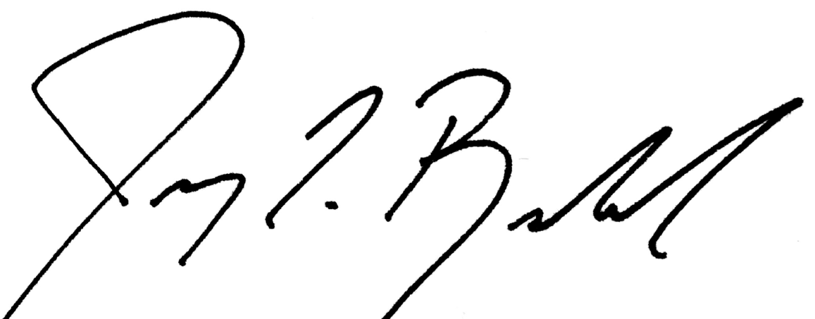

Jeremy Rowland,
General Director

